Columbia County, Oregon
HAZARDOUS MATERIALS TRANSPORTATION BY RAIL RESPONSE PLAN
September 2016

Prepared for:
Columbia Emergency Planning Association (CEPA)

By:

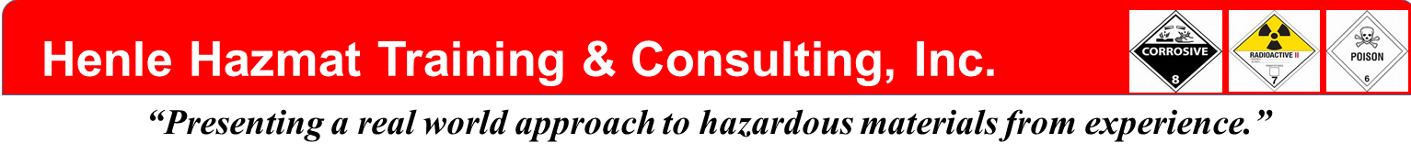

ACKNOWLEDGEMENTS

The following individuals comprised the Plan Core Group who met many times and contributed as stake-holders in the writing and development of this plan. Their efforts and contributions are greatly appreciated.

Chief Mike Greisen Chief Steve Sharek
Scappoose Fire District Clatskanie Fire District

Chief Eric Smythe Craig Ashenfelter
Columbia River Fire & Rescue P & W Railroad

Vincent Aarts LT Shon Christensen
Columbia County Emergency Management Portland Hazmat Team Coordinator

Chandra Egan Frankie Gonzales
Columbia 9-1-1 Communications District P & W Railroad

Chad Hawkins Michael Heffner
Oregon Office of State Fire Marshal Oregon Office of State Fire Marshal

Trish Hilsinger Brad Landers
Columbia 9-1-1 Communications District P & W Railroad

LT Wade Matthews Steve Pegram
Astoria Hazmat Team Coordinator Columbia County Emergency Management

Lonny Welter Bill Henle
Columbia County Road Department Henle Hazmat Training & Consulting

Steve Hermann
Henle Hazmat Training & Consulting

i

INTRODUCTION
This Hazardous Material Transportation by Rail Response Plan has been developed under a grant from the U.S. Department of Transportation, administered by the Oregon State Police, Office of State Fire Marshal. The grant documents require the plan to identify the three most hazardous substances shipped by rail line through Columbia County. These materials are crude oil, both regular and Bakken, ethanol, and anhydrous ammonia. Sodium Chlorate has been added as a fourth hazardous material shipped by rail in Columbia County. The planning process is designed to offer awareness/operations level participation by the local jurisdictions and agencies that are most likely to be affected by a hazardous materials by train incident. The response plan is specifically applicable to the three fire districts that are crossed by the main north south rail-line through the county. The plan also provides maps of the rail line in Columbia County and plume projections of key areas with high public exposure potentials. Input from many County Agencies, Fire Districts, the Railroad, State Hazmat Teams and the State Fire Marshal have been included in the Plan.

The plan is organized into three parts, Part 1 Operational Guidelines, Part 2, the basic plan administration, and Part 3 the Response Packet. Part 1 addresses basic response criteria to successfully respond to and mitigate a hazardous materials rail incident. Part 2 consists of administrative supporting material. Part 3 includes checklists, appendixes and worksheets designed for on-scene use.

This project was funded by the U.S. Department of Transportation, Pipeline and Hazardous Materials Safety Administration, Hazardous Materials Emergency Preparedness grant program through the Oregon State Police, Office of State Fire Marshal and Columbia County Local Emergency Planning Committee. The opinions, findings and conclusions or recommendations expressed in this publication are those of the author and do not necessarily reflect views of the U.S. Department of Transportation or Oregon State Police, Office of State Fire Marshal.

1
Table of Contents
- Introduction…………………………………………………...……...………….....1
Table of Contents………………………………………………………..………………………….…2
- Part 1, Operational Guidelines…………………………………….……….…….3
Levels 1-3 Incident Classification……………………………………………………………….……4
6 Step Process: Size-up, Hazard Analysis, Risk Assessment………………………………...….5
Strategic Goals (Objectives), Tactics & Strategies, Debriefing……………………………….…..7
FOAM APPLICATION GUIDELINES…………………….……………………………………...…..8
Incident Command Guidelines: Single Command, Unified Command…….…………………...10
Resource Guidelines, Communications (Dispatch) Guidelines………………………………….11
- Jurisdictional (Lead) Agencies....................................................................14
Fire, Law Enforcement…………………..…………………………………...…………………...…16
Emergency Management; Emergency Medical, Public Health………...……………….....……19
Railroad, State Agencies………………………………………………………………………….…20
- Supporting Agencies……………………………………………….………..…..22
Fire Departments; County, Federal, State & Private Agencies, NGOs
- Basic Plan Administration…………………………………………..……….....24
Letter of Promulgation, Record of Changes, Record of Distribution……………………………24
Purpose, Scope, Situation Overview and Planning Assumptions……………….……………...27
Concept of Operations (CONOPS); Organization and Assignment of Responsibilities………29
Direction, Control and Coordination; Information Collection, Analysis, and Dissemination..…31
Communications; Administration, Finance & Logistics………………………….………………..32
Plan Development and Maintenance, Authorities & References……………….…………….…34
Acronyms, Glossary……..………………………………………………………………………...…37
- Response Packet (Checklists & Appendixes)……………....…………….…41
Checklist # 1, First Arriving Unit Checklist…………………………….…………………….…..…43
Checklist # 2, Hazard Analysis Checklist……………………………………………………….….44
Checklist # 3, Risk Assessment Checklist………………………………………………………….45
Checklist # 4, Incident Objectives (Strategic Goals) Checklist………………………………..…46
Checklist # 5, Tactics……………………………………………………..…………………….……47
Checklist # 6, Debriefing Checklist…………………………………………….……………………48
Single Command Worksheet, Unified Command Worksheet………………………………..….49
Other Possible Agencies for Unified Command………………………….……………………….50
Resource Worksheet, Short and Long Lists……………………..………………………………...51
Schools, Nursing Homes, Assisted Living, Urgent Care Center……..…………..54
Appendix A, Maps-schools, nursing/assisted living homes, Urgent Care near RR tracks…...56
Appendix B, PLUME PROJECTIONS & HAZARDOUS MATERIALS…….………………….65
Clatskanie…………………………………………………………………………………………….68
Columbia City…………………………………………………………………………………….….73
Prescott……………………………………………………………………………………………….76
Rainier…………………………………………………………………………………….................78
Saint Helens…………………………………………………………………….……………….......83
Scappoose………………………………...………………………………………………………....91
Warren…………………………………………………………………………………………...……99
Appendix C, RAILROAD MILEPOST MAPS……………………………………………………103
Appendix D, Foam Application Guide………………………...………………..…………………118
Appendix E, Hazard Analysis Checklists, SDSs, NIOSH Guide Data……….………………..121
Appendix F, Four Railroad Chemicals, Guidelines…………………………….……………......156
Appendix G, Apparatus Inventories………………………………………………………...……..162
Appendix H, ICS Forms……………………..…………………………..……….……………...…166
Appendix I, Contact List………………………………………………………….…………..…….215

2

II. Part 1
Operational Guidelines

Part 1, Operational Guidelines, presents information for the First Responder to assist in the formulation of a comprehensive response to a hazardous materials rail incident in Columbia County. Part 1 is designed to give basic information and tools for the First Responder to successfully respond to and mitigate a hazardous materials rail incident. The information presented in Part 1 are basic guidelines that may not address every aspect of a hazardous materials rail emergency because an incident has its own variables and conditions that are impossible to predict. Part 1 addresses basic response criteria that assist the appropriately trained First Responder in developing a safe, organized and common sense “game plan” to mitigate the emergency. It is recommended that Incident Commanders (IC) be trained to the Hazardous Materials Incident Commander Level required by OSHA (29CFR1910.120) and be DPSST/NFPA 472 certified.

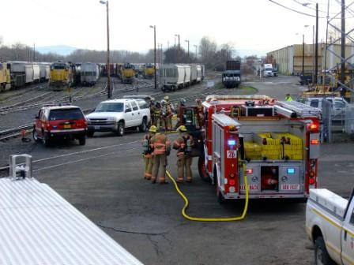

3

Part 1 Operational Guidelines

Preliminary Information:
- Classification of Incident
A response to a hazardous materials transportation incident by rail can be classified by 3 Levels. The purpose of this classification is to give dispatch and all responders a general idea of how serious or how complex the incident may be. The 3 Level concept increases awareness, adds to safety and helps in resource allocation. This concept is being adopted and used more frequently by emergency response organizations across the U.S. for hazardous materials response and planning. The numbers and types of units dispatched will reflect this Level concept.

Hazardous Material Transportation by Rail
Level of Incident:
Level 1 – Potential Emergency Condition (HZS)
- Investigative Call
-Limited Caller Information
- “Something doesn’t look right”
- Minor derailment/No Spill or Fire/no ignition source/product contained in car
- Local response
- No or unknown threat to life, environment, property

Level 2 – Limited Emergency Condition (HZM)
- Greater than a Level 1
- Potential threat to life, environment, property
- Above capabilities of first responder
- Require Hazmat Team/Railroad assets
- Limited Protective Action (Evacuation/Shelter-In-Place of community
- Train derailment with a leak/no fire
- No ignition source or source controlled
- Multi-unit response (Mutual Aid Type Response)
- May require Mutual Aid
Level 3 - Full Emergency Condition-Fire (HZL)
- Extreme hazard to life, environment, property
- Requires extensive resources
- May require large scale evacuation/shelter-in-place
- Train derailment with a leak and fire.
- State/Federal involvement
- Multi-jurisdictional involvement
- Specialists/technical teams involved
- Extensive resource management and allocation
- Multiple emergency operations
4
Part 1
Operational Guidelines

- 6 Step Process for the Incident Commander (IC)

The following is a 6 step process for commanding a hazardous materials incident. These are the basic steps an IC should follow (in a logical order) for successfully mitigating a hazardous materials incident after the scene is secured.
- Size-up
- Hazard analysis
- Risk Assessment
- Strategic Goals (Objectives)
- Tactics and Strategies
- Debriefing

The 3 Levels of Incidents and the 6 Step Process from above will be covered in detail in Procedural Guidelines Section of the Operational Guidelines as well as Checklists provided. All decisions and operations are based upon 3 priorities (in order): LIFE, ENVIRONMENT,PROPERTY

5

Part 1

Operational Guidelines

Procedural Guidelines:
- Size-Up First Arriving Unit – Size-Up
  - Announce arrival and give brief size-up and location of Command. Confirm Level of Incident or upgrade/downgrade Level, over the air, if necessary. Example: “All units- Engine 2 is on scene and Engine 2 is in Command. We may have a leaking tank car of anhydrous ammonia. Confirming this is a Level 3 Incident, responding units approach from the South and stage at the high school. Command is located at 1st and Johnson.”
  - Secure the scene – Keep people and vehicles from entering the scene. Give incoming units approach and staging directions i.e. upwind etc. Contact Rail Crew ASAP.
  - Complete a detailed size-up. Include everything the incident “touches”. Includes-
    - Population/environment/resources at risk-water ways, ship channels, burial grounds, wildlife refuge
    - Weather
    - Time of day
    - Flow of material
    - Container Size
    - Container Condition
    - Fire/ No Fire
    - Attempt to identify the material involved via placards, shipping papers, train list/consist, train crew etc.
  - Announce results of the detailed size-up to all units over the radio. Example “All units from Command. We have confirmed we have a leaking railroad tank car of anhydrous ammonia with a vapor cloud headed toward the downtown area. The vapor cloud covers a 2 block square area. Wind is from the South at 5 mph. All personnel don full turnouts and SCBA.”
  - Prepare to transfer Command. Try to do a Face-to-Face briefing with incoming IC as information transfer is critical.
See “First Arriving Unit Checklist” in Response Packet.

- Hazard Analysis
  - Once the material has been identified, the IC must complete a Hazard Analysis of the product. This analysis evaluates the physical and chemical hazards of the product from information found on SDS’s, DOT ERG, WISER etc. (See SDS’s in Response Packet).
  - The basic physical and chemical hazards of the product pertinent to an emergency
include:
    - Flash Point
6
    - Flammable/Explosive range
    - Vapor Pressure
    - Vapor Density
    - Corrosivity
    - Solubility
    - Toxicity
  - Knowing and understanding the important physical and chemical hazards of the product will assist the IC in making decisions/tactics regarding:
a .Safety
- Evacuation/Shelter-In-Place
- Fire Control
- Levels of PPE
- Environmental Control
- Decontamination
- Hot, Cold, Warm Zone parameters
  - Without knowing and understanding the physical/chemical properties of a material, the IC cannot make many encompassing tactical directives in a safe, efficient and pertinent manner. If need be, contact technical experts to assist in interpreting this data.
  - If a product cannot be identified assume a worst case scenario and protect exposures/public until this data becomes available. See “Physical/Chemical Data Checklist” in Response Packet.

- Risk Assessment
  - Risk Assessment is an evaluation of harm that may occur to life, the environment and property. This harm is variable and changes with every incident. The risks are a component to be evaluated in determining incident objectives.
  - Factors that influence the degree of risk include:
    - Hazardous Material Involved – Physical/Chemical Properties
    - Type of Container and its Integrity
    - Quantity
    - Environmental Exposure (Location)
    - Exposures – Community, Responders, Property, Environment
    - Resources and Responder Capabilities
    - Rate of Release
See “Risk Assessment Checklist”, “Plume Projections”, “Maps of Exposures” in Response Packet.

- Strategic Goals(Objectives)

- Strategic Goals is another name for OBJECTIVES.
- Objectives are the end result accomplishments, initially selected by the IC, to mitigate the emergency. They are selected early in the incident.
- Objectives should be short, concise and reasonable and communicated in simple terms.
- Objectives are the IC’s overall game plan.

7
- Common objectives for a hazardous materials transportation emergency would be:
  - Safety
  - Rescue
  - Public Protection
  - Spill Control (Confinement)
  - Leak Control (Containment)
  - Fire Control
  - Recovery
Additional “objectives” would be based upon the incident and local factors.
- Hazmat objectives and associated tactics can be implemented from 3 Operational Modes:
  - Offensive – Highly aggressive, quick acting, higher risk.
  - Defensive – Less aggressive, less risk, employed in early stages of the incident.
  - Non-Intervention – No action other than isolating the area. Letting incident run its course before intervening.
- SAFETY is always an Objective at every hazmat scene!
See “Strategic Goals (Objectives) Checklist” in Response Pckt.

- Tactics

- 1. Tactics are methods to achieve the Incident Objectives and are implemented from the three Operational Modes – Offensive, Defensive, Non-Intervention.
- 2. IC develops the Objectives, then subordinate groups, divisions, resources etc., will establish specific tactics to meet the Objectives.
- 3. Tactics should be precise (with little interpretation), reasonable, achievable, easily evaluated and within specified time frames.
- 4. Hazmat Tactics examples:
  - Rescue of trapped train crew - Rescue
  - Foam application – Fire Control
  - Extinguish or let fire burn. – Fire Control
  - Evacuation/Shelter-In-Place – Public Protection
  - Dispersing Vapors with hose streams – Fire Control or Public Protection
  - Diking or Damming – Spill Control (confinement)
  - Patching a leaking rail car – Leak Control (containment)
5. Foam Application Guidelines – Hydrocarbon scenario

SINGLE CAR RELEASE, CONTAINED SPILL, WITH FIRE
If fire suppression operations are initiated, responders need sufficient foam concentrate supplies, adequate water supply, foam appliances, equipment and properly trained personnel to effectively implement and sustain fire suppression and post-fire suppression operations.
CRITICAL QUESTION: Do you have the ability to extinguish a single tank car containing 30,000 gallons of crude oil? Based on the guidance in NFPA 11, Standard for Low-Medium- and High- Expansion Foam (2011 edition) -- for a spill scenario greater than one (1) inch in depth, agencies will need a minimum of approximately 216 gallons of 3% foam concentrate available for the first 15 minutes of the operation based on a spill area of approximately 3,000 sq. ft. In addition, reapplication of foam will normally be necessary to maintain an adequate foam blanket.

8
Note: If 1% foam concentrate is available and used, approximately 72 gallons of foam concentrate would be required for the first 15 minutes of the operations.
If you do not have the capability to safely and effectively implement and sustain this tactic, defensive or non-intervention strategies should be pursued.
When large quantities of cooling water are being applied, rather than foam, an initial guideline is 1,500 gallons-per-minute (GPM) for a single car. If flame impingement is involved, 500 gpm per point of flame contact is recommended.

MULTIPLE CARS, RELEASE, SPILL WITH FIRE
The resource requirements to safely and effectively respond to an incident of this magnitude will exceed the capabilities of most emergency response organizations. In situations of this nature, the amount of foam concentrate that is required to be available on-site to begin suppression operations per NFPA 11 (2011 edition), -- for a spill scenario greater than one (1) inch in depth, is approximately 26,000 gallons of 3% foam concentrate for the first 15 minutes of the operation based on a spill area of approximately 360,000 sq. ft. In addition, reapplication of foam will normally be necessary to maintain an adequate foam blanket.
Note: If 1% foam concentrate is available and used, approximately 8,666 gallons of foam concentrate would be required for the first 15 minutes of the operations.
NOTE: THE TACTIC FOR THIS TYPE OF INCIDENT THAT PROVIDES THE HIGHEST LEVEL OF SAFETY TO RESPONDERS IS DEFENSIVE TO PROTECT EXPOSURES OR NON-INTERVENTION.
When large quantities of cooling water are being applied, rather than foam, an initial guideline is 1,500 gallons-per-minute (GPM) for each car. If flame impingement is involved, 500 gpm per point of flame contact is recommended.

Inhalation Hazard Guidelines: Those hazardous materials which are toxic and present an inhalation hazard require strict adherence to the recommended initial isolation distances for first responders. Until qualified individuals with the proper detection instruments arrive, it is not possible to determine if an Immediately Dangerous to Life and Health (IDLH) atmosphere is present.

See “Tactical Worksheet” and Appendix D “Foam Application Guide” in Response Packet

- Debriefing

- According to OSHA, the IC is responsible for conducting a “Debriefing” at the end of scene operations or when certain units leave the scene before the end of operations. The IC may appoint a representative in his/her place to conduct the Debriefing.
- Elements of a Debriefing:
  - Informing personnel of what they may have been exposed to, and the signs and symptoms of exposure.
  - Identifying contaminated/damaged equipment.
  - Identify any unsafe work conditions left behind.
  - Assign information-gathering responsibilities for post-incident analysis.

9
  - Thanking personnel – Positive Message
  - Conducted before leaving scene, take no more than 15-30 min. See “Debriefing Checklist” in Response Packet.

Incident Command Guidelines:
- Single Command
- A Single Command structure is used when one response agency has total responsibility for the overall incident. In most cases, for a Columbia County Hazmat Rail Response, the local fire jurisdiction would be a Single Incident Command for a Level 1 incident.
- A Single Command individual is responsible for the management of on-scene emergency response operations.
- The IC must be trained to assume the responsibilities necessary for incident mitigation.
- The IC may elect to have a Public Information Officer, Liaison Officer and a Safety Officer if required by the incident.
- The Incident Command Post must be located in a safe area preferably uphill and upwind with its location broadcast to all scene personnel.
- The IC is OSHA mandated for appointing an Incident Safety Officer who is knowledgeable with the operations at hand.
- If the incident escalates or becomes unmanageable, it may be necessary to form a Unified Command.
- A Single Command should follow NIMS scene management doctrine if at all possible.

- Unified Command (UC)
- A Unified Command Structure is used when more than one organization/entity shares incident management responsibility. The makeup of a Unified Command shall be based upon the needs of the incident and each “player” in the Unified Command shall have a legitimate stake or jurisdictional responsibility in the command process.
- For all Level 2 or Level 3 Hazmat Transportation by Rail Incidents, a Unified Command shall be established with the following 3 entities at a minimum – Fire, Railroad, Law Enforcement. More entities may be added to the Unified Command if required by the incident.
- Fire shall be the lead agency of the Unified Command or “Chairman of the Board”. Unified Command is not management by committee.
- Unified Command, led by Fire, shall jointly make decisions and speak as “one” voice as well as following prescribed NIMS doctrine for Unified Command.
- Depending on Incident factors, additional members of a Unified Command besides Fire, Railroad, Law Enforcement might be DEQ, State Fire Marshal etc.
- The makeup of a Unified Command should be kept to a necessary minimum with no more than 5-6 members if possible.
- Members of a Unified Command should only perform “command level tasks”.
- Experienced Incident Management Teams (IMT) can be requested through the State Fire Marshal. State IMTs have formal certification and qualification, notification, deployment, and operational procedures in place, and can be a valuable asset at a complex scene. One primary “trigger point” for requesting an IMT would be when UC realizes “We’ve exhausted our mutual aid resources, and we still need…”
10
See “Single Command Worksheet”, “Unified Command Worksheet”, “Possible Agencies for Unified Command” in Response Packet.

Resource Guidelines:

- Resources required at a hazardous materials rail incident are many and mainly dependent on the needs of the incident itself. A Level 3 Incident will most likely require more resources than a Level 2 Incident etc.
- A hazardous materials incident requires 3 basic types of resources:
- a. Human Resources – responders, support personnel, specialists.
- Equipment Resources – Foam Units, Rail Equipment, Aircraft Crash Trucks, Water Tenders etc.
- Supply Resources – Usually expendable items – Foam concentrate, limited-use PPE, medical supplies etc.
- Usually the Logistics Section Chief will manage Equipment and Supply Resources and the Liaison Officer will manage Human Resources.
- Ordering resources:
  - Order as soon as possible. Time is critical and a delay in resource allocation can have a negative impact on incident operations.
  - If unsure about a resource need, order anyway – resources can always be turned around if not needed.
  - Predict future resource needs to get “ahead of the curve”. This will aid in a faster resource response.
  - When ordering resources, provide information on where to stage or report when on scene and the best approach direction to the rail incident.
  - Refer to the “Short List” and “Long List” of possible resources in the Response Packet. The “Short List” are basic resources that are most likely needed at a Hazmat Rail Incident and the “Long List” includes resources for the larger, more complex incident.
- Staging Areas are established for the temporary location of available resources. A Staging Area can be any location in which personnel, supplies, and equipment can be temporarily housed or parked while awaiting operational assignment. Beneficial to be uphill and upwind from scene.
See “Resource Checklist” and “Possible Required Resources” (Short and Long Lists) in the response Packet.

Communications (Dispatch) Guidelines

The following are guidelines and criteria for the dispatching of initial responses to a hazardous materials rail incident in the County. These guidelines and criteria are based upon the 3 Levels of Response found in Part 1, page 4 of the Plan. Listed below are guidelines and criteria for Dispatchers to follow when taking reporting calls from the public, agencies or the railroad as well as requests from fire agencies to upgrade or downgrade an incident to another Level. If
initial reporting information is vague or incomplete or the dispatcher is in doubt about
determining an appropriate dispatch level, he/she should always take a safe approach and initially dispatch a higher level until more data is received to make a more accurate determination.
11
Listed below are basic dispatch criteria for the 3 Levels of Hazmat Response. (There may be other criteria not listed that might be used to determine an appropriate Level selection. Please see Levels of Incidents in Part 1, page 4 of Plan. Those criteria marked with an * are key criteria in determining the Level.):

Level 1 - Potential Emergency Condition (HZS)
Investigative Call (initial limited caller information)*
Minor derailment*
No Spill or Fire*
No presence of ignition sources
No or unknown threat to life, environment, property
Local Response

Level 2 - Limited Emergency Condition (HZM)
Potential threat to life, environment, property
Requires Hazmat Team/Railroad assets*
Derailment with a Leak but No Fire*
No presence of ignition sources*
May require limited evacuation/shelter-in-place
May require Mutual Aid

Level 3 - Full Emergency Condition (HZL)
Extreme hazard to life, environment, property
Derailment with Fire*
Non-Derailment with Fire*
Requires extensive resources
May require large-scale evacuation/shelter-in-place
Multiple emergency operations*

Questions for Initial Caller(s)

The following recommended questions, to ask initial caller(s), may help dispatch to make a determination of an appropriate Level.
1. Is there a fire? Yes (Level 3) No (Level 1 or 2)
2. Is there a leak? Yes (Level 2) No (Level 1)
3. Is there a smell or odor? Yes (Level 2) No (Level 1)
4. Can you see vapors or mists? Yes (Level 2) No (Level 1)
5. Are there ignition sources/people in the immediate area if there is a leak?
Yes (Level 3) No (Level 2)

Unit Dispatch (Fire Agencies)
Clatskanie RFPD:
Level 1 - Eng. 481
Level 2 - Eng. 481, Water Tender 486, Hazmat Trailer 491, Astoria
Hazmat Team (OSFM), Medic (?)

12
Level 3 - Eng's 481, 461, 471, Water Tender 486, Hazmat Trailer 491,
Medic (?), Astoria Hazmat Team (OSFM), Portland Hazmat
Team (OSFM), Columbia Pacific Bio Refinery Global Foam
Trailer.

Columbia River Fire and Rescue:
Level 1 - 1 Engine, 1 CRDO
Level 2 - 1 Engine, 1 CRDO, Portland Hazmat Team (OSFM)
Level 3 - 1 Engine, 1 CRDO, Portland Hazmat Team (OSFM), Astoria
Hazmat Team (OSFM)

Scappoose Rural Fire Protection District:
Level 1 - 1 Engine
Level 2 - 1 Engine, 1 Rescue, 1 Logistics, Portland Hazmat Team (OSFM)
Level 3 - 2 Engines, 1 SDO, 1 Rescue, 1 Medic, 1 Logistic, 1 SGEN,
1 SPIO, Portland Hazmat Team, TVF&R Hazmat Team (OSFM)

Radio Interoperability Issues: After initial requests, there have not been any radio interoperability issues reported.

13
- Jurisdictional (Lead) Agencies
(List those agencies that have a lead (jurisdictional) role during an emergency and describe/address the strategies, emergency functions, and incident-specific tasks and procedures they are responsible for implementing. The level of detail varies according to the needs of each agency. Those with detailed Standard Operating Procedures/Standard Operating Guides [SOPs/SOGs] may not need much information in this portion of the plan.)

RAIL RESPONSE ZONES
Rail Response Zones (RRZ) are used to define areas of railroad track adjacent to Highway 30 that have unique emergency response jurisdictional concerns. These zones identify areas of impact and ensure that all agencies with responsibility to mitigate an incident are notified.
NOTE: FOR ANY LEVEL 2 (HZM) OR LEVEL 3 (HZL) INCIDENT ADD TO THE FOLLOWING NOTIFY LISTINGS: Oregon State Fire Marshal, OERS, Oregon Office of Emergency Management.
FOR ANY LEVEL 2 (HZM) OR LEVEL 3 (HZL) INCIDENT WITHIN ONE-QUARTER MILE OF THE COLUMBIA RIVER ADD TO THE FOLLOWING NOTIFY LISTINGS: United States Coast Guard (USCG), Oregon Department of Environmental Quality (ODEQ)

Rail Response Zones North (RRZN): Clatskanie Rural Fire Protection District (CRFPD) Lead fire Jurisdiction
RRZN 1 Columbia/Clatsop County Line (milepost 70) to Clatskanie (milepost 62)
Notify: CRFPD, ODOT, CORD (Columbia County Road Department), Clatskanie Police, Clatskanie Public Works, Clatsop County Emergency Management

Rail Response Zones Central (RRZC): Columbia River Fire & Rescue (CRFR) lead fire Jurisdiction
RRZC 2 Clatskanie (milepost 62) to Heath Road (milepost 52). (From milepost 51 north of Rainier to milepost 62 outside of Clatskanie on Highway 30, Portland & Western (P&W) Railroad track moves into primarily rural country, at least over one-half mile from highway 30
14
and in some cases several miles. For the majority of this distance the track runs within one-quarter mile of the Columbia River.
Notify: CRFPD, ODOT, CORD, Clatskanie Police, Clatskanie Public Works, Columbia County Sheriff’s Office (CCSO)
RRZC 3 Heath Road (milepost 52) to Larsen Road (milepost 51)
Notify: CRFPD, ODOT, CORD, CCSO
RRZC 4 Larsen Road (milepost 51) to Lindberg Road (milepost 44)
Notify: CRFR, ODOT, CORD, Rainier Police, Rainier Public Works
RRZC 5 Lindberg Road (milepost 44 to Milepost 33. For the majority of this zone, the track is within one-quarter mile of the Columbia River.
Notify: CRFR, ODOT, CORD, CCSO
RRZC 6 Milepost 33 to Deer Island Road (milepost 29). For the majority of this zone, the track is within one-quarter mile of the Columbia River.
Notify: CRFR, ODOT, CORD, CCSO
RRZC 7 Deer Island Road (milepost 29) to Bennett Road (milepost 25). For the majority of this zone, the track is within one-quarter mile of the Columbia River.
Notify: CRFR, ODOT, CORD, St Helens Police, St Helens Public Works
RRZC 8 Bennett Road (milepost 25) to Wikstrom Road (milepost 22)
Notify: CRFR, ODOT, CORD, CCSO

Rail Response Zones South (RRZS): Scappoose Rural Fire Protection District (SRFPD) Lead fire Jurisdiction
RRZS 9 Wikstrom Road (milepost 22) to Columbia/Multnomah County Line (milepost 18)
Notify: SRFPD, ODOT, CORD, Scappoose Police, Scappoose Public Works
RRZS 10 Columbia/Multnomah County Line (milepost 18) to Cornelius Pass (milepost 13)
Notify: SRFPD, ODOT, Multnomah County

15

Fire Agencies.

Clatskanie Rural Fire Protection District
- Provide initial Incident Command and act as the lead agency in the North County area
- Coordinate additional medical response with the outside ambulance transport services and C911CD.
- Support EOC management.
- Coordinate evacuation and shelter-in-place operations with the Sheriff’s Office.
- Perform fire suppression, rescue and EMS duties.
- Develop public information messages and function within the JIC when established.
- Support the Sheriff’s Office in rural SAR.
- Provide initial Incident Command, participate in Unified Command

Columbia River Fire and Rescue
- Provide initial Incident Command and act as the lead agency in the Central County area
- Coordinate additional medical response with the outside ambulance transport services and C911CD.
- Support EOC management.
- Coordinate evacuation and shelter-in-place operations with the Sheriff’s Office.
- Perform fire suppression, rescue and EMS duties.
- Develop public information messages and function within the JIC when established.
- Support the Sheriff’s Office in rural SAR.
- Provide initial Incident Command, participate in Unified Command

16

Scappoose Rural Fire Protection District
- Provide initial Incident Command and act as the lead agency in the South County area
- Coordinate additional medical response with the outside ambulance transport services and C911CD.
- Support EOC management.
- Coordinate evacuation and shelter-in-place operations with the Sheriff’s Office.
- Perform fire suppression, rescue and EMS duties.
- Develop public information messages and function within the JIC when established.
- Support the Sheriff’s Office in rural SAR.
- Provide initial Incident Command, participate in Unified Command

17
Law Enforcement
Law enforcement agencies share common functions based on the County EOP:
  - Determine road closures, roadblocks, and detours. Provide staff to set up and coordinate with Road Departments for detours.
  - Coordinate all Law Enforcement activities on and off-scene relative to the incident.
  - Provide on-scene security for the personal effects of incident victims.
  - Coordinate all off-scene SAR activities to include land- based SAR and dive rescue.
  - Initiate and coordinate the evacuation of personnel as deemed necessary.
  - Provide site traffic plan that includes routes of ingress, egress, and evacuation; and continual updating of the Traffic Plan to the IC and Operations Chief.

PRIMARY LAW ENFORCEMENT AGENCY
(Many of these duties may be delegated to other law enforcement agencies)
    - Coordinate alert and warning of the public with support from the BOCC and Emergency Management.
    - Support damage assessment.
    - Support emergency medical activities with Fire Services, EMS, and Public Health.
    - Coordinate evacuation and shelter-in-place operations with support from Fire Services and the Road Department.
    - Coordinate missing persons locator activities.
    - Support mass fatality operations with Public Health.
    - Support public information with the JIC/JIS and the BOCC.
    - Coordinate rural search and rescue (SAR) operations.
    - Support traffic planning with the Road Department.
    - Coordinate intelligence investigation information activities with other law enforcement agencies, as needed.
    - Participate in Unified Command.

Columbia County Sherriff’s Office

Clatskanie Police Department

Columbia City Police Department

Rainier Police Department

St Helens Police Department

Scappoose Police Department

18
Emergency Management
Columbia County Department of Emergency Management
    - Activate the EOC.
    - Implement the Rail Response Plan and County EOP, when appropriate.
    - Coordinate EOC management.
    - Coordinate with Countywide EOCs and DOCs.
    - Support alert and warning of the public.
    - Coordinate communications with impacted organizations.
    - Coordinate communications with the Columbia 9-1-1 Communications District (C911CD).
    - Coordinate with Multnomah and Clatsop counties Emergency Management as needed, and ensure they are notified if in their jurisdiction.
    - Coordinate direction and control with the BOCC, appropriate department heads, and elected officials.
    - Support environmental services with Land Development Services.
    - Support public information dissemination.

Emergency Medical (EMS)

EMS agencies share common functions in the County EOP:
- Triage, treatment and transport operations

Clatskanie Rural Fire Protection District Columbia River Fire & Rescue
Mist-Birkenfield Rural Fire Protection Dist Scappoose Rural Fire Protection
American Medical Response (AMR)
Metro West Ambulance
Medix Ambulance
Lifeguard Air Ambulance
Life Flight Helicopter

Columbia County Road Department
    - Coordinate damage assessment of county roads and bridges at the derailment
    - Support evacuation operations with the Sheriff’s Office.
    - Support heavy rescue with the Fire Services.
    - Establish detour routes for non-responding traffic (general public) in coordination with ODOT, IC and the EOC.

Public Health

Public Health Foundation of Columbia County
    - Evaluate and inform the public about health hazards
    - Coordinate provision of health and medical services during an emergency.

19
    - Facilitate assistance to special needs populations.
    - Provide assistance to the State Medical Examiner’s Office as required.

Railroad

Portland and Western Railroad (PNWR)
  - Perform initial on-site emergency duties at the scene of a hazardous materials spill when caused by PNWR operations.
  - Utilize PNWR resources for the immediate administration of its own emergency response plan and the Columbia County Hazardous Materials Transportation by Rail Response Plan when a hazardous materials spill was caused by PNWR operations.
  - Function as a member of Unified Command at a hazardous materials spill when caused by PNWR operations.

State Agencies

Oregon State Police
  - Coordinate with law enforcement resources.
  - Support traffic control, performance and maintenance of evacuation.
  - Assist in the dissemination of warning and evacuation information to the public.

Oregon Department of Environmental Quality (DEQ)
  - Represent state laws and interests in oil and hazardous substances incidents by acting as the State On-Scene Coordinator in the Unified Command System.
  - Coordinate response efforts with other local, tribal, state and federal agencies.
  - Maintain resource list of cleanup contractors, equipment and technical/scientific personnel.
  - Provide on-scene coordination and technical assistance on containment, cleanup, disposal, recovery, natural resource damage assessment, laboratory analysis and evidence collection for enforcement actions.
  - Establish cleanup standards for the incident in accordance with federal and state law.
  - Ensure source control, containment, cleanup and disposal are accomplished.
  - Provide equipment and manpower to assist in the containment of a hazardous material release.
  - Provide equipment and manpower to repair essential, jurisdictional facilities damaged as a result of a hazardous material release.
  - Provide assistance to law enforcement with regard to traffic control on evacuation routes and at the incident scene.

Oregon Emergency Response System (OERS)
  - Coordinate and notify state resources as requested in response to an emergency.
  - Dispatch a Regional HazMat Team as requested.

20
Oregon Office of Emergency Management (OEM)
- OEM coordinates with local jurisdictions to develop and maintain city and county emergency operations plans.
- Serves as the state’s twenty-four hour central reporting point for the notification of oil and hazardous materials spills.
- Through OERS, OEM provides a single point of contact to obtain the assistance of any state emergency response agency 24 hours a day, 7 days a week.
Oregon Office of the State Fire Marshal (OSFM)
- Oversee training, equipment and response activities of the state’s 14 Regional HazMat teams.
- Provide a Rail Specialist to assist at the scene of railroad emergencies.

Portland Area HazMat Team #7/ Astoria HazMat Team #11
- Provide telephonic technical advice to on-scene hazardous materials responders
- Respond to the scene of hazardous materials emergencies to support local responders with hazardous materials technician skills and equipment

21
- Supporting Agencies
(List those agencies that have a support role during an emergency and describe/address the strategies, emergency functions, and incident-specific tasks and procedures they are responsible for implementing. The level of detail varies according to the needs of each agency. Those with detailed Standard Operating Procedures/Standard Operating Guides [SOPs/SOGs] may not need much information in this section.)

Fire Departments

Mist-Birkenfield Rural Fire Protection District

Vernonia Fire Department

Communications

Columbia 9-1-1 Communications District
- Activate alert and warning systems at the 9-1-1 center
- Coordinate communications with emergency management and other responder agencies

Amateur Radio Emergency Service (ARES)
- Provide additional communications links to assist all echelons of local government and volunteer emergency relief agencies

County/City Agencies

County Counsel
- Support EOC management
- Manage legal problems and policies
- Coordinate the declaration process

Federal Agencies

  - Coast Guard (USCG)
    - Act as the Federal On-Scene Coordinator at hazardous materials spills affecting waters under USCG jurisdiction
    - Respond to the scene of hazardous materials spills bordering waters under USCG jurisdiction for technical advice and support

22
U.S. Environmental Protection Agency

U.S. Army Corps of Engineers

State Agencies/Regional Teams

Tualatin Valley HazMat Team # 9

Gresham-Multnomah County HazMat Team # 3

Private Agencies

Chemical Transportation Emergency Center (CHEMTREC)
    - Provide 24/7 hazardous materials technical advice
    - Assist public safety agencies in contacting chemical shippers and manufacturers

Area Hospitals
    - Treats the injured
    - Maintain contamination control procedures
    - Develop and exercise emergency response plans
    - Maintain adequate medical supplies

Non-Governmental Organizations (NGOs)

American Red Cross
    - Coordinate and provide shelter and care.
    - Support damage assessment by providing information on human impact.
    - Support evacuation with the Sheriff’s Office and Fire Services.
    - Support missing persons location activities.
    - Support public information with the BOCC and the JIC.
    - Support transportation needs with the Road Department.
    - Support volunteer coordination.

23
VI. Basic Plan Administration

Letter of Promulgation

Government at all levels has the responsibility to plan for and respond to disasters resulting from all hazards. In view of this fact, the Board of County Commissioners has established an Emergency Management Program, through its Department of Emergency Management, to provide overall planning and coordination for disasters. This Rail Response Plan provides specific guidance to County Departments, emergency responders, and other agencies operating within Columbia County during disasters.
It is hereby directed that Emergency Management annually review this Rail Response Plan, and their disaster responsibilities. Plan activation or exercise participation will serve as review. Thorough familiarity with this plan will result in the efficient and effective execution of disaster responsibilities and in better service to the citizens of Columbia County.
Government entities complying with this Rail Response Plan shall not be liable for injury, death, or loss of property except in the case of willful misconduct or gross negligence.
Promulgated herewith and officially adopted is the Rail Response Plan for railroad emergencies in Columbia County. This Plan supersedes any previous Rail Response Plan.

Dated this ____ day of ____________, 2016.
BOARD OF COUNTY COMMISSIONERS FOR COLUMBIA COUNTY, OREGON
By:

______________________________________
Anthony Hyde, Chair

______________________________________
Henry Heimuller, Commissioner

______________________________________
Earl Fisher,. Commissioner

24
Record of Changes
All updates and revisions to the plan will be tracked and recorded in the following table. This process will ensure that the most recent version of the plan is disseminated and implemented by emergency response personnel.

Change Number | Date of Change | Person Making Change | Change Summary

25
Record of Distribution
Copies of this plan have been provided to the following jurisdictions, agencies and persons. Updates will be provided when available. Recipients will be responsible for updating their respective Rail Response Plans when they receive changes. The County Emergency Manager is ultimately responsible for all plan updates.
Date | Copies | Jurisdiction/Agency/Person/Title

26

Purpose
The primary purpose of this plan is to outline the County Emergency Responders approach to railroad emergency operations in order to protect the safety, health, and welfare of its citizens. The goal of developing and maintaining a Columbia County Rail Response Plan is to coordinate local agency Standard Operating Procedures/Standard Operating Guides (SOPs/SOGs), define disaster-specific procedures, and outline roles and limitations.
Section I Immediate Action Checklist addresses action required to initiate an immediate response to a railroad emergency incident. Section II Jurisdictional (Lead) Agencies lists those agencies with a lead role in a rail emergency, and addresses their responsibilities. Section III Supporting Agencies identifies those agencies that have a support role during a rail emergency, and describes the emergency functions they are responsible for implementing. Section IV Schools, Nursing Homes and Hazardous Materials gives critical information emergency responders may need to reference. Section V Basic Plan contains the plan purpose, administrative information, and legal authorities and references.

Scope
This plan is activated whenever the County must respond to an emergency railroad incident whose size or complexity is beyond that normally handled by routine operations. This plan is intended to guide the County Emergency Responders emergency operations while complementing and supporting the emergency response plans and procedures of responding agencies, other local governments, special districts, and other public, nonprofit/volunteer, and private-sector entities, but not taking precedence over them.

The primary users of this plan are elected officials, department heads and their senior staff members, emergency management staff, leaders of local volunteer support organizations, and others who may participate in emergency operations. The general public is also welcome to review non-sensitive parts of this plan to better understand how the County manages railroad emergency operations. The geographic area to which this plan applies is the route which generally parallels State Highway 30 of the approximately 53 miles of track owned and operated by the Portland & Western Railroad, starting from about Highway 30 and Cornelius Pass Road in Multnomah County to the Wauna Paper Mill in Clatsop County (rail mileposts 11.5 to 73).

Situation Overview
Columbia County is located in the northwestern corner of Oregon and is bordered by the state of Washington across the Columbia River to the north and east, Washington and Multnomah Counties to the south, and Clatsop County to the west. As of July 1, 2015, the estimated County population was approximately 49,600, with a large portion of the population living in rural areas. St. Helens, consisting of 13,158 residents, is the largest population center and the County Seat.
State Highway 30 and the Portland & Western Railroad (PNWR) run parallel to the Columbia River along the eastern and northern edges of the County and divide the cities of Scappoose, St. Helens, Columbia City, Rainier, and Clatskanie. These transportation routes enter the County from the south through Multnomah County and leave the County at Westport to the west through

27
Clatsop County. Highway30 is a major transportation route between the northern coastal area and the Portland metropolitan area. At the time of the final draft the Portland & Western Inc. is the county’s only railroad operating on the rail line.
Conducting a Hazard Analysis, each of the hazards and threats described below is scored using a formula with four independently weighted rating criteria (history, vulnerability, maximum threat, probability) and three levels of severity (low, moderate, and high). The hazards are in descending order of total score: (highest possible score is 340, lowest possible score is 24)
- Flood 290
- Severe weather 255
- Earthquake 217
- Transportation accident 190
- Hazardous material 180
- Multiple casualty incident 110
- Volcanic eruption 109
- Drought 105
- Wildland/urban interface fire 105
- Civil disorder/terrorism 29
A railroad derailment (transportation accident) involving hazardous material thus falls midway in the total score ranking of hazards.
Columbia County does not have a state Regional HazMat Team stationed within its boundaries, and depends on support from either the Portland Team #7 (primary) or Astoria Team #11.
In 2008, Columbia County’s Community Emergency Planning Association (CEPA) Community Awareness Emergency Response (CAER) group evolved into the first Local Emergency Planning Committee (LEPC) in Oregon. The LEPC continues to be proactive and involves representation from industry and local government.
Vulnerable critical facilities (nursing homes, schools, hospitals), and the three most critical hazardous materials transported by rail are addressed in Section IV of this plan.
Planning Assumptions
- Outside assistance will be available in most emergency situations affecting the County.
- Major railroad derailments and hazardous materials spills occur with little or no warning.
- Columbia County government will have adequate communications necessary to respond to a disaster. The regional Tactical Interoperable Communications Plan procedures will be used when necessary for multi-discipline/jurisdictional response.
- Some residents will not evacuate regardless of the imminent danger presented by a hazardous materials release.
- Residents with access and functional needs may require assistance to evacuate.
- Hazardous materials could potentially enter water or sewer systems and necessitate the shutdown of those systems.
28
Concept of Operations
Agencies responding to the release will do so only to the extent of their personnel’s training and qualification, available resources and capabilities. The incident commander will request the assistance of mutual aid partners and the hazardous materials regional response team when the size and scope of the release exceeds the response capabilities of Columbia County responders.
The closest Regional HazMat Response Teams are located in Portland (primary) and Astoria and provide hazardous material emergency response to incidents that exceed the resources of local jurisdictions. They are a technical resource for incident command. Team members are trained to the technician level and are equipped to provide any assistance from phone consultation to Level A response.
The first priority for the Incident Commander will be to determine the appropriate protective actions to protect first responders and the public, disseminate the recommendations and implement them. Consult the US DOT Emergency Response Guide to determine initial isolation and protective action distances, and the factors to consider for determining the protective action. The Incident Commander should coordinate with the Safety Officer and the HazMat Team to determine the appropriate protective action.
The Portland & Western Railroad is the responsible party for any railroad hazardous material incident in Columbia County. As the responding jurisdictional (lead) agencies arrive on the scene, the initial Incident Command should prepare to transition to Unified Command, which will include the responsible party.
Primarily due to the lack of sufficient foam concentrate in the county, a defensive strategy is indicated for the initial stages of any railroad incident involving significant spills of flammable liquids from leaking tank cars.
A synopsis of major emergency response resources is available in Section II Jurisdictional (Lead) Agencies and Section III Supporting Agencies.
Organization and Assignment of Responsibilities
This section is an overview of the key functions that jurisdictional (lead) agencies will accomplish, the roles of support organizations, and identifies existing mutual aid agreements (MAA) for the quick activation and sharing of resources during an emergency.
JURISDICTIONAL (LEAD) AGENCIES
Fire Service: Fire suppression, rescue, EMS, Incident Command
- Clatskanie Rural Fire Protection District

29
- Clatskanie Rural Fire Protection District
- Columbia River Fire and Rescue
- Scappoose Rural Fire Protection District
Law Enforcement: Scene security, traffic control, personnel evacuation
- Columbia County Sheriff’s Office
- Clatskanie Police Department
- Columbia City Police Department
- Rainier Police Department
- St Helens Police Department
- Scappoose City Police Department
- Oregon State Police
Emergency Management: Coordinate Incident Command support activities
- Columbia County Emergency Management
- Multnomah County Emergency Management (notify if incident is in their county)
- Clatsop County Emergency Management (notify if incident is in their county)
- Oregon Office of Emergency Management
Outside Emergency Medical (EMS): Triage/treatment/transport casualties
- Metro West Ambulance
- Medix Ambulance Service
- AMR
- Life Flight
- Life Guard
- Mist-Birkenfield Rural Fire Protection District
Railroad:
- Portland and Western Inc.
State Agencies: Support on-scene operations
- Oregon Emergency Response System (OERS)
- Oregon Department of Transportation (ODOT)
- Oregon Office of the State Fire Marshal (OSFM)
- Oregon Department of Environmental Quality (DEQ)

SUPPORTING AGENCIES
County/District Agencies: Support on-scene operations
- Columbia 9-1-1 Communications District (C911CD)
- Columbia County Road Department
- Public Health Foundation of Columbia County
- County Counsel
State Agencies: Support operations with regional team hazmat technicians
- Portland Area HazMat Team # 7/Astoria HazMat Team # 11
- Gresham-Multnomah County HazMat Team # 3/Tualatin Valley HazMat Team # 9
Federal Agencies: Support on-scene operations

30
- US EPA
- US Coast Guard (USCG)
Private Sector: Support on-scene operations
- CHEMTREC
- Legacy Urgent Care Center

Mutual Aid Agreements (MAA)
- Omnibus Mutual Aid Agreement for Emergency Management
- Multnomah County Fire Agencies – Oregon
- Washington County Fire Agencies – Oregon
- Clatsop County Fire Agencies – Oregon
- Cowlitz County Fire Agencies – Washington
- Clark County Fire #3 (Fireboat) – Washington
- MORE (Managing Oregon Resources Efficiently)
- Columbia County – ODOT
- Columbia County – UASI/RDPO (Urban Area Security Initiative / Regional Disaster Preparedness Organization)

Direction, Control and Coordination
The National Incident Management System (NIMS) has been adopted by public safety emergency response agencies throughout Columbia County. In Oregon, implementation of NIMS and an Incident Command System (ICS) is mandatory during an emergency incident. The Columbia County Board of County Commissioners is tasked with ensuring County NIMS compliance.
The designated Incident Commanders (ICs) for jurisdictions within the Columbia County are selected from fire departments, as provided in the County Emergency Operations Plan. The Incident Commander will direct the activities of deployed emergency response elements through the Incident Command Post (ICP). The response will initially concentrate on the immediate needs at the incident. Immediate needs include, isolating the area, implementing traffic controls, notifying Oregon Emergency Response System (OERS) of the need to dispatch a Regional Hazardous Materials Emergency Response Team to contain the spill, if beyond the local responders training and abilities, and formulating and implementing protective actions for emergency responders and the public at risk.
The Public Information Officer (PIO) will convey protective measures to the public by utilizing Emergency Alert System (EAS) messages, the Columbia Alert Network (CAN), and the County Public Inquiry Center (PIC) established by the EOC to provide PIO-approved information to the public regarding incident activity, impacts, and available resources. The PIO is also responsible for conducting media briefings, and coordinating the development of door-to-door protective action statements. The PIO will be assisted by the EOC in coordinating public information collection and dissemination.
31
The Columbia County Emergency Operations Center (EOC) will activate according to local policies and procedures, or when requested to support Incident Command (IC) actions. The EOC is generally responsible for coordinating public information, strategic resource allocation, and policy decisions on a countywide basis in support of Incident Command. The authority to activate the County EOC resides with the Chair of the Board of County Commissioners (BOCC), the Sheriff, the Director of the Road Department, the Emergency Manager, or their designees.

Effective exchange of critical information between the EOC and ICP is essential for overall response efforts to be successful. The EOC is responsible for establishing initial contact with the Incident Commander to begin their coordination and support process. The ICP is responsible for advising the EOC of changes to the situation, and requirements for information or resources. The Incident Commander has tactical and operational control of response assets.

Information Collection, Analysis, and Dissemination
The County Emergency Operations Center (EOC) is the primary facility for management of County—and oversight of Countywide—activities and coordination. It establishes strategic goals
for County and Countywide activities, manages resources and information, and coordinates with the State and other outside agencies (see ESF 5 – Emergency Management).

Critical or essential information for on-scene operations at the incident consists of hazard and response information from the train consist, train manifest, train list, shipping papers, Safety Data Sheet (SDS), placards, name of commodity stenciled on car, CHEMTREC, local, state, and federal authorities and shipper/manufacturer contacts to allow a hazard analysis.

A Hazard Analysis is the use of a model or methodology to estimate the movement of hazardous materials at a concentration level of concern from an accident site, either at a fixed site or on a transportation route to the surrounding area in order to determine which portions of a community may be at risk by a release of such materials. The fastest field method is to utilize the US DOT Emergency Response Guidebook Table of Isolation and Protective Action Distances to determine the appropriate protective action.

The choice of protective actions for a given situation depends on a number of factors. For some
cases, evacuation may be the best option; in others, sheltering in-place may be the best course.
Sometimes, these two actions may be used in combination. In any emergency, officials need to
quickly give the public instructions. The public will need continuing information and instructions
while being evacuated or sheltered in-place. Proper evaluation of factors involving the hazardous material, population threatened and weather conditions will determine the effectiveness of evacuation or in-place protection (shelter in-place).

Communications
- Emergency calls from the public are received by the Public Safety Answering Point (PSAP). This PSAP, commonly referred to as the 9-1-1 center, also dispatches public safety agencies in response to calls received. Columbia 9-1-1 Communications District (C911CD) is the PSAP for calls for service in Columbia County and dispatches for all public safety agencies based in Columbia County.
32
- Non-public safety agencies are usually self-dispatched during business hours, e.g., County Road Department, city public works, Columbia County Rider assets, school buses, etc. After hours, dispatched by C911CD.
- There are numerous public safety/service radios regularly operated by County and city personnel. In the event of telephone line failure, these daily operations radios will continue to be used, as much as possible, as the primary means of communication.
The public safety radio system may be widely impacted due to the number of radios trying to use the available frequencies.
- The Emergency Alert System (EAS) may be activated to disseminate emergency information via radio and television.
- The Amateur Radio Emergency Services (ARES), composed of radio operators licensed by the FCC for non-commercial (amateur) communications, has voluntarily registered its services and formed an organized pool of trained communication specialists to assist Columbia County Emergency Management in providing alternate emergency and disaster communications including, among other services, packet radio (e-mail using radios instead of telephone lines).
- Columbia 9-1-1 Communications District (C911CD) will coordinate communications with Emergency Management and all responder agencies.
- Columbia County government and responder agencies have adequate communications necessary to respond to an emergency. The regional Tactical Interoperable Communications Plan procedures will be used when necessary for multi-discipline jurisdictional response.
- Incident Commanders will establish required radio communications networks utilizing their agency tactical operational radio systems to support their on-scene operations.
- Columbia Alert Network (CAN) is a high-speed telephone emergency notification system that enables safety officials to provide critical information to large numbers of people in a short period of time by geographical area and/or predetermined lists.

Administration, Finance, and Logistics
State law (ORS 402.010 and 402.015) authorizes local governments to enter into Cooperative Assistance Agreements with public and private agencies in accordance with their needs (e.g., the Omnibus Mutual Aid Agreement). Personnel, supplies, and services may be used by a requesting agency if the granting agency cooperates and extends such services. However, without a mutual aid pact, both parties must be aware that State statutes do not provide umbrella protection, except in the case of fire suppression pursuant to ORS 476 (the Oregon State Emergency Conflagration Act).
Copies of these documents can be accessed through individual departments During an emergency situation, a local declaration may be necessary to activate these agreements and allocate appropriate resources. Liability issues and potential concerns among government agencies, private entities, and other response partners and across jurisdictions are addressed in existing mutual aid agreements and other formal memoranda established for the County and its surrounding areas.
33
An Emergency Management Assistance Compact (EMAC) is a congressionally ratified organization that provides form and structure to interstate mutual aid. Through EMAC, a disaster-affected State can request and receive assistance from other member States quickly and efficiently, resolving two key issues up front: liability and reimbursement.
Emergency operations will be conducted by County departments, augmented as required by trained reserves, volunteer groups, forces supplied through mutual aid agreements, and private contractors. County, State, and federal support will be requested if the situation dictates.
Proper documentation and reporting during an emergency is critical for the County to receive proper reimbursement for emergency expenditures and to maintain a historical record of the incident. County staff will maintain thorough and accurate documentation throughout the course of an incident or event. Incident documentation should include:
- Incident and damage assessment reports
- Incident Command logs
- Cost recovery forms
- Incident critiques and After-Action Reports (AARs)

All documentation related to the County’s emergency management program will be maintained in accordance with Oregon’s public records and meetings law (ORS 192), subject to applicable exemptions such as for “Public Safety Plans,” as appropriate.

Plan Development and Maintenance
At a minimum, this plan will be formally reviewed and re-promulgated every five years to comply with State requirements. This review will be coordinated by the County Emergency Manager and will include participation by members from each of the departments assigned as lead agencies in this plan. This review will:
- Verify contact information;
- Review the status of resources noted in the plan; and
- Evaluate the procedures outlined in this plan to ensure their continued viability.

In addition, lead agencies will review the sections assigned to their respective departments. A more frequent schedule for plan review and revision may be necessary. Recommended changes should be forwarded to:

Columbia County Emergency Management
ATTN: Emergency Manager
230 Strand Street
St. Helens, OR 97051

The Columbia County EOP Plan Development, Maintenance and Implementation section contains a complete discussion of the regular cycle of training, evaluating, reviewing and updating of emergency response plans.
34
Legal Authorities and References
Legal Authorities
This plan is issued in accordance with, and under the provisions of, Oregon Revised Statutes (ORS) Chapter 401, which establishes the authority for Board of County Commissioners (BOCC) to declare a state of emergency.
As approved by the BOCC, per County Order Number 35-99, County Emergency Management has been identified as the lead agency in the Emergency Management Organization (EMO). Emergency Management has the authority and responsibility for the organization, administration, and operations of the EMO.
The following Table sets forth the Federal, State, and local legal authorities upon which the organizational and operational concepts of this plan are based: (see next page)

35
Legal Authorities Table
Federal
- Robert T. Stafford Disaster Relief and Emergency Assistance Act (Public Law 93-288) as amended, April 2013, Accessed on 30 May 2016 at: http://www/fema.gov/robert-t-stafford-disaster-relief-and-emergency-assistance-act-public-law-93-288-amended
- Homeland Security Act of 2002 (Public Law 107-296), Accessed on 30 May 2016 at: http://www.dhs.gov/key-dhs-laws
- Post-Katrina Emergency Management Reform Act of 2006 (Public Law 109-295), Accessed on 30 May 2016 at: http://www.dhs.gov/key-dhs-laws
- Homeland Security Policy Directive/HSPD-5: Management of Domestic Incidents, Accessed on 30 May 2016 at: http://www.fas.org/irp/offdocs/nspd/hspd-5.html
- Presidential Policy Directive/PPD-8: National Preparedness, Accessed on 30 May 2016 at: http://www.dhs.gov/presidential-policy-directive-8-national-preparedness
FEMA Policy
- National Incident Management System, December 2008, Accessed on 30 May 2016 at: http://www.fema.gov/national-incident-management-system
- Developing and Maintaining Emergency Operations Plan, Comprehensive Preparedness Guide (CPG) 101, Version 2,0, November 2010, Accessed on 30 May 2016 at: http://www.fema.gov/media-library/assets/documents/25975
State of Oregon
- Oregon Revised Statutes (ORS) 2011 Edition, Chapters 401 through 404, Accessed on 30 May 2016 at: https://www.oregonlegislature.gov/bills_laws/Pages/ORS.aspx
- State of Oregon Emergency Operations Plan, as revised November 2013, Accessed on 30 May 2016 at: http://www.oregon.gov/OMD/OEM/Pages/plans_train/EOP.aspx
- Emergency Declaration Guidelines for Local Elected and Appointed Officials, September 2011, Accessed on 30 May 2016 at: http://www.oregon.gov/OMD/OEM/docs/library/ea_officials_guide_sept_2011.pdf
- Oregon Administrative Rules (OAR) 104: Oregon Military Department, Accessed on 30 May 2016 at: http://arcweb.sos.state.or.us/pages/rules/oars_100/oar_104/104_tofc.html
- Oregon Regional Tactical Interoperable Communications Field Operations Guide (TICFOG) Version 1.17 Dated: July 1, 2014, Accessed on 30 May 2016 at: www.oregon.gov/SIEC/Docs/OREGON REGIONAL TICFOG_July 1 2014_Version 1.17_Updated(1).pdf
Columbia County (document copies available from Emergency Manager)
- Columbia County Order Number 4-99, January 27, 1999 (establishing internal work priorities during times of emergency)
- Columbia County Order Number 35-99, June 9, 1999 (establishing an Emergency Management Department separate from the General Services Department)
- Emergency Operations Plan (EOP)
- Natural Hazard Mitigation Plan
- Community Wildfire Protection Plan
- Memoranda of Agreement / Understanding
- Mutual Aid Agreements (MAAs)

36
Acronyms
AAR After-Action Report
ARES Amateur Radio Emergency Services
BOCC Board of County Commissioners
CHEMTREC Chemical Transportation Emergency Center
C911CD Columbia 9-1-1 Communications District
EAS Emergency Alert System
EMAC Emergency Management Assistance Compact
EMO Emergency Management Organization
EMS Emergency Medical Services
EOC Emergency Operations Center
EOP Emergency Operations Plan
FEMA Federal Emergency Management Agency
IAP Incident Action Plan
IC Incident Commander
ICS Incident Command System
JIC Joint Information Center
LEPC Local Emergency Planning Committee
MOU Memorandum of Understanding
MAA Mutual Aid Agreement
MSDS Material Safety Data Sheet
NGO Nongovernmental organization
NIMS National Incident Management System
ODOT Oregon Department of Transportation
OERS Oregon Emergency Response System
ORS Oregon Revised Statutes
OSFM Oregon State Fire Marshal
37
PIO Public Information Officer
PPE Personal Protective Equipment
PNWR Portland & Western Railroad
PSAP Public Safety Answering Point
SAR Search and Rescue
SOG Standard Operating Guidelines
SOP Standard Operating Procedure
UC Unified Command

Glossary
Assistant: Title for subordinates of principal Command Staff positions. The title indicates a level of technical capability, qualifications, and responsibility subordinate to the primary positions. Assistants may also be assigned to Unit Leaders.
Branch: The organizational level having functional or geographical responsibility for major aspects of incident operations. A Branch is organizationally situated between the Section Chief and the Division or Group in the Operations Section, and between the Section and Units in the Logistics Section. Branches are identified by the use of Roman numerals or by functional area.
Chief: The Incident Command System (ICS) title for individuals responsible for management of functional Sections: Operations, Planning, Logistics, Finance & Administration, and Intelligence/Investigations (if established as a separate Section).
Command: The act of directing, ordering, or controlling by virtue of explicit statutory, regulatory, or delegated authority.
Command Staff: The staff who report directly to the Incident Commander, including the Public Information Officer, Safety Officer, Liaison Officer, and other positions as required. They may have an assistant or assistants, as needed.
Deputy: A fully qualified individual who, in the absence of a superior, can be delegated the authority to manage a functional operation or to perform a specific task. In some cases a deputy can act as relief for a superior, and therefore must be fully qualified in the position. Deputies generally can be assigned to the Incident Commander, General Staff, and Branch Directors.
Emergency Operations Center (EOC): The physical location at which the coordination of information and resources to support incident management (on-scene operations) activities normally takes place. An EOC may be a temporary facility or may be located in a more central
38
or permanently established facility, perhaps at a higher level of organization within a jurisdiction. EOCs may be organized by major functional disciplines (e.g., fire, law enforcement, medical services), by jurisdiction (e.g., Federal, State, regional, tribal, city, county), or by some combination thereof.
Evacuation: The organized, phased, and supervised withdrawal, dispersal, or removal of civilians from dangerous or potentially dangerous areas, and their reception and care in safe areas.
General Staff: A group of incident management personnel organized according to function and reporting to the Incident Commander. The General Staff normally consists of the Operations Section Chief, Planning Section Chief, Logistics Section Chief, and Finance/Administration Section Chief. An Intelligence/Investigations Chief may be established, if required, to meet incident management needs.
Incident Action Plan (IAP): An oral or written plan containing general objectives reflecting the overall strategy for managing an incident. It may include the identification of operational resources and assignments. It may also include attachments that provide direction and important information for management of the incident during one or more operational periods.
Incident Command System (ICS): A standardized on-scene emergency management construct specifically designed to provide an integrated organizational structure that reflects the complexity and demands of single or multiple incidents, without being hindered by jurisdictional boundaries. ICS is the combination of facilities, equipment, personnel, procedures, and communications operating within a common organizational structure, designed to aid in the management of resources during incidents. It is used for all kinds of emergencies and is applicable to small as well as large and complex incidents. ICS is used by various jurisdictions and functional agencies, both public and private, to organize field- level incident management operations.
Incident Commander (IC): The individual responsible for all incident activities, including the development of strategies and tactics and the ordering and release of resources. The IC has overall authority and responsibility for conducting incident operations and is responsible for the management of all incident operations at the incident site.
Incident Objectives: Statements of guidance and direction needed to select appropriate strategy(s) and the tactical direction of resources. Incident objectives are based on realistic expectations of what can be accomplished when all allocated resources have been effectively deployed. Incident objectives must be achievable and measurable, yet flexible enough to allow strategic and tactical alternatives.
Joint Information Center (JIC): A facility established to coordinate all incident-related public information activities. It is the central point of contact for all news media. Public information officials from all participating agencies should co-locate at the JIC.
39
Jurisdiction: A range or sphere of authority. Public agencies have jurisdiction at an incident related to their legal responsibilities and authority. Jurisdictional authority at an incident can be political or geographical (e.g., Federal, State, tribal, local boundary lines) or functional (e.g., law enforcement, public health).
Liaison Officer: A member of the Command Staff responsible for coordinating with representatives from cooperating and assisting agencies or organizations.
Multi-jurisdictional incident: An incident requiring action from multiple agencies that each have jurisdiction to manage certain aspects of an incident. In the Incident Command System, these incidents will be managed under a Unified Command.
Mutual Aid Agreement (MAA) or Assistance Agreement: Written or oral agreement between and among agencies or organizations and/or jurisdictions that provides a mechanism to quickly obtain emergency assistance in the form of personnel, equipment, materials, and other associated services. The primary objective is to facilitate rapid, short-term deployment of emergency support prior to, during, and/or after an incident.
National Incident Management System (NIMS): A set of principles that provides a systematic, proactive approach guiding government agencies at all levels, nongovernmental organizations, and the private sector to work seamlessly to prevent, protect against, respond to, recover from, and mitigate the effects of incidents, regardless of cause, size, location, or complexity, in order to reduce the loss of life or property and harm to the environment.
Nongovernmental organization (NGO): An entity with an association that is based on interests of its members, individuals, or institutions. It is not created by a government, but it may work cooperatively with government. Such organizations serve a public purpose, not a private benefit. Examples of NGOs include faith-based charity organizations and the American Red Cross. NGOs, including voluntary and faith-based groups, provide relief services to sustain life, reduce physical and emotional distress, and promote the recovery of disaster victims. Often these groups provide specialized services that help individuals with disabilities. NGOs and voluntary organizations play a major role in assisting emergency managers before, during, and after an emergency.
Operational Period: The time scheduled for executing a given set of operation actions, as specified in the Incident Action Plan. Operational periods can be of various lengths, although usually they last 12 to 24 hours.
Operations Section: The Incident Command System (ICS) Section responsible for all tactical incident operations and implementation of the Incident Action Plan. In ICS, the Operations Section normally includes subordinate Branches, Divisions, and/or Groups.
Oregon Emergency Response System (OERS) – The purpose of the Oregon Emergency Response System (OERS) is to coordinate and manage state resources in response to natural and
40
technological emergencies and civil unrest involving multi-jurisdictional cooperation between all levels of government and the private sector.
Private Sector: Organizations and individuals that are not part of any governmental structure. The private sector includes for-profit and not-for-profit organizations, formal and informal structures, commerce, and industry.
Public Information Officer (PIO): A member of the Command Staff responsible for interfacing with the public and media and/or with other agencies with incident-related information requirements.
Resources: Personnel and major items of equipment, supplies, and facilities available or potentially available for assignment to incident operations and for which status is maintained. Resources are described by kind and type and may be used in operational support or supervisory capacities at an incident or at an Emergency Operations Center.
Safety Officer: A member of the Command Staff responsible for monitoring incident operations and advising the Incident Commander on all matters relating to operational safety, including the health and safety of emergency responder personnel.
Section: The Incident Command System organizational level having responsibility for a major functional area of incident management (e.g., Operations, Planning, Logistics, Finance/Administration, and Intelligence/Investigations (if established)). The Section is organizationally situated between the Branch and the Incident Command.
Staging Area: Temporary location for available resources. A Staging Area can be any location in which personnel, supplies, and equipment can be temporarily housed or parked while awaiting operational assignment.
Standard Operating Guidelines (SOGs): A set of instructions having the force of a directive, covering those features of operations which lend themselves to a definite or standardized procedure without loss of effectiveness.
Standard Operating Procedure (SOP): A complete reference document or an operations manual that provides the purpose, authorities, duration, and details for the preferred method of performing a single function or a number of interrelated functions in a uniform manner.
Unified Command (UC): An Incident Command System application used when more than one agency has incident jurisdiction or when incidents cross political jurisdictions. Agencies work together through the designated members of the UC, often the senior persons from agencies and/or disciplines participating in the UC, to establish a common set of objectives and strategies and a single Incident Action Plan.

41

Hazardous Materials Transportation By Rail
Response Plan
Columbia County, Oregon

CHECKLISTS

The following Checklists are provided to give County responders a quick view of operational functions that may be needed at a rail hazardous materials incident.
These checklists are general in nature and may not include all functions or considerations necessary to be undertaken at an incident. They are presented in a manner as a “Quick Guide” to remind responders of actions that may be necessary to consider or implement. There are many aspects to be addressed at an incident and remembering all aspects is difficult and these Checklists will aid in addressing those aspects. Some items on a Checklist may not be applicable to a specific incident and may not require an action on the part of the responder.
The Checklists are numbered in order of the 6 Step Response Process described in the Plan and follows this prescribed order.
The Checklists are designed to be reproduced as part of the Response Packet in this plan, and carried in all public safety agency vehicles which respond to railroad emergencies.

42
Checklist #1
First Arriving Unit – Size-Up
____ Announce Incident via Radio, quick size-up, establish Command and name
_____Announce, via radio, the quick size-up info to all incoming units with approach instructions for incoming units. (up wind etc.)
_____Secure the scene. Set roadblock parameters.
_____Contact RR Crew, Identify need for Coast Guard/DEQ/OERS
_____Confirm Haz Mat level and confirm team response.
_____Identify Product. (Placards, Shipping Paper [Train Consist], Train Crew, Car Number etc.
Product Name:________________________________
DOT 2016 ERG Guide No.: __________ (Orange border pages)
_____Complete a Detailed Size-Up
Area impacted by vapors, spills etc. __________________________________________
Public Exposed___________________________________________________________
Fire or Fire potential_______________________________________________________
Exact nature of release/fire_________________________________________________
Type of Container and its Condition___________________________________________
Wind Speed/Direction________________________
Level of PPE (TO’s, SCBA, etc.)__________________
Miscellaneous____________________________________________________________
_____Announce, via radio, the results of the Detailed Size-Up
_____Prepare for Transfer of Command
43

Checklist #2
Hazard Analysis
Product Name:_______________________________________________
Flash Point:______________
Flammable/Explosive Range:_______________
Vapor Pressure: (water=25 mm/Hg)_______________
Vapor Density: (Air=1 <1 Rise >1 Sink) _______________
Corrosivity: (Acid or Caustic)______________
Solubility: (Soluble-Yes or No)_____________
Toxicity: (TLV, IDLH)____________
DOT 2016 ERG Guide Number: _______ (Orange border pages)
PPE requirements:

_____Contact Hazmat Team for assistance in interpretation of data.
_____If product is not identified or data is inconclusive, assume a worst case scenario and protect public/exposures.
_____Set Cold, Warm and Hot Zones if possible.

44
Checklist #3
Risk Assessment

______Survey Scene from a 360 degree perspective
______Identify Areas of Risk*
a. Public (Who and Where)______________________________
b. Environment (Location to waterways, sewers etc.)__________
c. Responders (location and PPE)__________________________
d. Container and its integrity (Damage, fire impingement, explosion
potential)___________________________________________
e. Quantity of material involved or at risk___________________
f. Rate of release (Estimated)_____________________________

*See “Maps of Schools and Nursing Homes” in Appendix A, “Plume Projections” in Appendix B, “Railroad Mile Post Maps” Appendix C of the Response Packet.

45
Checklist #4

Incident Objectives (Strategic Goals)

__X__ Safety (Public and Personnel)
_____ Rescue
_____ Public Protection
_____ Spill Control
_____ Leak Control
_____ Fire Control
_____ Recovery
_____ Additional Objectives (List)
1.___________________________________
2. ___________________________________
3. ___________________________________

_____ SAFETY is always an Objective. OSHA requires that an Incident Safety Officer be appointed who is knowledgeable about the operations at hand. Has one been appointed and who? ____________________________________

46
Checklist #5
Tactics

Tactics are specific methods to meet the Objectives. The following is a list of general tactics that may be selected to meet Incident Objectives. Since every incident has its own variables and conditions, some of the tactics listed below may not be applicable and additional unlisted tactics may have to be added to the list on the lines called “Additional Tactics”. Tactics may include:
_____ Evacuation (Specified area)
_____ Shelter-In-Place (Specified Area)
_____ Foam Application (See Foam Application Guide – in Appendix D) (Consider two 500 lb PKW Dry Chemical Skid Mounted units)
_____ Rescue (Example: Entry and Rescue of Train Crew)
_____ Fog or Master Stream Applications (Fire Suppression/Vapor Control)
_____ Fire Extinguishment vs. Letting Fire Burn
_____ Diking/Damming of spilled product or firefighting runoff (Confinement)
_____ Patching or Stopping Leak (Containment)
_____ Venting/Flaring
Additional tactics (write in):
_____ - ________________________________________________________
_____ - ________________________________________________________
_____ - ________________________________________________________
_____ - ________________________________________________________

47
Checklist #6
Debriefing

To be conducted at the end of the incident or before units leave the scene.
Debriefing Elements:
_____ Name and type of material involved
_____ Symptoms of Exposure
_____ Any damaged equipment ?
_____ Any contaminated equipment, PPE, supplies?
_____ Who to contact if symptoms develop (Medical follow-up) ?
_____ Critical Incident Stress Debriefing (If applicable)
_____ Point of Contact for Post Incident Information?
_____ Thank personnel before leaving scene

48
Single Command Worksheet

Incident Commander:___________________________________
Command Staff:
PIO:_______________________
Liaison:_______________________
Safety Officer:________________________

Section Chiefs:
Operations:_______________________________
Logistics:_________________________________
Planning:_________________________________
Finance:__________________________________

Incident Objectives:
1._________________________________________
2._________________________________________
3._________________________________________
4._________________________________________
5._________________________________________

49
Unified Command Worksheet
(For All Level 2 and 3 Incidents)
Unified Command Members:
Fire:_____________________
Law Enforcement:_________________________
Railroad:________________________
Other:_______________________________
Other:_______________________________
Other:_______________________________
Other:_______________________________
Section Chiefs:
Operations:___________________________
Logistics:______________________________
Planning:______________________________
Finance:_______________________________
Incident Objectives:
1.____________________________________
2.____________________________________
3.____________________________________
4.____________________________________
5.____________________________________

50
Other Possible Agencies for Unified Command

United States Coast Guard
Federal Railroad Administration
Office of the State Fire Marshal
County Health (Medical)
Oregon DEQ (EPA)

51
Resource Worksheet

The type and kinds of resources are dependent on the nature of the incident. Resources should be managed by 3 basic types: Human, Equipment, Supplies. Resources listed on this worksheet may only be part of the resources required.
Probable Resources (Short List):
_____Railroad Operating Specialists
_____Hazmat Team and Specialists
_____Foam Application Apparatus – Airport Crash Units, Engines, etc.
_____Railroad Heavy Equipment (track clearing etc.)
_____Environmental Specialists (DEQ) and Railroad Contractor
_____Firefighters, Police, EMS, from mutual aid and other jurisdictions
_____County Emergency Management Officials
_____County Public Works Equipment

Possible Resources (Long List): In addition to the “Short List” resources, some of the following resources may be needed.
_____Tank Car Specialists
_____Foam Caches – State Fire Marshal, Clean Rivers Coop., Tank farms
_____EMS Units
_____State Emergency Management Officials
52
_____State Public Works Equipment
_____Product (Chemical) Specialists
_____State Incident Management Teams
_____National Transportation Safety Board
_____Federal Railway Administration
_____Federal EPA
_____Salvation Army
_____American Red Cross
_____Local Merchants (Food, Motel, Hardware etc.)
_____Safety Equipment Suppliers
_____Fish and Wildlife
_____County Health Dept.
_____US Coast Guard
_____Water and Sewage Departments
_____Oregon DOT

53
SCHOOLS:

Clatskanie Elementary School
815 S Nehalem St
Clatskanie, OR 97016

Clatskanie Middle/High School
471 SW Bel Air Drive
Clatskanie, OR 97016

Piercing Arrow Private School
330 N Nehalem
Clatskanie, OR 97016

Columbia City Elementary School
2000 Second Street
Columbia City, OR 97018

Hudson Park Elementary School
28176 Old Rainier Rd
Rainier, OR 97048

North Columbia Academy
28168 Old Rainier Rd
Rainier, OR 97048

Rainier Jr/Sr High School
28170 Old Rainier Rd
Rainier, OR 97048

Rainier Special Education
28166 Old Rainier Rd
Rainier, OR 97048

NURSING HOMES/ASSISTED LIVING & URGENT CARE CENTER:
Amber Assisted Living, 365 SW Bel Aire Dr, Clatskanie, OR 97016 32 beds
Avamere Assisted Living, 2400 Gable Rd, St Helens, OR 97051
Meadow Park Health Specialty, 75 Shore Dr, St Helens, OR 97051 92 beds
Columbia Care Center, 33910 Columbia Ave, Scappoose, OR 97016 40 beds
Rose Valley Assisted Living, 33800 SE Fredericks, Scappoose, OR 97016
Legacy Urgent Care Center, 500 N Columbia River Highway, St Helens, OR 97051
SMALLER SAINT HELENS ASSISTED LIVING FACILITIES:
Alternatives CCMH, 105 S 3rd St
Company & Care Home, 2149 Columbia Blvd
Cornerstone CCMH, 271 Columbia Blvd
Creekside Center CCMH, 58646 McNulty Way
Detox Center CCMH, 185 N 4th St
Hope House Adult Foster Care, 59354 Cherrywood Dr
Our House Care Facility CCMH, 124 Forest Park Dr
Spring Meadows Assisted Living, 36070 Pittsburg Rd
Thanksgiving House Adult Foster Care, 184 N 2nd St

Creekside Jr Academy Pre-School
2696 Columbia Blvd
St Helens, OR 97051

St Helens High School
2375 Gable Rd
St Helens, OR 97051

St Helens Middle School
354 N 15th St
St Helens, OR 97051

CCEC High School
474 N 16th St
St Helens, OR 97051

Lewis & Clark Elementary School
111 S 9th St
St Helens, OR 97051

McBride Elementary School
2774 Columbia Blvd
St Helens, OR 97051

Connection Academy Pre School
1050 Old Portland Rd
St Helens, OR 97051

Grant Watts Elementary School
52000 SE Third Pl
Scappoose, OR 97056

54

54

Otto Peterson Elementary School
52050 SE 3rd Street
Scappoose, OR 97056

Scappoose High School
33700 SE HS Way
Scappoose, OR 97056

Scappoose Middle School
52265 Col River Hwy
Scappoose, OR 97056

Grace Christian Pre School
51737 Col River Hwy
Scappoose, OR 97056

Seventh Day Adventist School
54285 Columbia River Hwy
Scappoose, OR 97056

Warren Elementary School
34555 Berg Rd
Warren, OR 97053

S Columbia Family School
34555 Berg Rd
Warren, OR 97053

Columbia County Christian School
56523 Columbia River Hwy
Warren, OR 97053

Response Packet Appendixes
The material in these Appendixes is designed to be reproduced as part of the Response Packet in this plan, and carried in all public safety agency vehicles which respond to railroad emergencies.

55

Appendix A
Maps of Schools & Nursing Homes Near RR

56

CLATSKANIE SCHOOLS
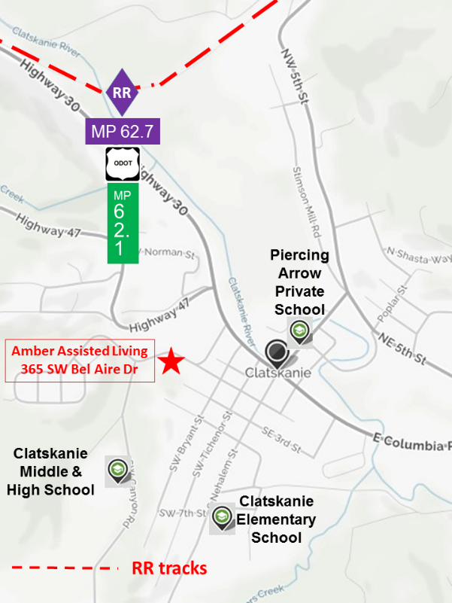

57

COLUMBIA CITY SCHOOL
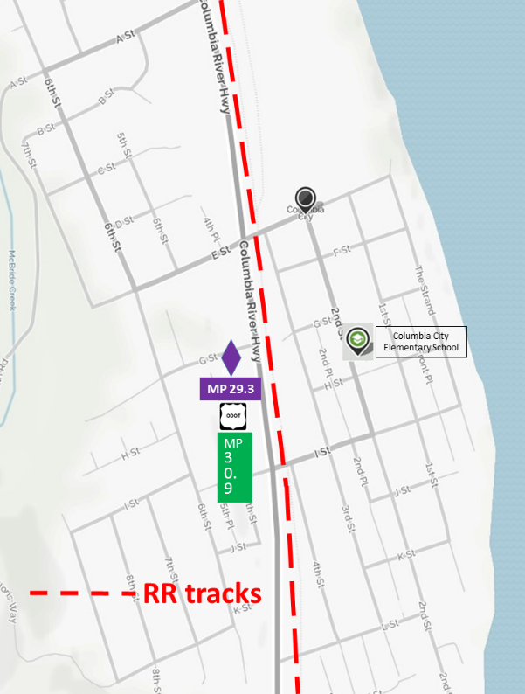
58

RAINIER SCHOOLS
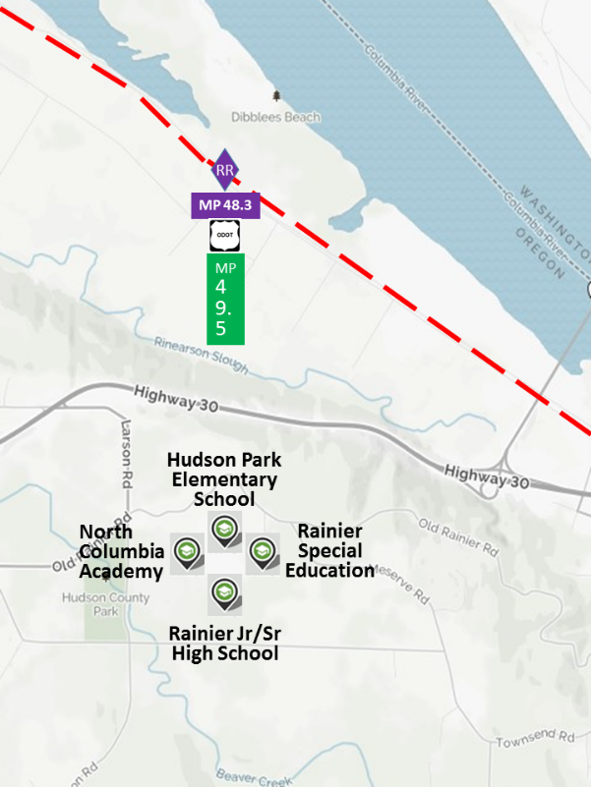
RR tracks

59

SAINT HELENS SCHOOLS NORTH
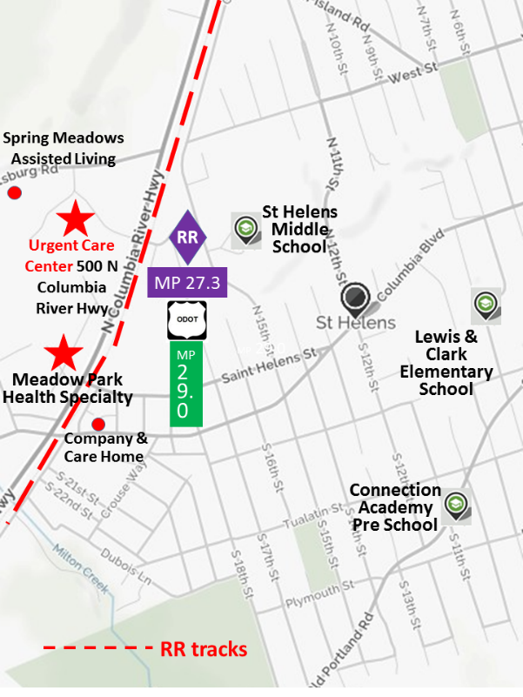

60

SAINT HELENS SCHOOLS SOUTH
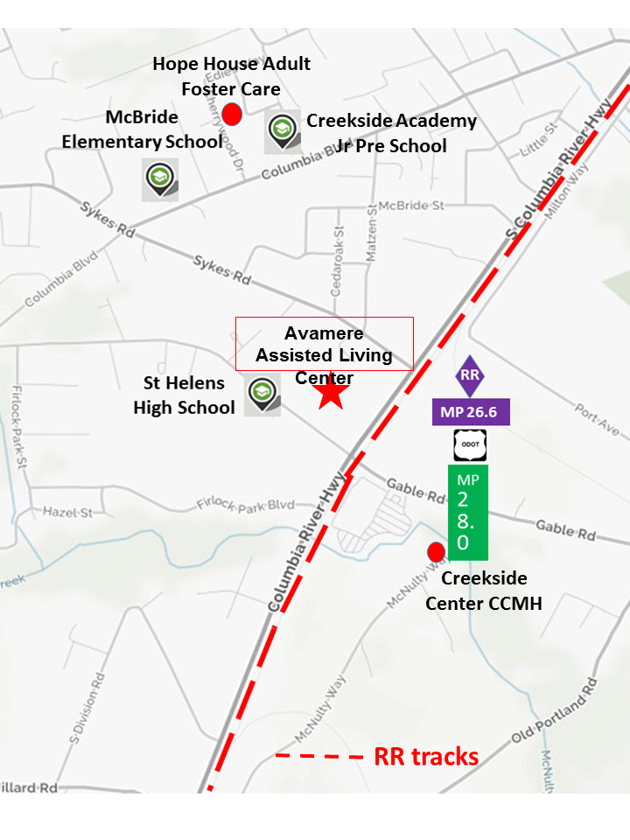
61

SCAPPOOSE SCHOOLS
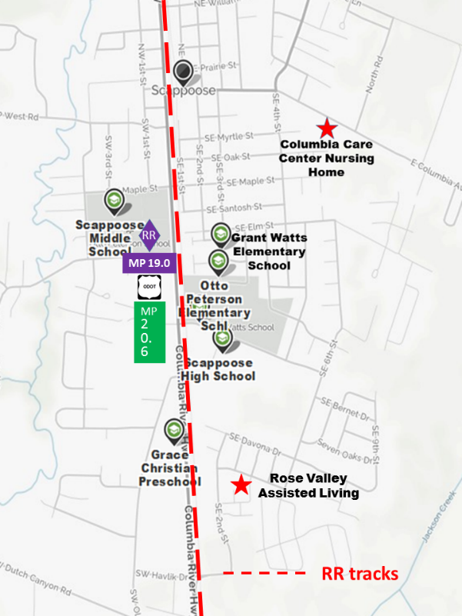

62

SCAPPOOSE SCHOOLS NORTH
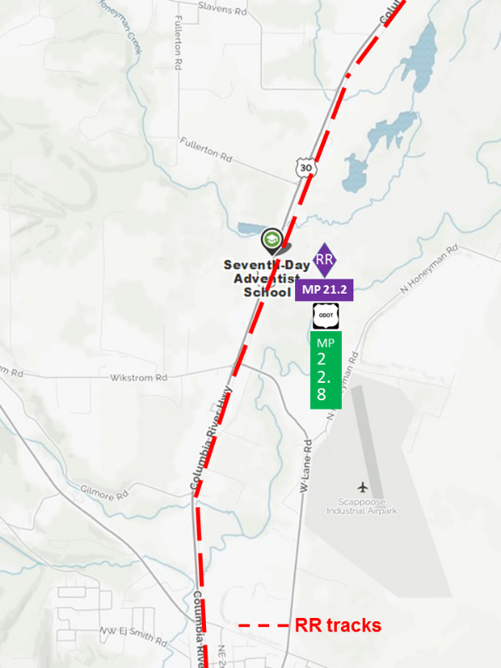
63

WARREN SCHOOLS
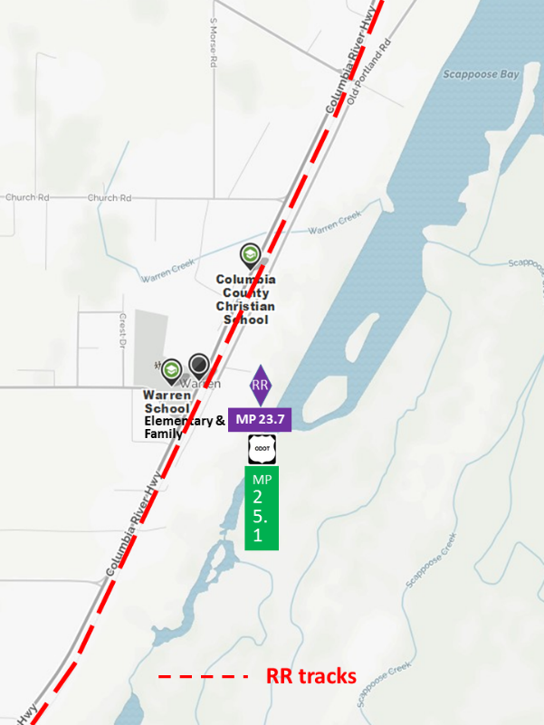
64

PLUME PROJECTIONS & HAZARDOUS MATERIALS
Crude oil, ethanol, anhydrous ammonia and sodium chlorate are 4 products selected for the most probable worst case scenario for a train derailment and chemical release in Columbia County. These products are routinely transported through the County on Portland & Western Railroad track. They all have toxic characteristics which can be calculated and plotted by a software program WISER, which then displays a downwind protective action distance (PLUME PROJECTION) , considering variables such as wind direction, size of spill and whether it occurs during the day or night.
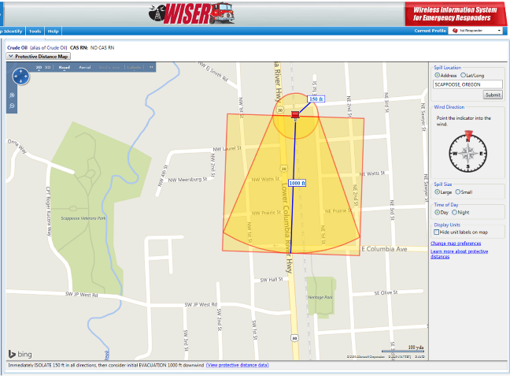
WISER (Wireless Information System for Emergency Responders) is a free software program of the National Institutes of Health, National Library of Medicine. It provides first responders at the scene of an incident with integrated information and decision support tools, even with no access to the internet. It has a built-in database of 4,700 known substances which can display characteristics and detailed properties. It contains information on human exposure, industrial hygiene, emergency handling procedures, environmental data, regulatory requirements, OSHA exposure guidelines, and US DOT Emergency Response Guidebook data.

With access to the internet WISER can produce downwind map plots of protective action distances, showing results for large or small spills, and day or night incidents. It can be installed on Microsoft Windows PCs, Apple’s IOS devices (iPhone, iPad, and iPod touch), Google Android devices, and BlackBerry devices (internet connectivity required). If a wireless connection is not available for the isolation/protective action distance overlays on maps, the handheld device still has full functionality with access to the critical data available on the device with the program.

Crude oil and ethanol both have the same initial isolation & protective action distances.

65

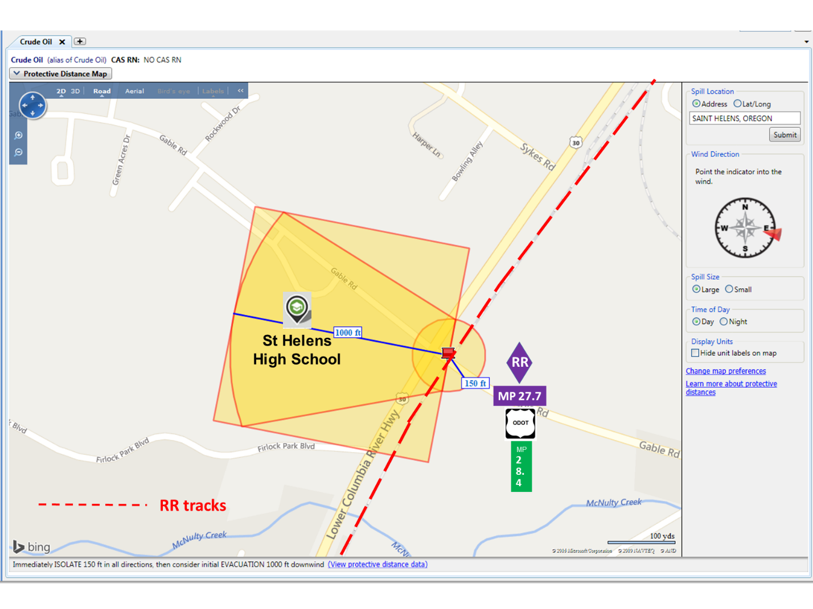
Downwind Protective Action Distance of 1,000 feet shown to the west of a large or small, day or night, crude oil release at Gable Road (PNWR milepost 27.7, US Highway 30 milepost 28.4), with the wind coming out of the east.
On all of the plume projections depicted in Appendix B, the railroad tracks are represented by the red dashed line. The exact railroad milepost location for the spill is located by the point of the red “push pin” at the center of the Initial Isolation Distance circle, in this case, 150 feet. The center of the purple “RR” diamond is located perpendicular from the spill, and the railroad milepost number is in the purple rectangle under the diamond, and above the white and black ODOT shield, which designates the Oregon Department of Transportation highway milepost marker adjacent to the spill, shown in the green vertical rectangle.
Individuals within the downwind Protective Action Zone square will either shelter in-place, evacuate, or a combination of both, depending on exact circumstances and emergency response resources. Individuals in the Protection Action Zone may become incapacitated and unable to take protective action and/or incur serious or irreversible health effects. Persons in the Initial Isolation Zone may7 be exposed to dangerous (upwind) and life threatening (downwind) concentrations of material.
66

PROTECTIVE ACTION DETERMINATION – EVACUATE OR SHELTER IN-PLACE

A Hazard Analysis is the use of a model or methodology to estimate the movement of hazardous materials at a concentration level of concern from an accident site, either at a fixed site or on a transportation route to the surrounding area in order to determine which portions of a community may be at risk by a release of such materials. The fastest field method is to utilize the US DOT Emergency Response Guidebook Table of Isolation and Protective Action Distances to determine the appropriate protective action.

The choice of protective actions for a given situation depends on a number of factors. For some
cases, evacuation may be the best option; in others, sheltering in-place may be the best course.
Sometimes, these two actions may be used in combination. In any emergency, officials need to
quickly give the public instructions. The public will need continuing information and instructions
while being evacuated or sheltered in-place.

Proper evaluation of the factors listed below will determine the effectiveness of evacuation or
in-place protection (shelter in-place). The importance of these factors can vary with emergency
conditions. In specific emergencies, other factors may need to be identified and considered
as well. This list indicates what kind of information may be needed to make the initial decision:

The Hazardous Material
• Degree of health hazard
• Chemical and physical properties
• Amount involved
• Containment/control of release
• Rate of vapor movement
The Population Threatened
• Location
• Number of people
• Time available to evacuate or shelter in-place
• Ability to control evacuation or shelter in-place
• Building types and availability
• Special institutions or populations, e.g., nursing homes, hospitals, prisons
Weather Conditions
• Effect on vapor and cloud movement
• Potential for change
• Effect on evacuation or shelter in-place

67

CLATSKANIE ANHYDROUS AMMONIA LARGE NIGHT RELEASE
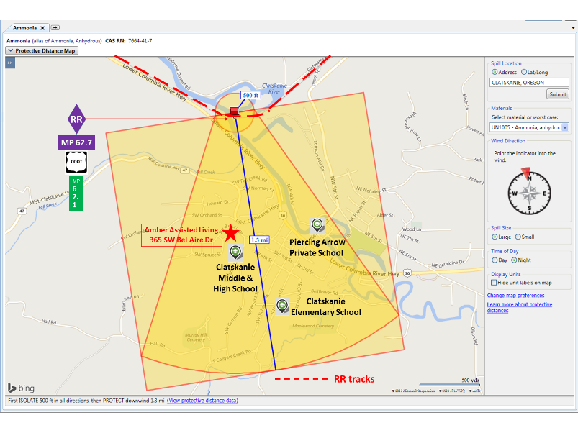
68

CLATSKANIE ANHYDROUS AMMONIA DAY LARGE RELEASE
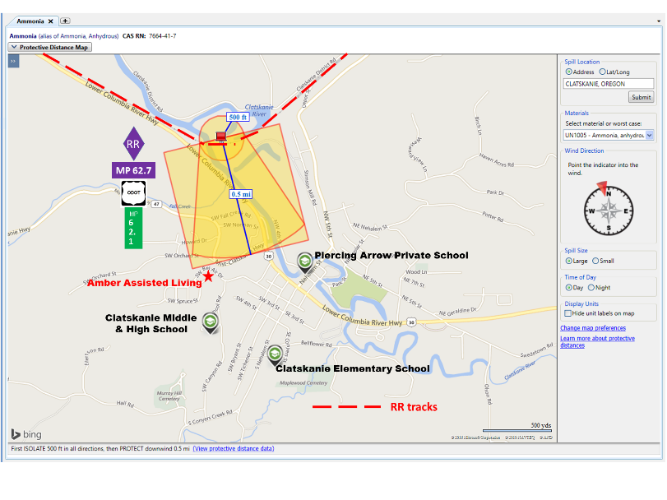
69

CLATSKANIE ANHYDROUS AMMONIA DAY SMALL RELEASE
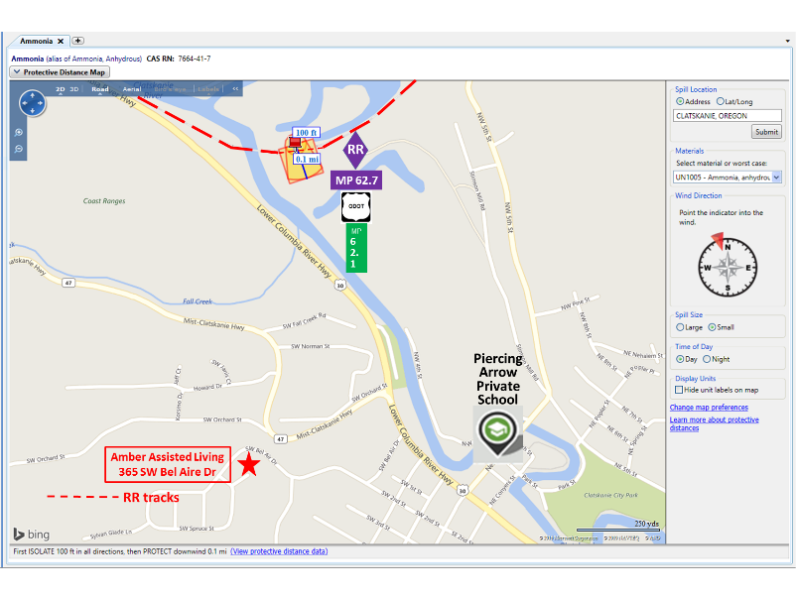
70

CLATSKANIE CRUDE OIL/ETHANOL DAY/NIGHT LARGE/SMALL SPILL
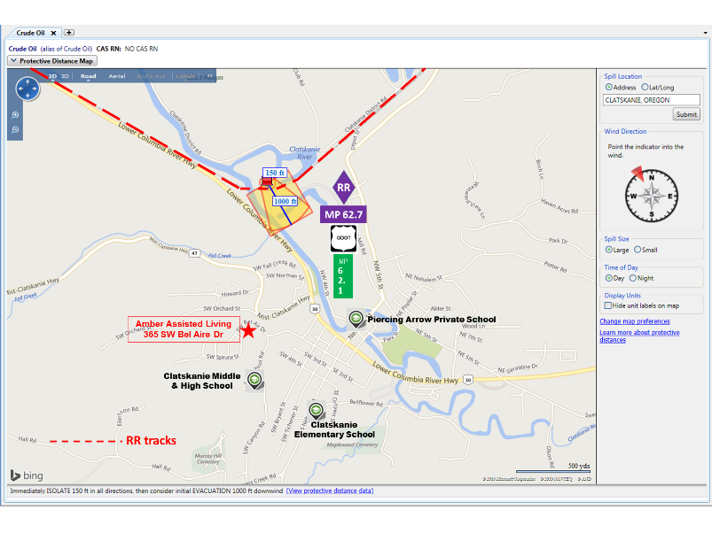
71

CLATSKANIE SODIUM CHLORATE DAY/NIGHT LARGE/SMALL RELEASE
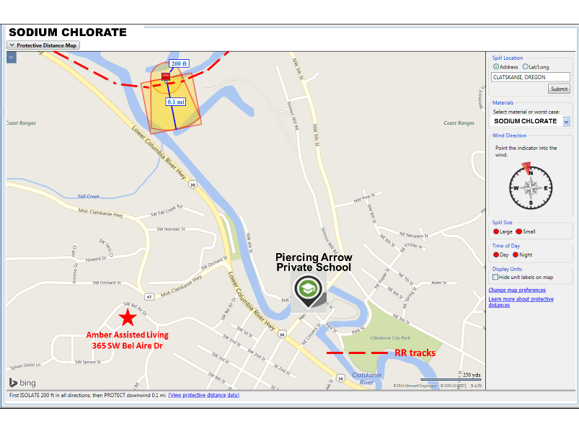
72

COLUMBIA CITY ANHYDROUS AMMONIA DAY SMALL RELEASE 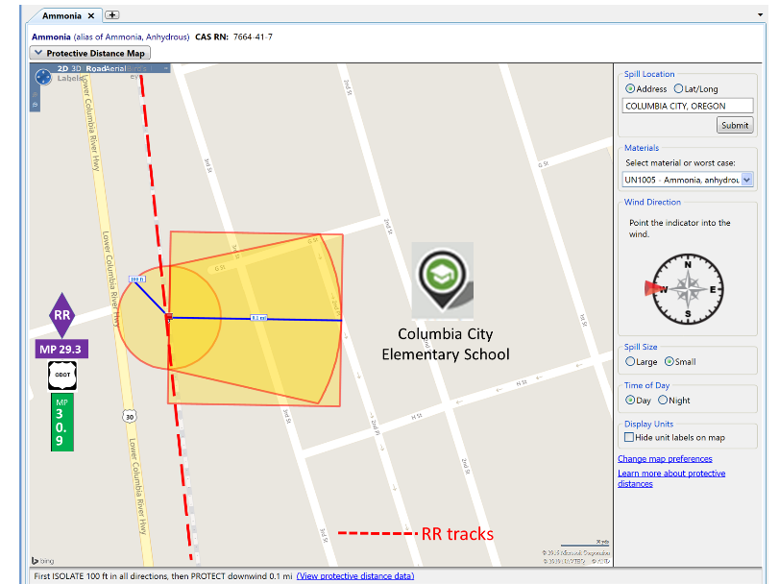
73

COLUMBIA CITY ANHYDROUS AMMONIA DAY LARGE RELEASE
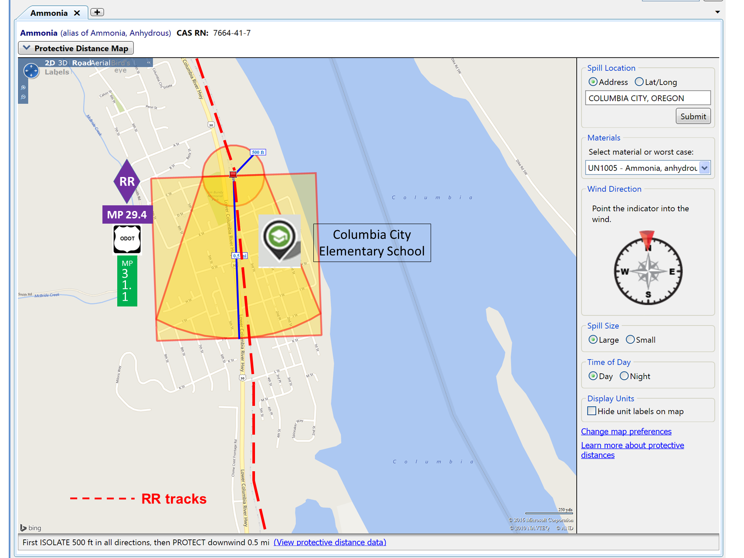
74

COLUMBIA CITY ETHYL ALCOHOL (ETHANOL) DAY/NIGHT LARGE/SMALL RELEASE
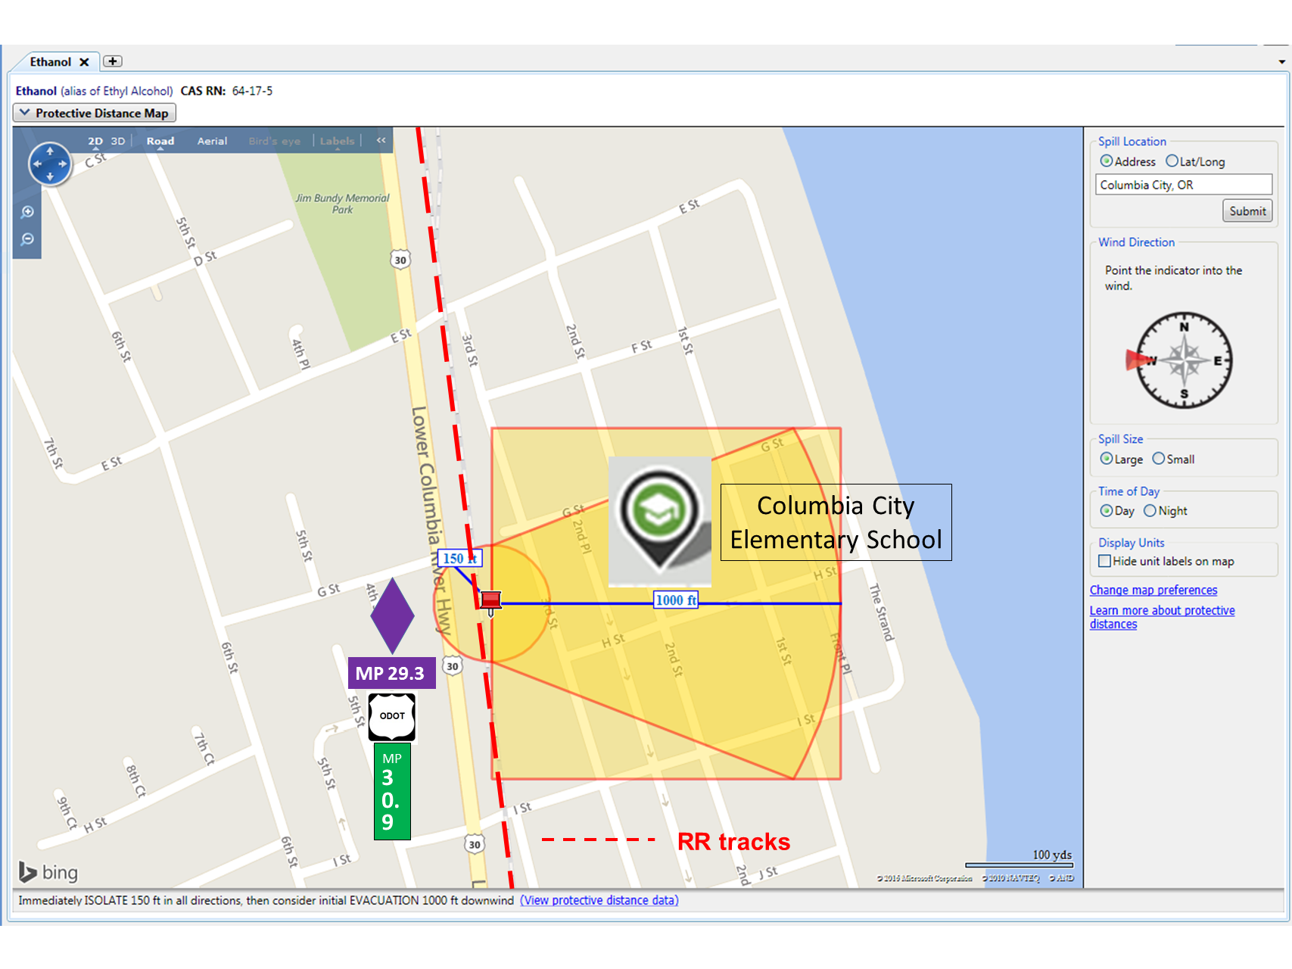
75

PRESCOTT CRUDE OIL/ETHANOL DAY/NIGHT LARGE/SMALL RELEASE
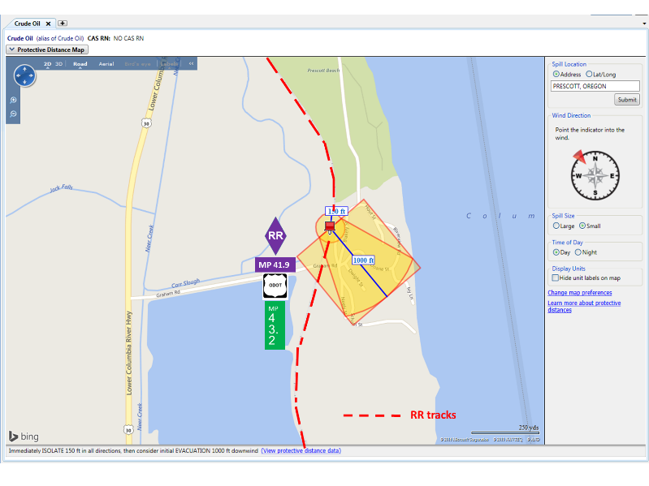
76

PRESCOTT SODIUM CHLORATE DAY/NIGHT LARGE/SMALL RELEASE
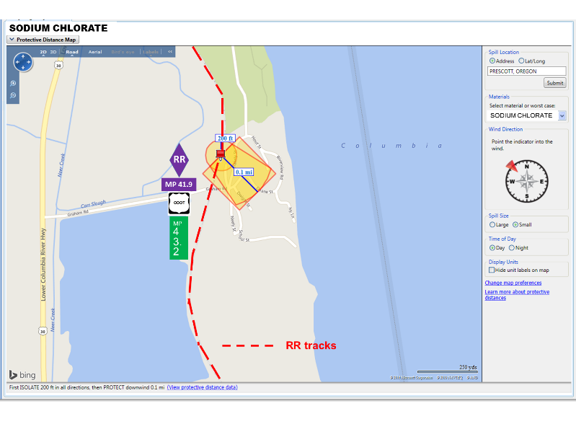
77

RAINIER ANHYDROUS AMMONIA LARGE NIGHT RELEASE
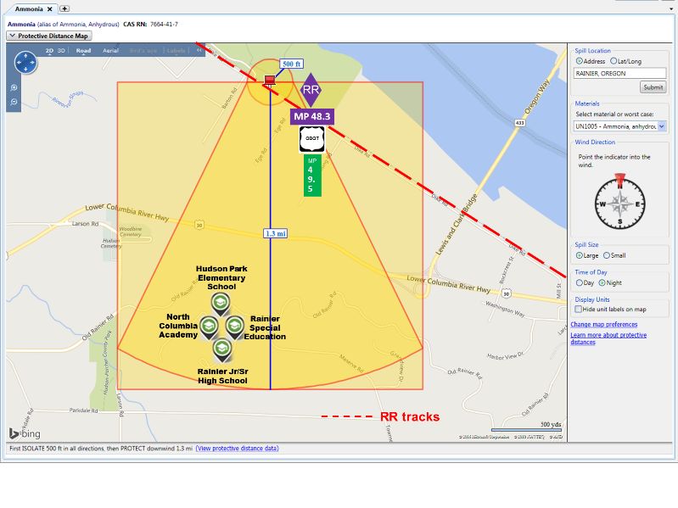
78

RAINIER ANHYDROUS AMMONIA DAY LARGE RELEASE
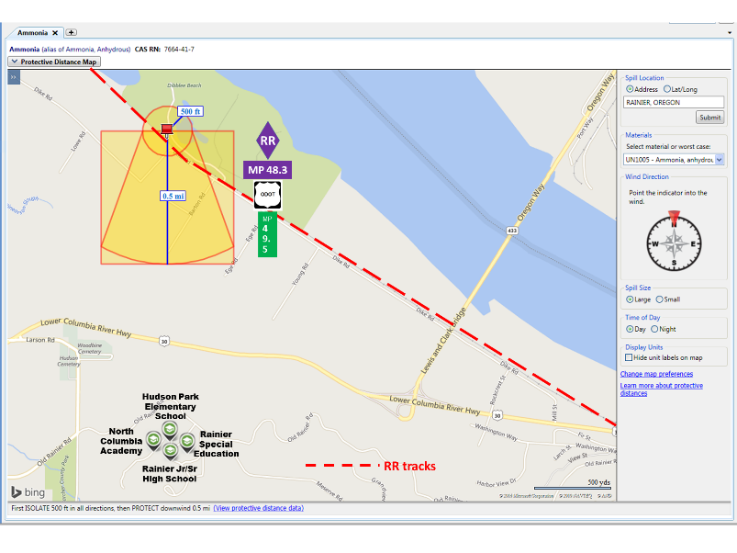
79

RAINIER ANHYDROUS AMMONIA NIGHT LARGE RELEASE TOWN
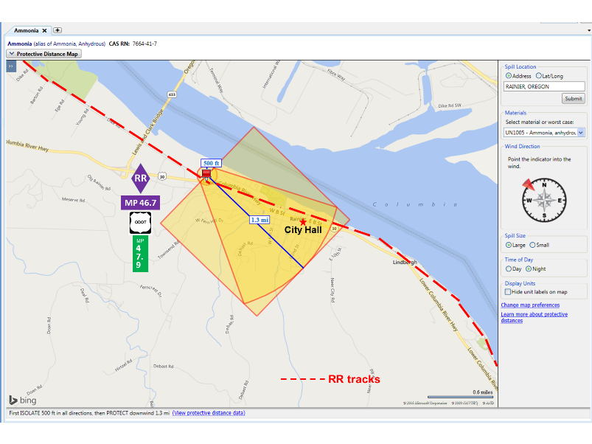
80

RAINIER ANHYDROUS AMMONIA DAY SMALL RELEASE TOWN
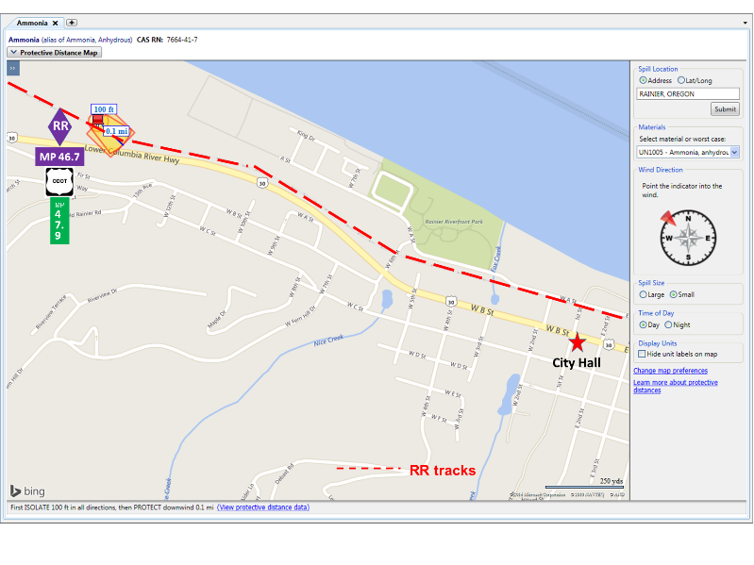
81

RAINIER CRUDE OIL/ETHANOL DAY/NIGHT LARGE/SMALL RELEASE TOWN
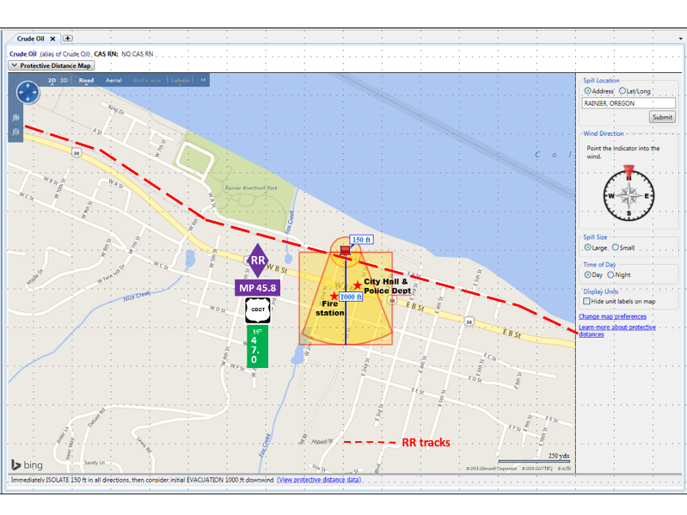
82

ST HELENS ANYHRDOUS AMMONIA LARGE NIGHT RELEASE
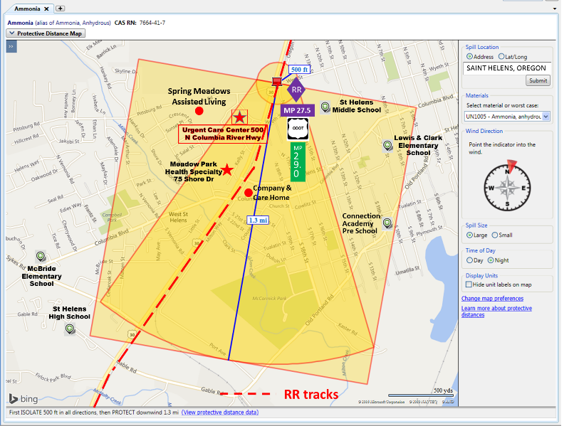
83

SAINT HELENS ANHYDROUS AMMONIA NIGHT LARGE RELEASE NORTH
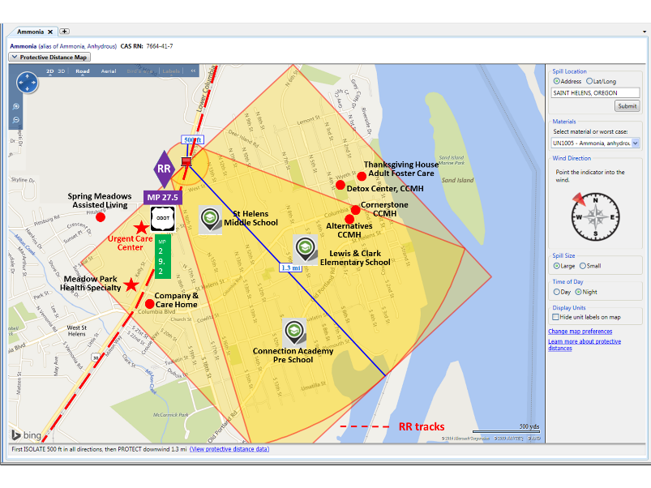
84

ST HELENS ANHYDROUS AMMONIA DAY LARGE RELEASE NORTH
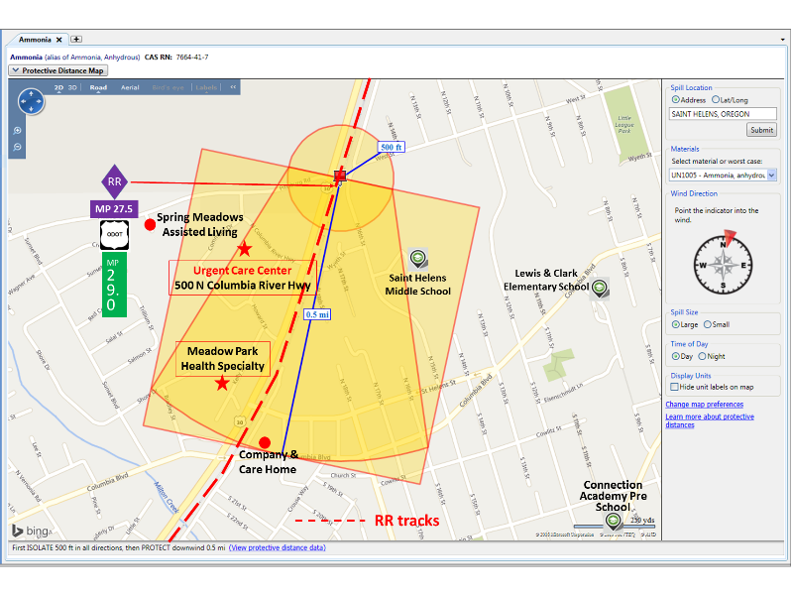
85

ST HELENS CRUDE OIL/ETHANOL DAY/NIGHT LARGE/SMALL RELEASE NORTH
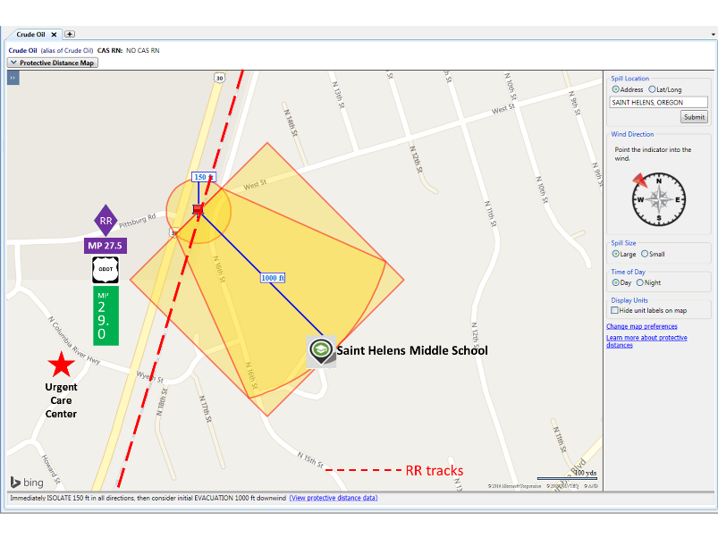
86

SAINT HELENS SODIUM CHLORATE DAY LARGE/SMALL RELEASE NORTH
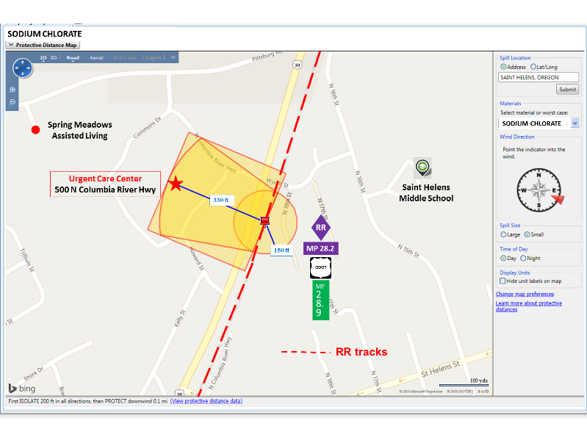
87
SAINT HELENS ANHYDROUS AMMONIA DAY LARGE RELEASE SOUTH
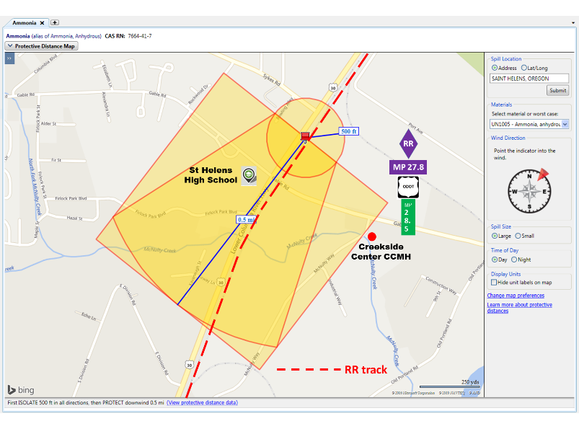
88

SAINT HELENS ANHYDROUS AMMONIA NIGHT LARGE RELEASE SOUTH
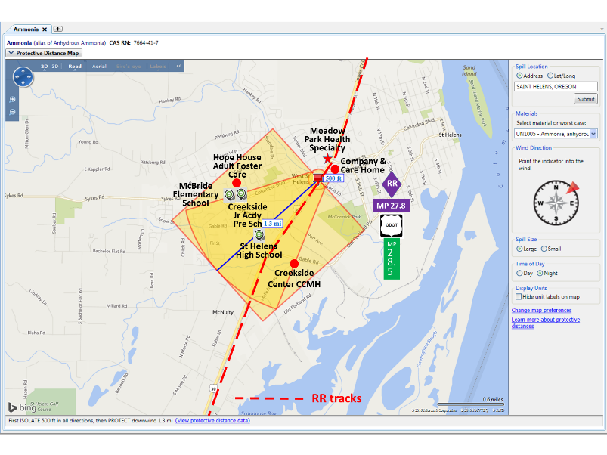
89

ST HELENS CRUDE OIL/ETHANOL DAY/NIGHT LARGE/SMALL RELEASE SOUTH
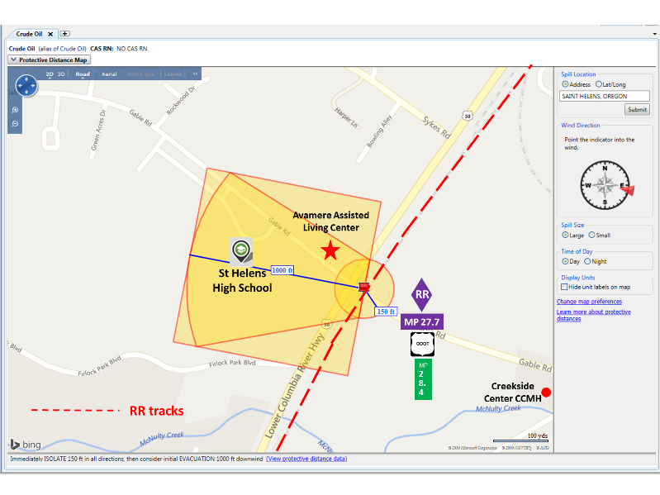
90

SCAPPOOSE ANHYDROUS AMMONIA NIGHT LARGE RELEASE
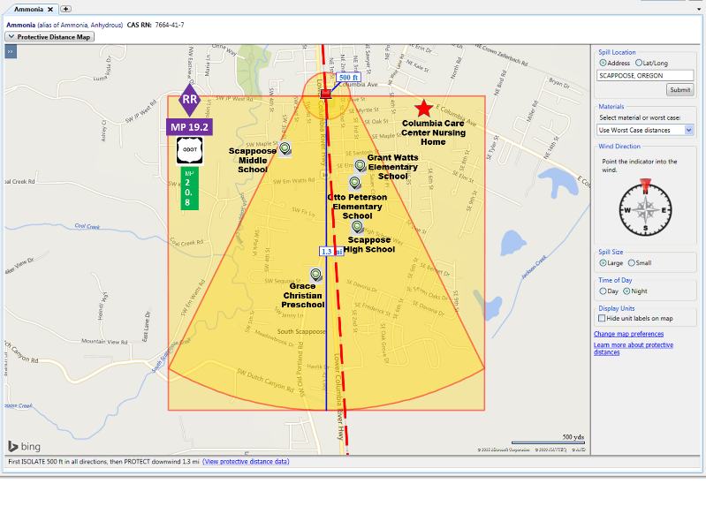
91

SCAPPOOSE ANHYDROUS AMMONIA DAY LARGE RELEASE
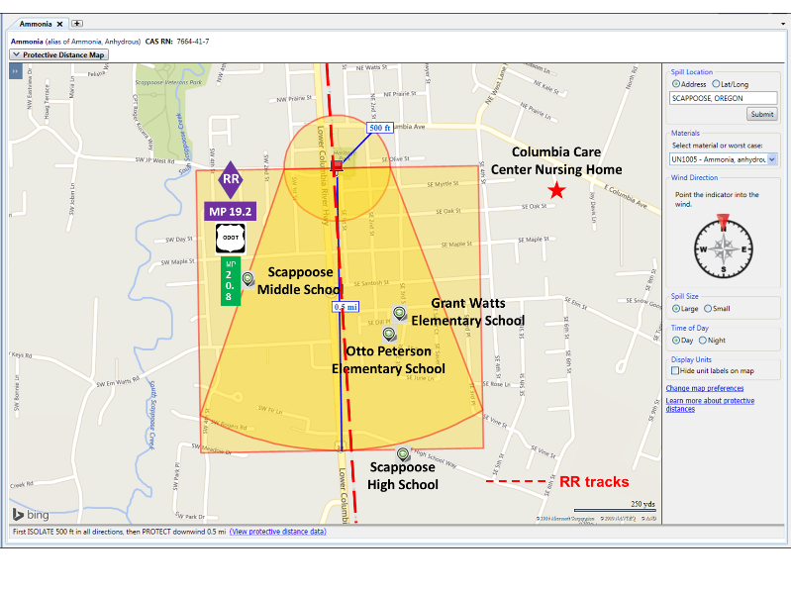
92

SCAPPOOSE ANHYDROUS AMMONIA DAY SMALL RELEASE
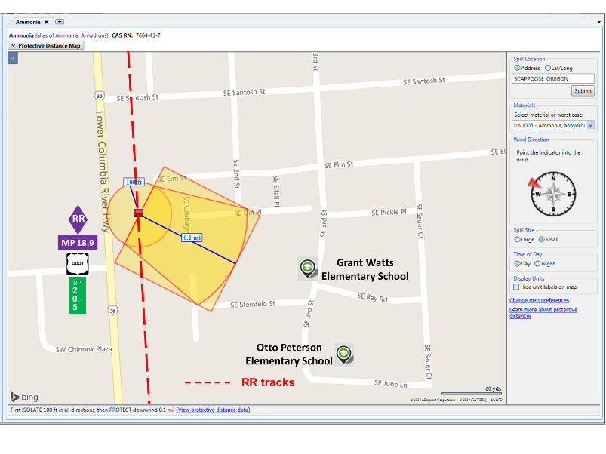
93

SCAPPOOSE CRUDE OIL/ETHANOL DAY/NIGHT LARGE/SMALL RELEASE
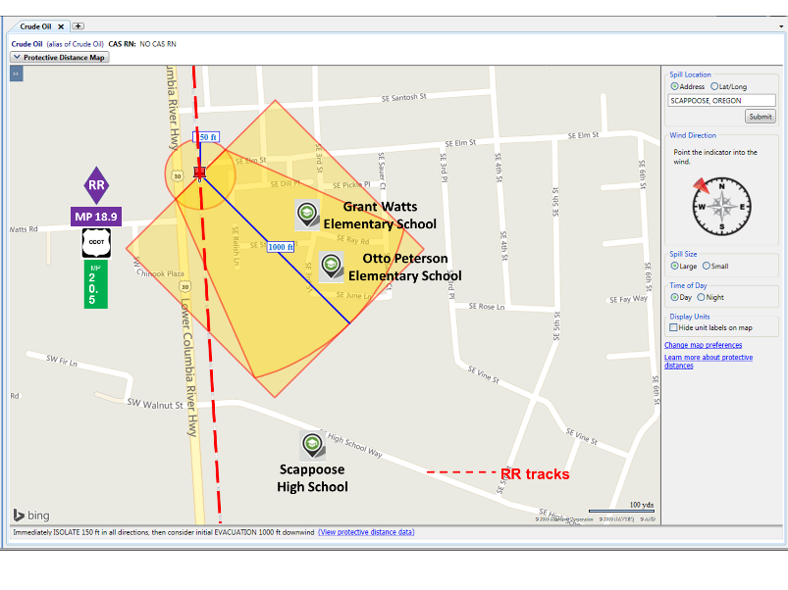
94

SCAPPOOSE SODIUM CHLORATE DAY/NIGHT LARGE/SMALL RELEASE
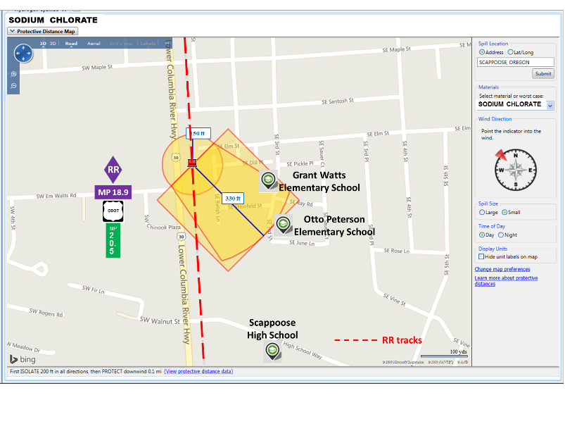

95

SCAPPOOSE ANHYDROUS AMMONIA DAY LARGE RELEASE NORTH
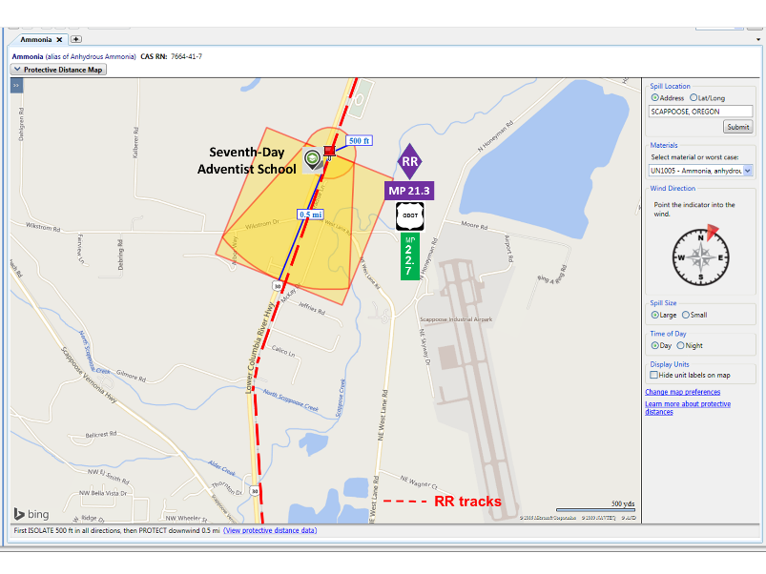
96

SCAPPOOSE CRUDE OIL/ETHANOL DAY/NIGHT LARGE/SMALL RELEASE NORTH
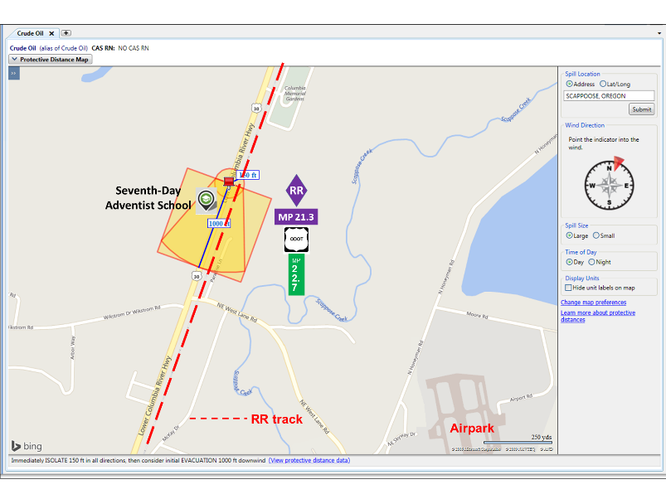
97

SCAPPOOSE SODIUM CHLORATE DAY/NIGHT LARGE/SMALL RELEASE NORTH
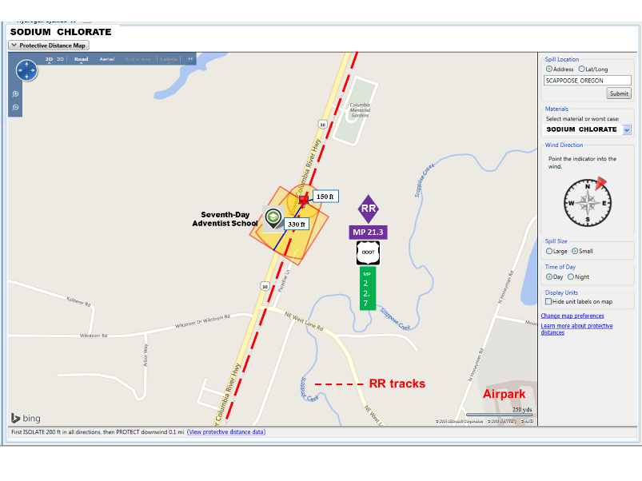
98

WARREN ANHYDROUS AMMONIA DAY LARGE RELEASE
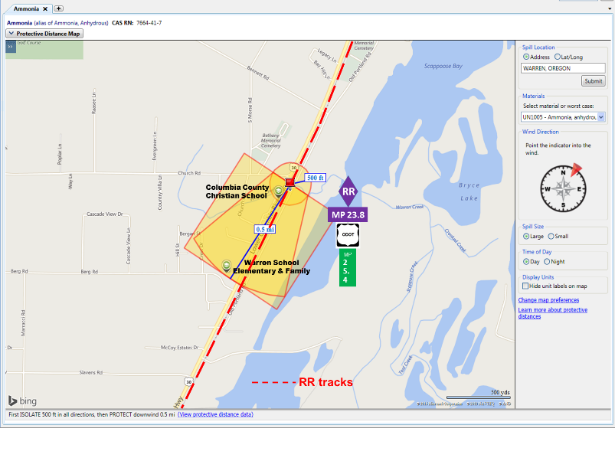
99

WARREN CRUDE OIL/ETHANOL DAY/NIGHT LARGE/SMALL RELEASE
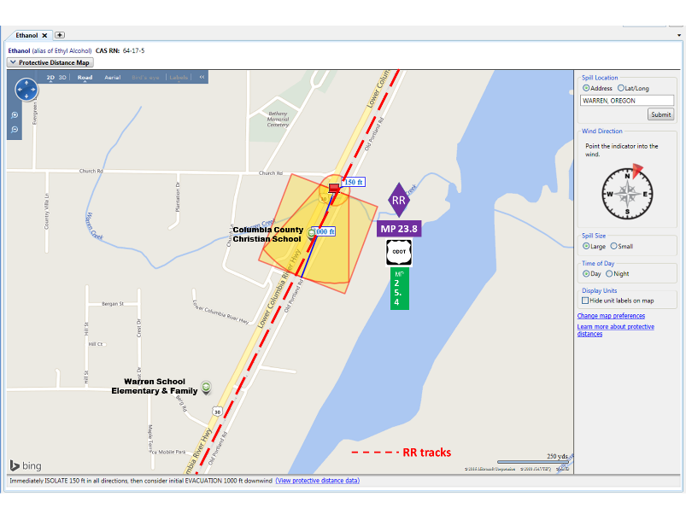
100

WARREN SODIUM CHLORATE DAY/NIGHT LARGE/SMALL RELEASE
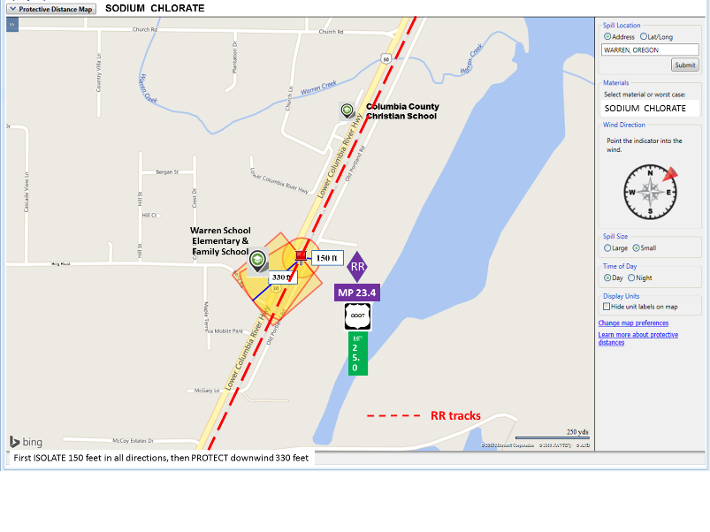
101

WARREN ANHYDROUS AMMONIA NIGHT LARGE RELEASE
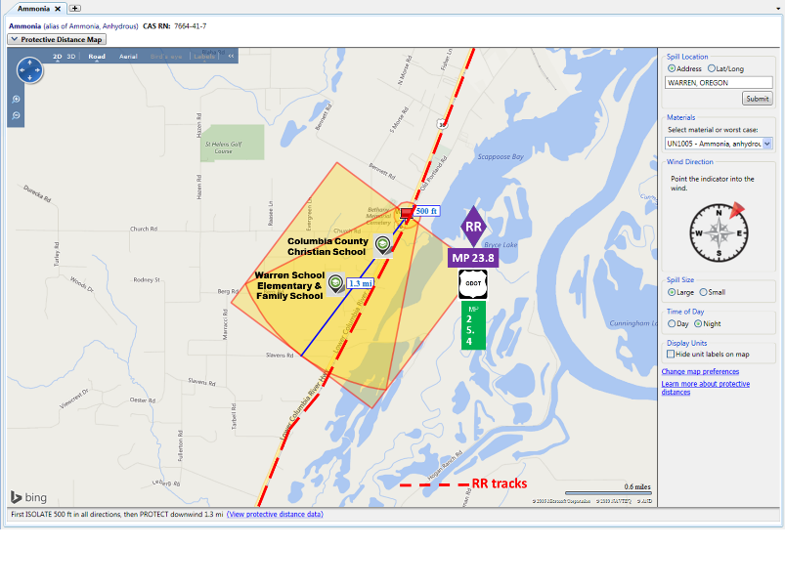
102

Appendix C
Railroad Milepost Maps
Map 1 Wauna Mill Milepost 70-75
Map 2 West County Border Milepost 68-72
Map 3 Wallace Island Milepost 64-68
Map 4 Clatskanie Milepost 59-64
Map 5 Quincy Mayger Road/Beaver Falls Road Milepost 56-61
Map 6 Crims Island Milepost 54-60
Map 7 Lord Island Milepost 51-56
Map 8 Rainier/Lewis & Clark Bridge Milepost 45-50
Map 9 Prescott Milepost 39-45
Map 10 Sandy Island Milepost 35-41
Map 11 Columbia City Milepost 29-34
Map 12 Saint Helen Milepost 24-30
Map 13 Warren/Airpark Milepost 20-25
Map 14 Scappoose Milepost 17-22

103

104

105
106

107
108

109
110
111
112
113
114
115
116
117

Appendix D
Foam Application Guide

118

SINGLE CAR RELEASE, CONTAINED SPILL, WITH FIRE
If fire suppression operations are initiated, responders need sufficient foam concentrate supplies, adequate water supply, foam appliances, equipment and properly trained personnel to effectively implement and sustain fire suppression and post-fire suppression operations.

CRITICAL QUESTION: Do you have the ability to extinguish a single tank car containing 30,000 gallons of crude oil? Based on the guidance in NFPA 11, Standard for Low-Medium- and High-Expansion Foam (2011 edition) -- for a spill scenario greater than one (1) inch in depth, agencies will need a minimum of approximately 216 gallons of 3% foam concentrate available for the first 15 minutes of the operation based on a spill area of approximately 3,000 sq. ft. In addition, reapplication of foam will normally be necessary to maintain an adequate foam blanket.

Note: If 1% foam concentrate is available and used, approximately 72 gallons of foam concentrate would be required for the first 15 minutes of the operations.

If you do not have the capability to safely and effectively implement and sustain this tactic, defensive or non-intervention strategies should be pursued.

MULTIPLE CARS, RELEASE, SPILL WITH FIRE
The resource requirements to safely and effectively respond to an incident of this magnitude will exceed the capabilities of most emergency response organizations. In situations of this nature, the amount of foam concentrate that is required to be available on-site to begin suppression operations per NFPA 11 (2011 edition), -- for a spill scenario greater than one (1) inch in depth, is approximately 26,000 gallons of 3% foam concentrate for the first 15 minutes of the operation based on a spill area of approximately 360,000 sq. ft. In addition, reapplication of foam will normally be necessary to maintain an adequate foam blanket.

Note: If 1% foam concentrate is available and used, approximately 8,666 gallons of foam concentrate would be required for the first 15 minutes of the operations.

NOTE: THE TACTIC FOR THIS TYPE OF INCIDENT THAT PROVIDES THE HIGHEST LEVEL OF SAFETY TO RESPONDERS IS DEFENSIVE TO PROTECT EXPOSURES OR NON-INTERVENTION.

See “Tactical Worksheet” and the above “Foam Application Guide” in Appendix D, Response Packet

119

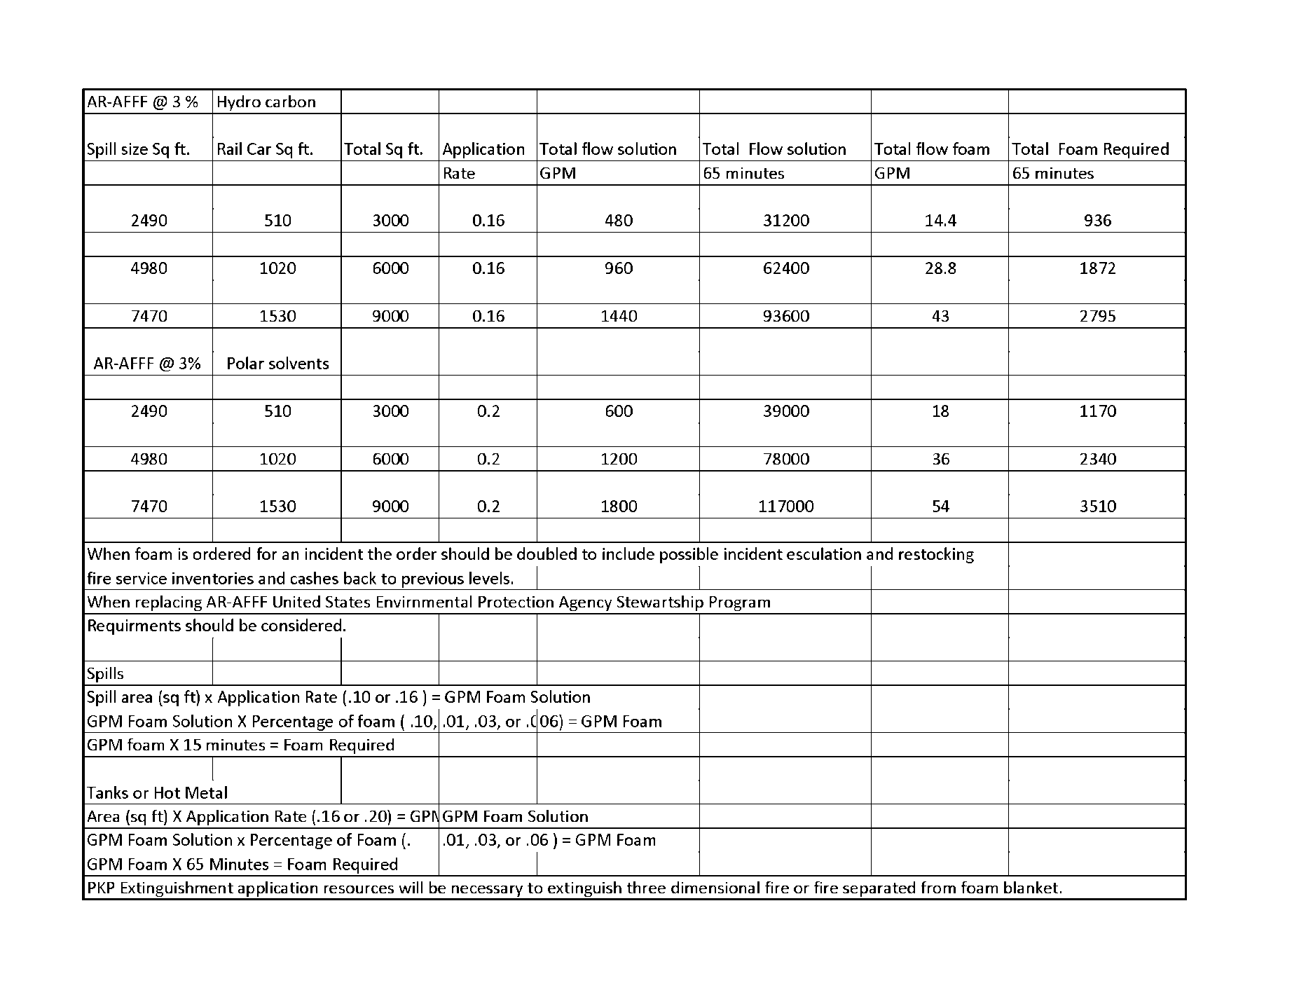

120

Appendix E
Hazard Analysis Checklists (Checklist #2): Anhydrous Ammonia, Crude Oil, Ethyl Alcohol (Ethanol), Sodium Chlorate

Safety Data Sheets (SDSs): – Anhydrous Ammonia, Crude Oil, Ethyl Alcohol (Ethanol), Sodium Chlorate

NIOSH Pocket Guides data- Anhydrous Ammonia, Ethyl Alcohol (Ethanol)

121

Checklist #2 - Hazard Analysis
Product Name: Anhydrous Ammonia
Flash Point: N/A
Flammable/Explosive Range: 15% - 28% (LEL-UEL)
Vapor Pressure: (water=25 mm/Hg) 8.5 atm
Vapor Density: (Air=1 <1 Rise >1 Sink) 0.60
Corrosivity: (Acid or Caustic) Caustic
Solubility: (Soluble-Yes or No) Yes
Toxicity: (TLV, IDLH) TWA 50 ppm (35 mg/m³ ) IDLH 300 ppm
DOT 2016 ERG Guide No: 125 (Orange border pages)
PPE requirements:
- Wear positive pressure self-contained breathing apparatus (SCBA).
- Wear chemical protective clothing that is specifically recommended by the manufacturer. It may provide little or no thermal protection.
- Structural firefighters' protective clothing provides limited protection in fire situations ONLY; it is not effective in spill situations where direct contact with the substance is possible.

_____Contact Hazmat Team for assistance in interpretation of data.
_____If product is not identified or data is inconclusive, assume a worst case scenario and protect public/exposures.
_____Set Cold, Warm and Hot Zones if possible.

122

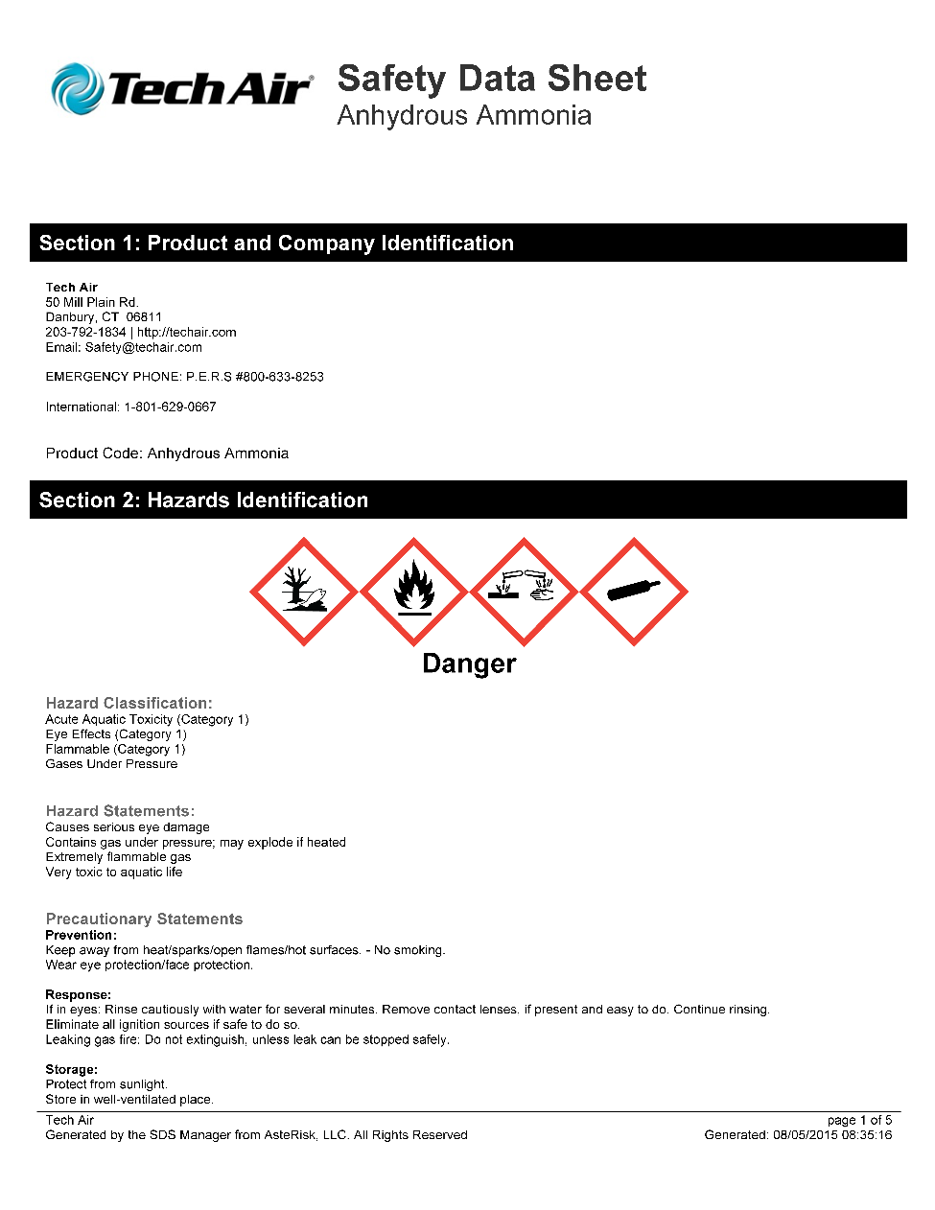

123

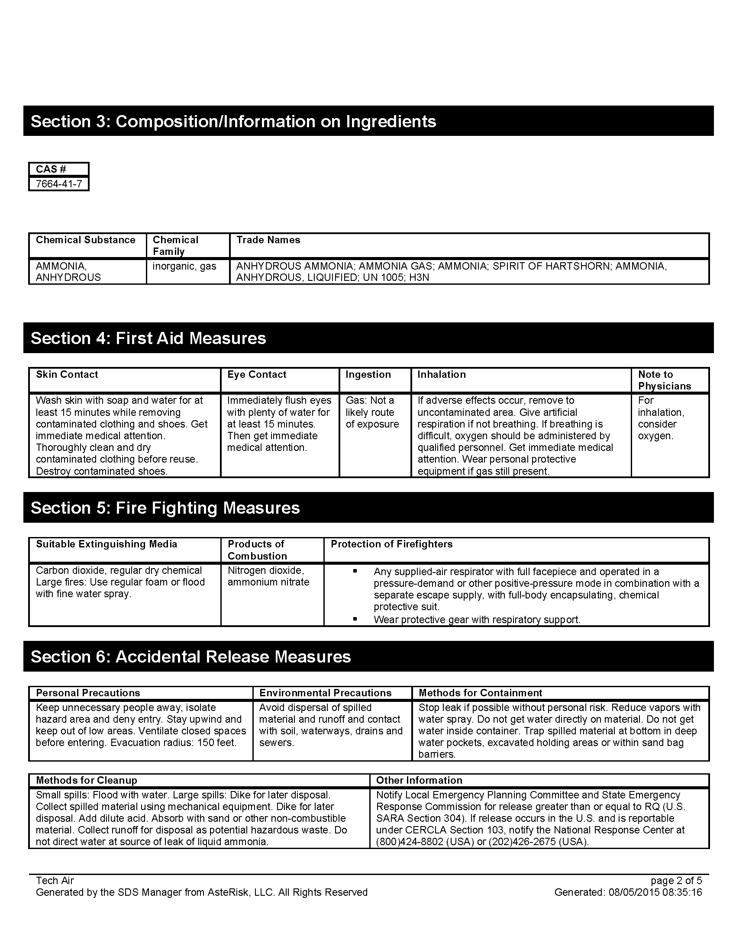

124

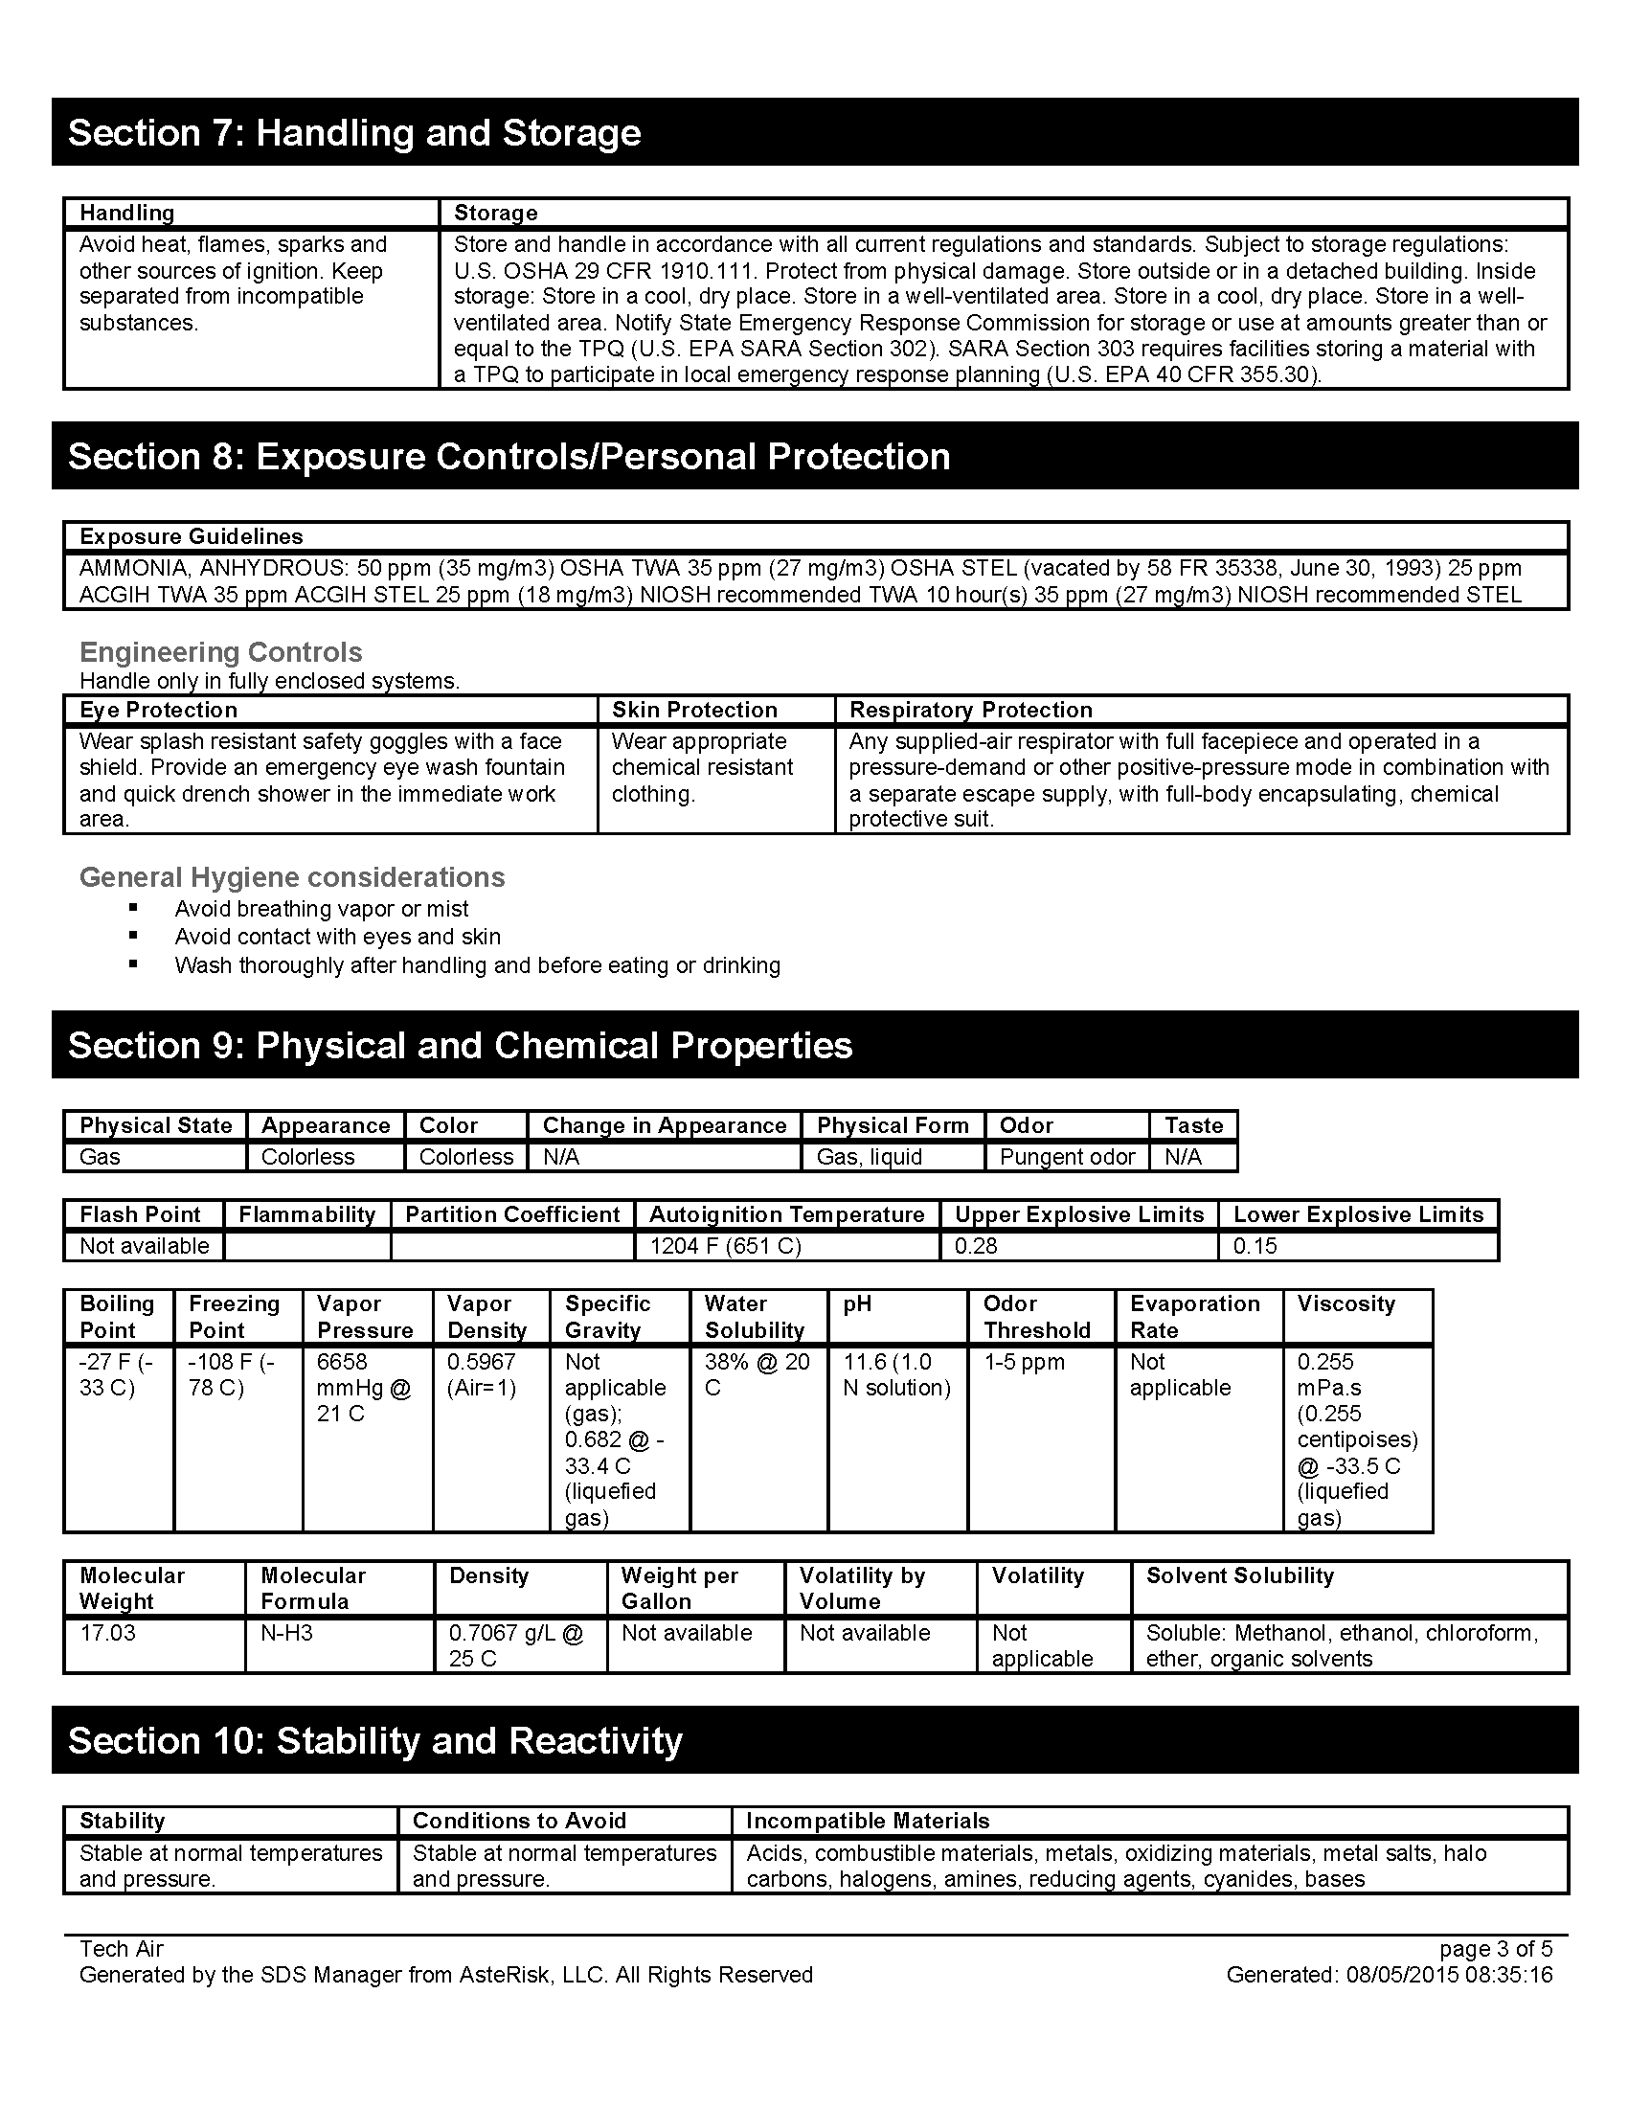

125

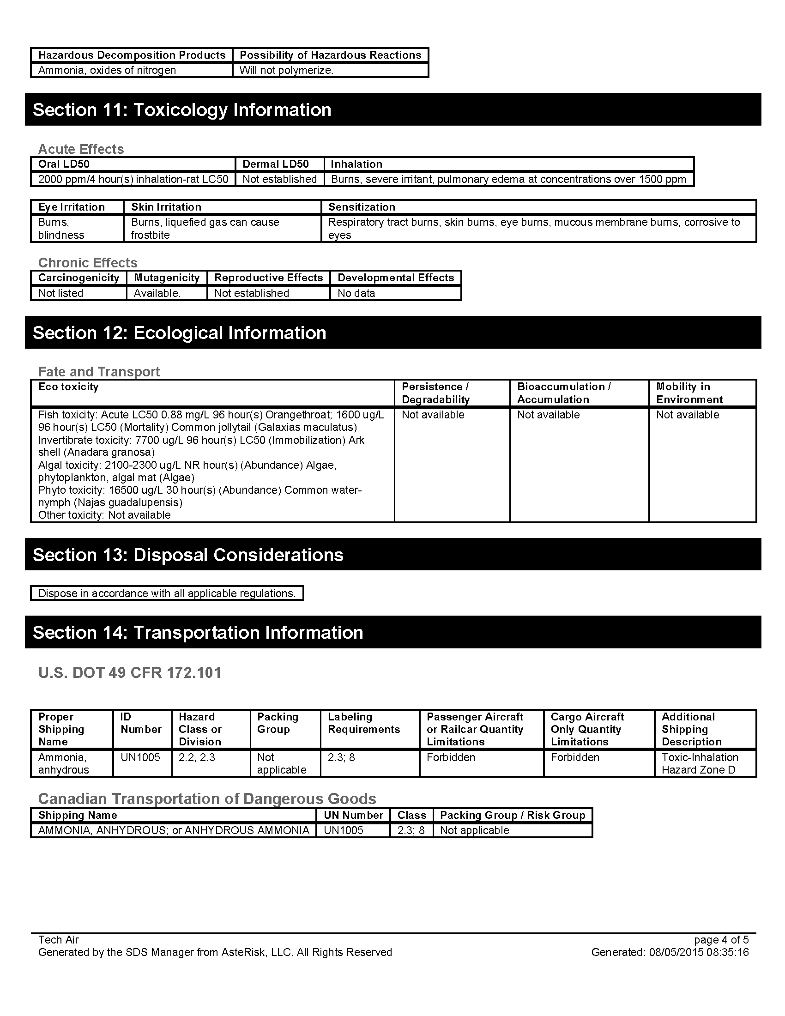
126

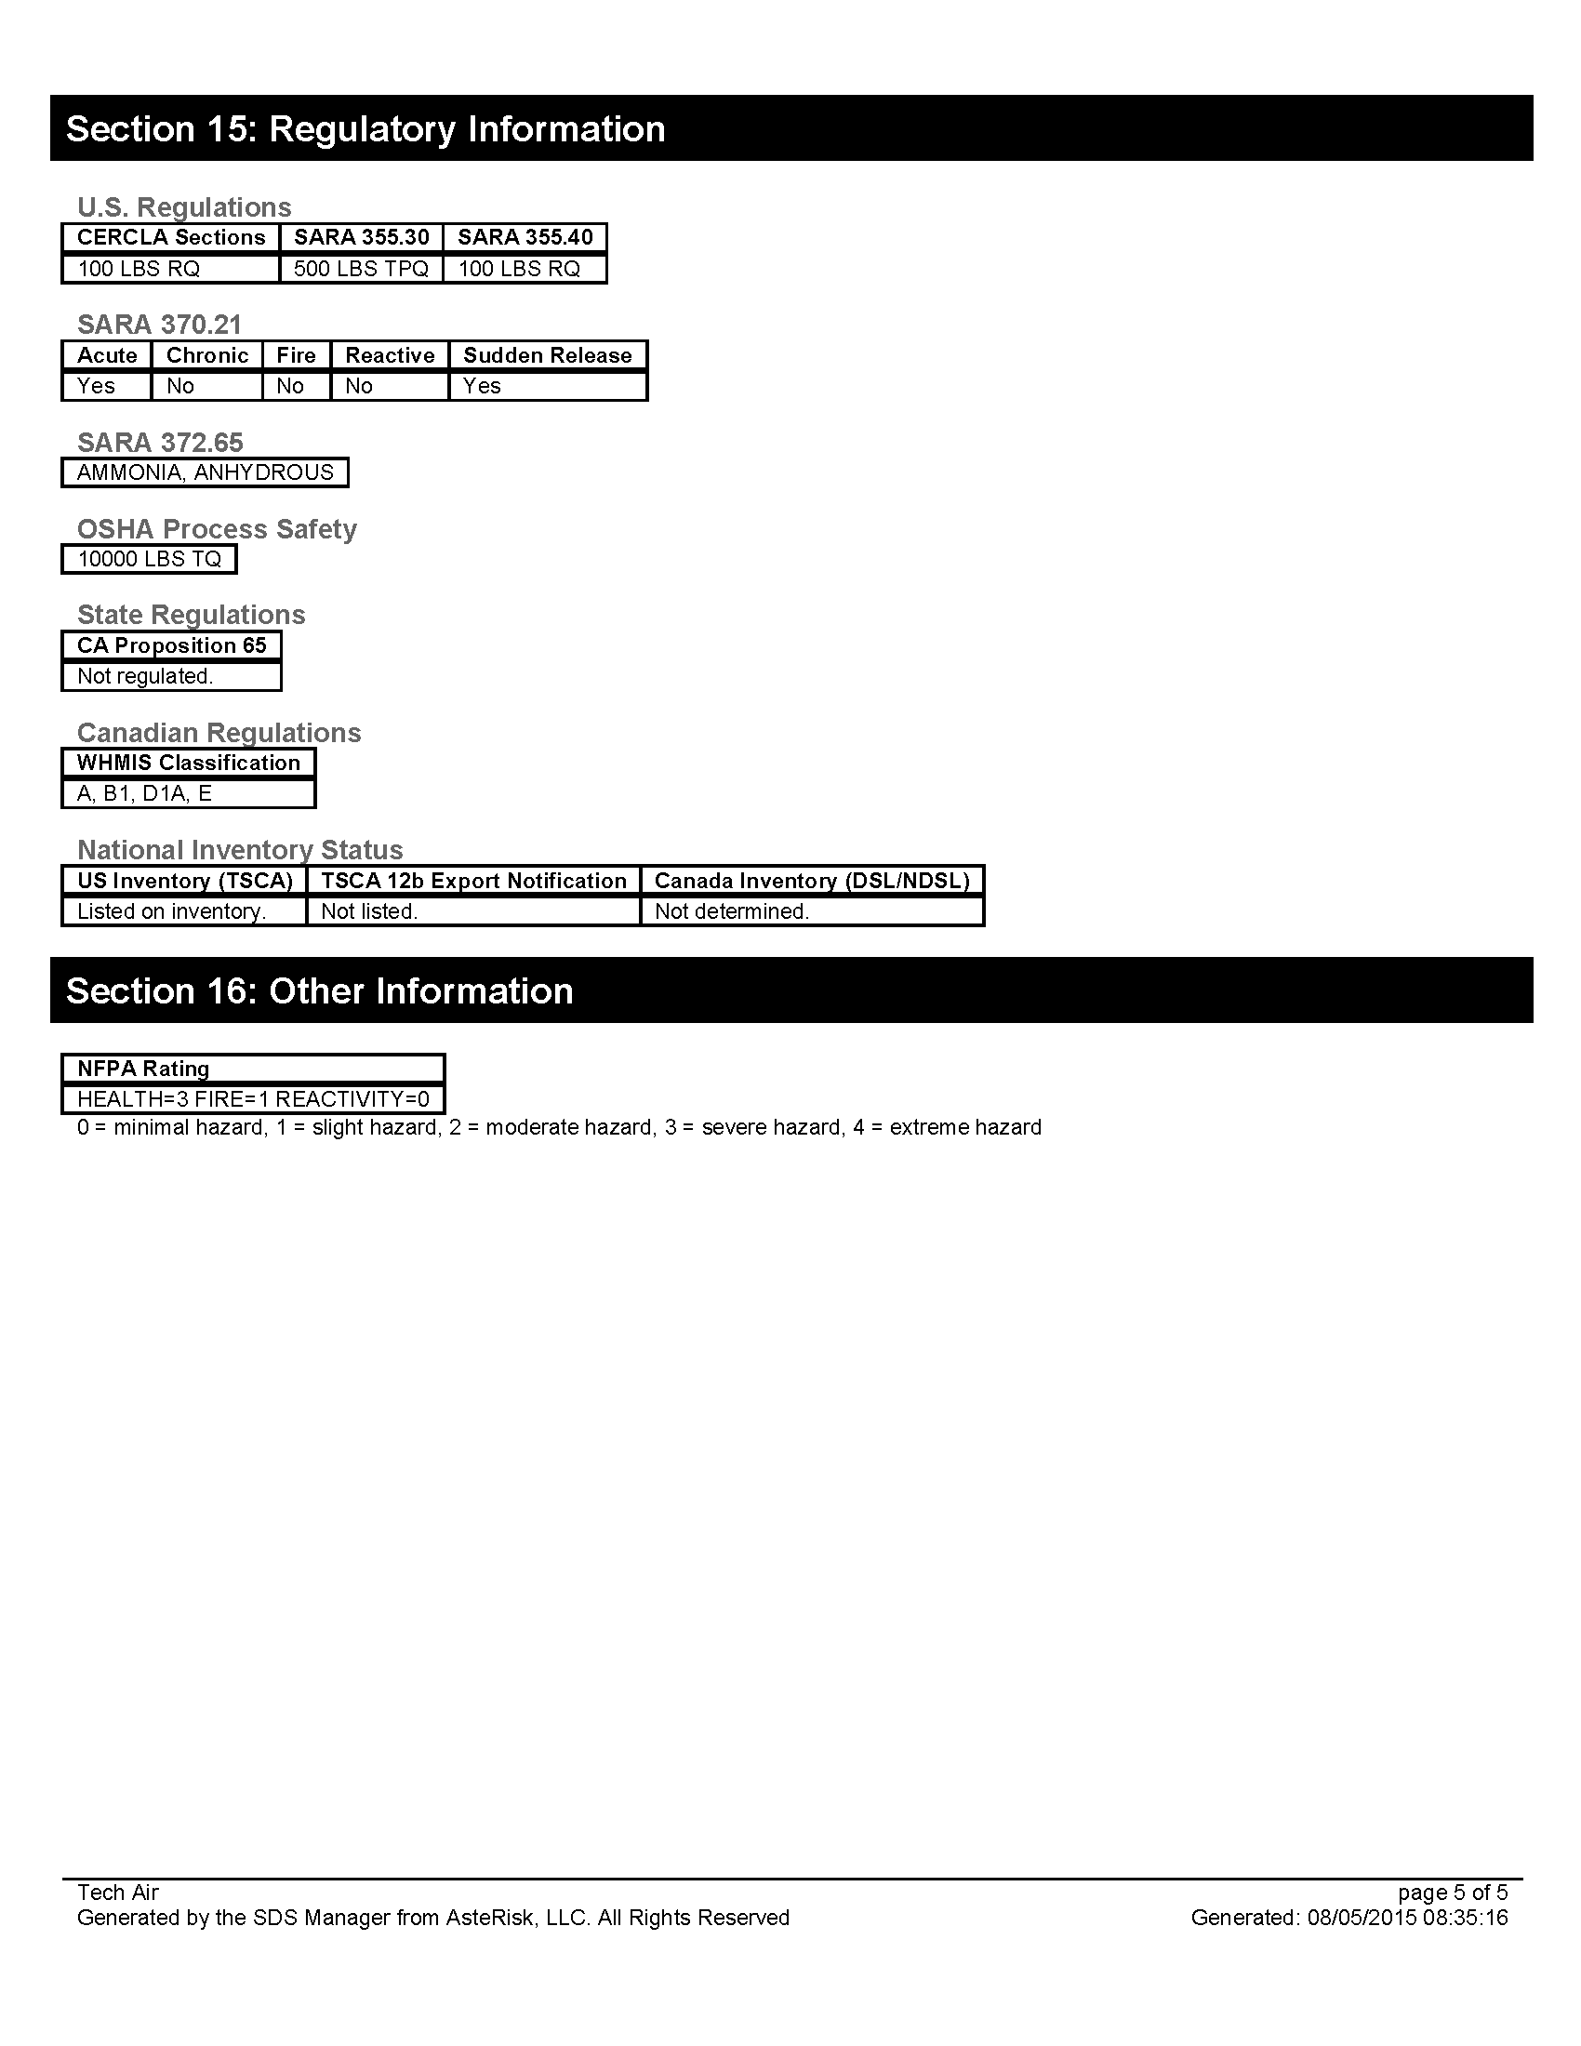
127

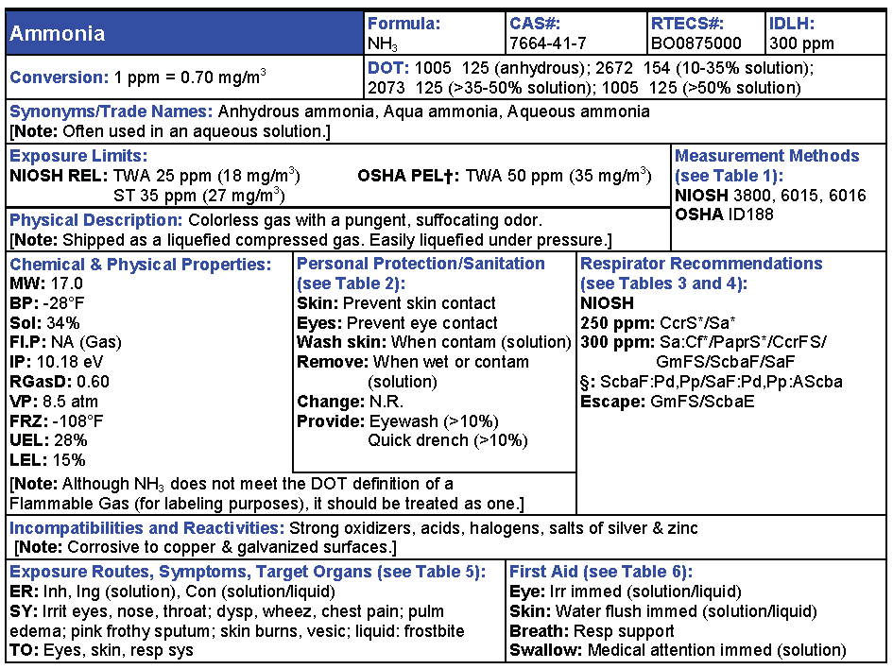

128

Checklist #2 - Hazard Analysis
Product Name: Crude Oil (DOT name: Petroleum oil)
Flash Point: < 60° - > 200° F
Flammable/Explosive Range: 0.8% - 8.0% (LEL-UEL)
Vapor Pressure: (water=25 mm/Hg) 280-360 mmHg @ 68°F
Vapor Density: (Air=1 <1 Rise >1 Sink) 2.5-5.0 estimated
Corrosivity: (Acid or Caustic)______________
Solubility: (Soluble-Yes or No)_____________
Toxicity: (TLV, IDLH)____________
DOT 2016 ERG Guide No: 128 (Orange border pages)
PPE requirements:
• Wear positive pressure self-contained breathing apparatus (SCBA).
• Structural firefighters’ protective clothing will only provide limited protection.

_____Contact Hazmat Team for assistance in interpretation of data.
_____If product is not identified or data is inconclusive, assume a worst case scenario and protect public/exposures.
_____Set Cold, Warm and Hot Zones if possible.

129

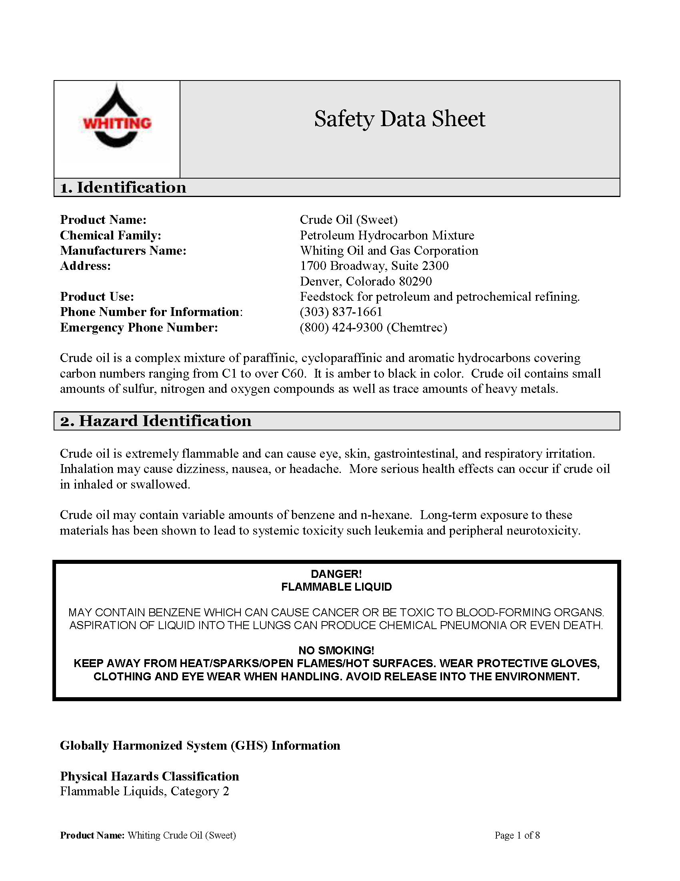

130

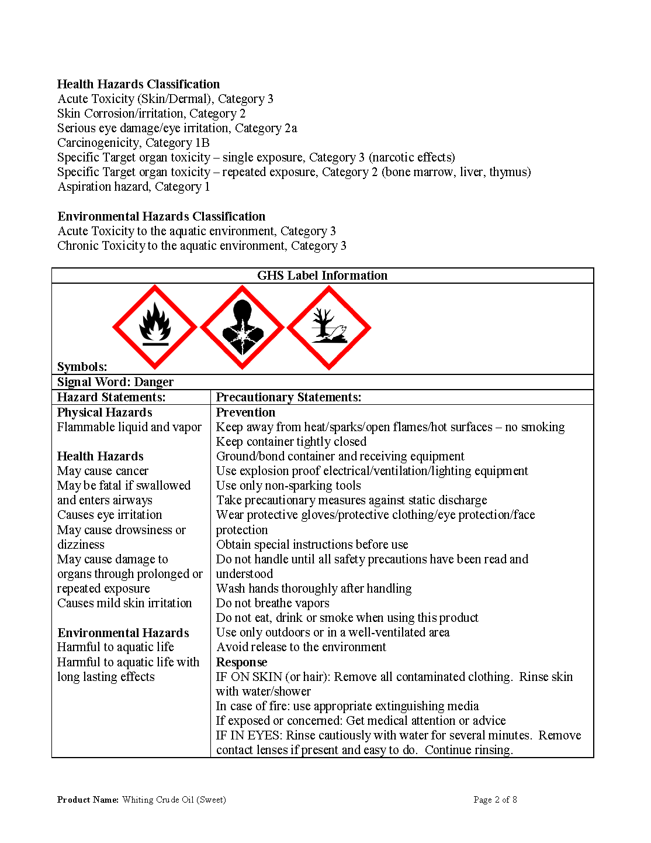

131

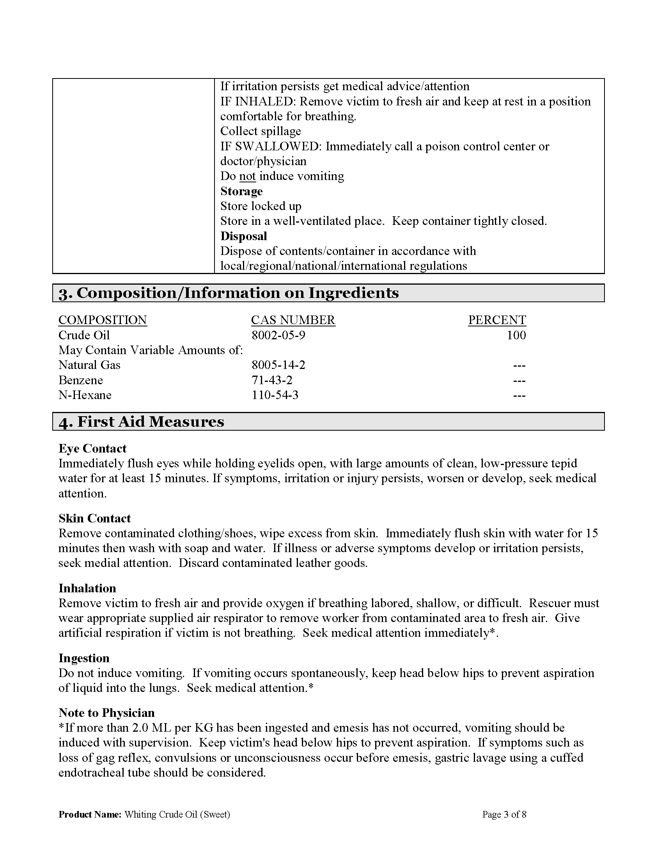

132

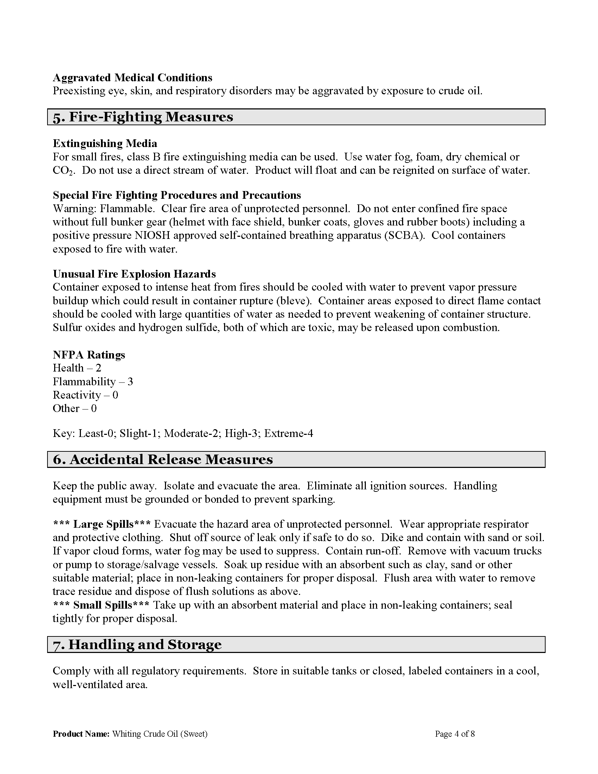

133

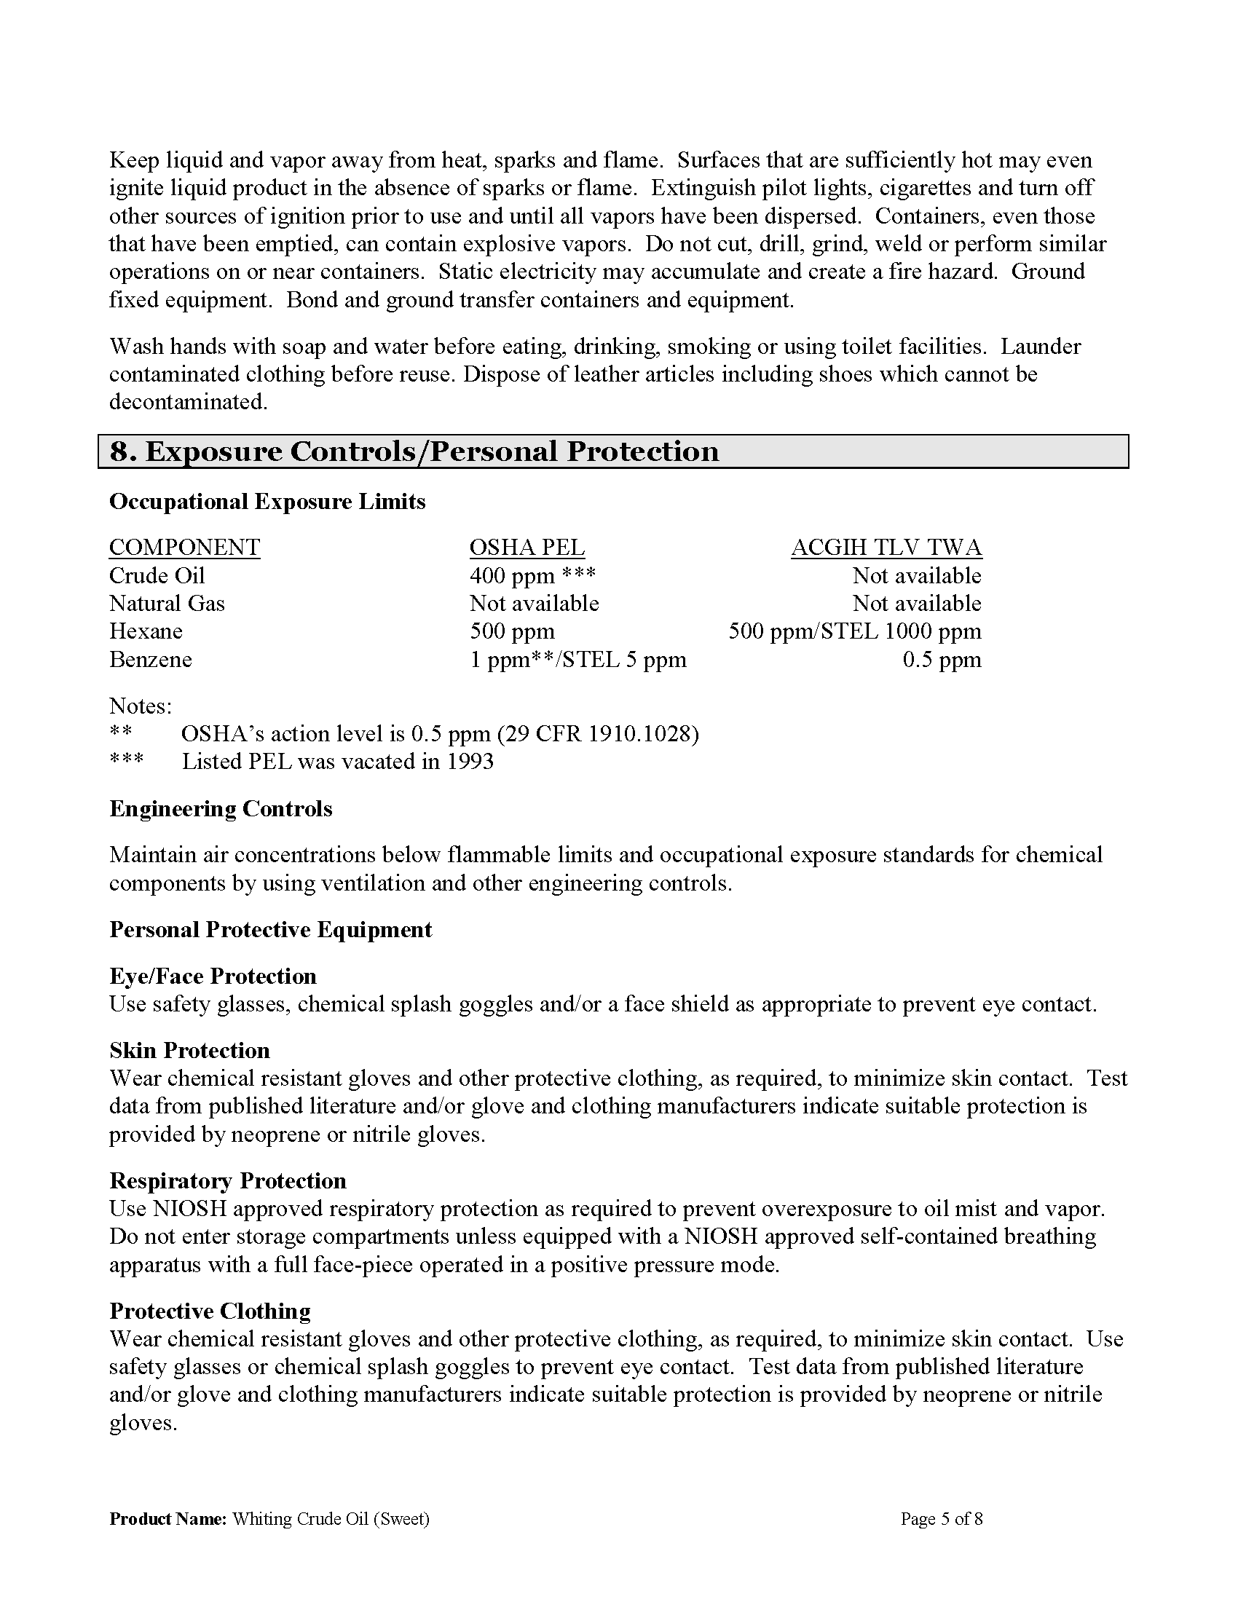

134

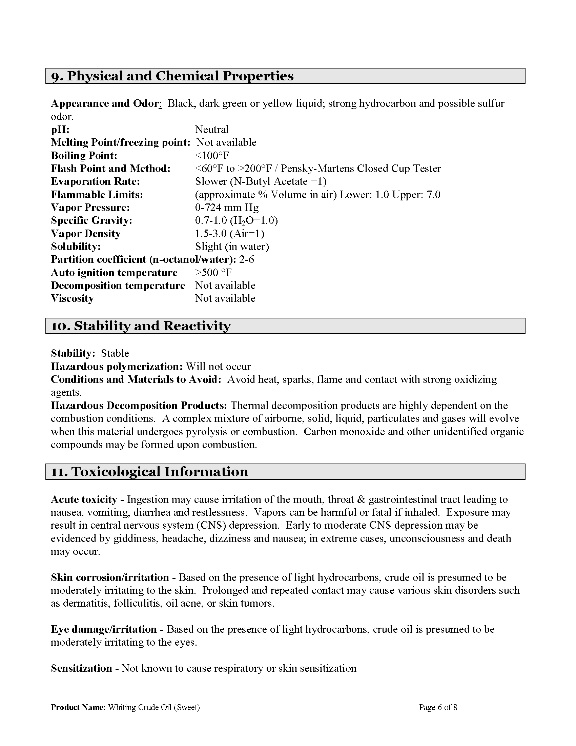

135

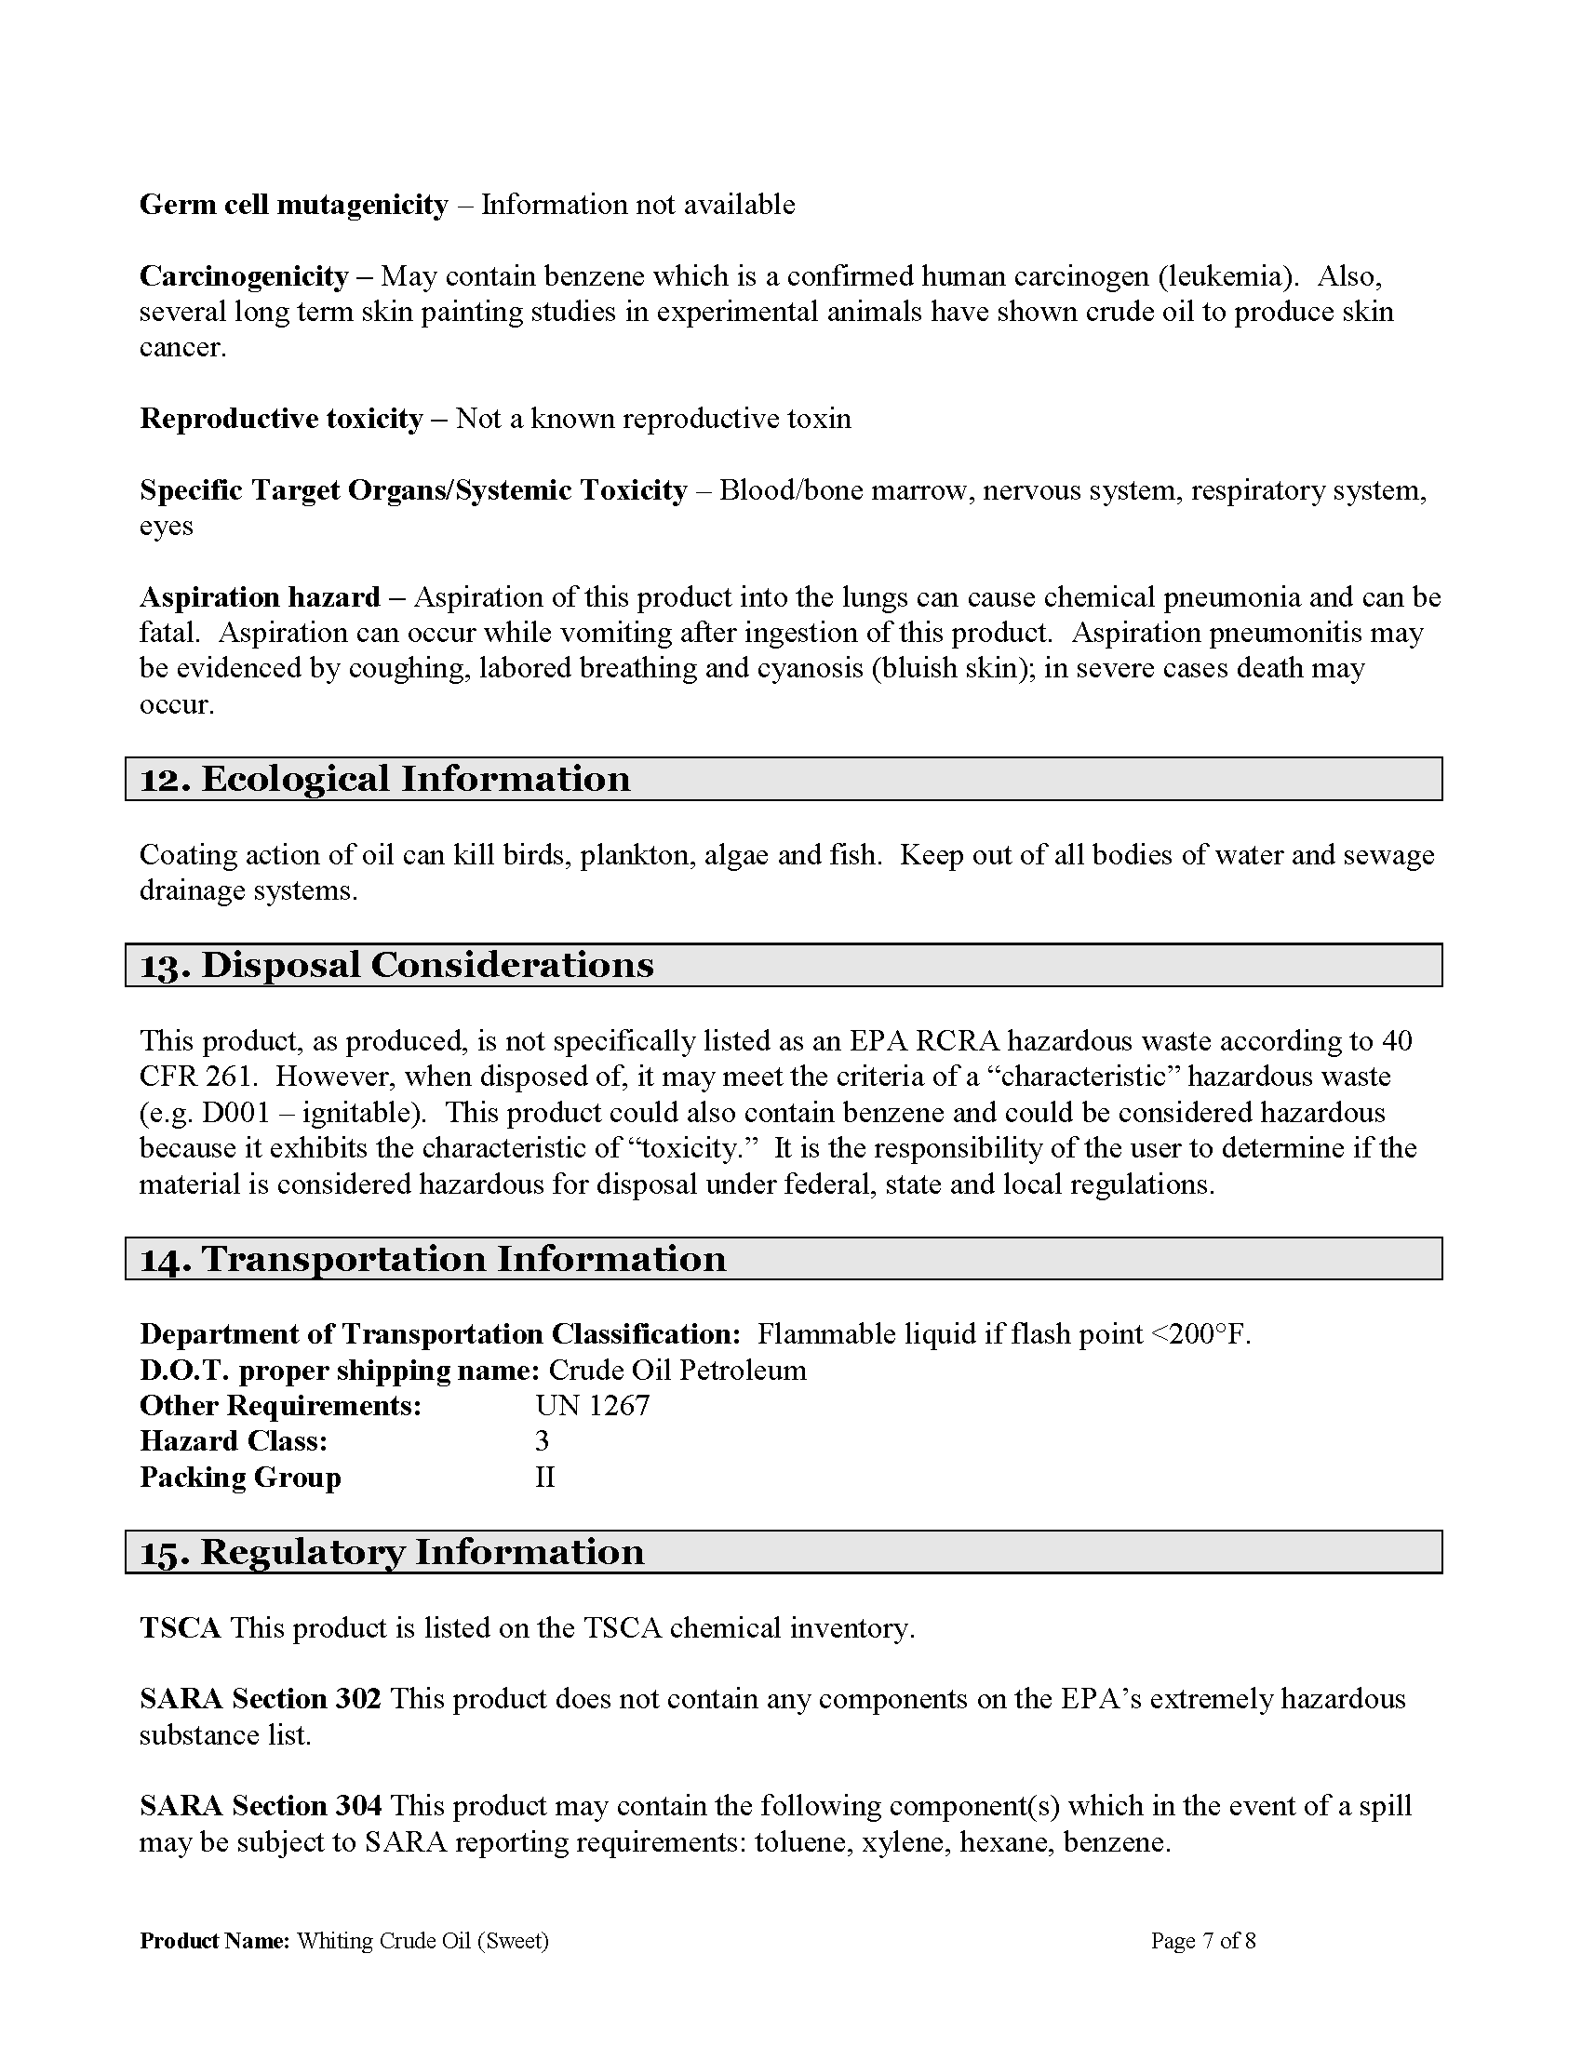

136

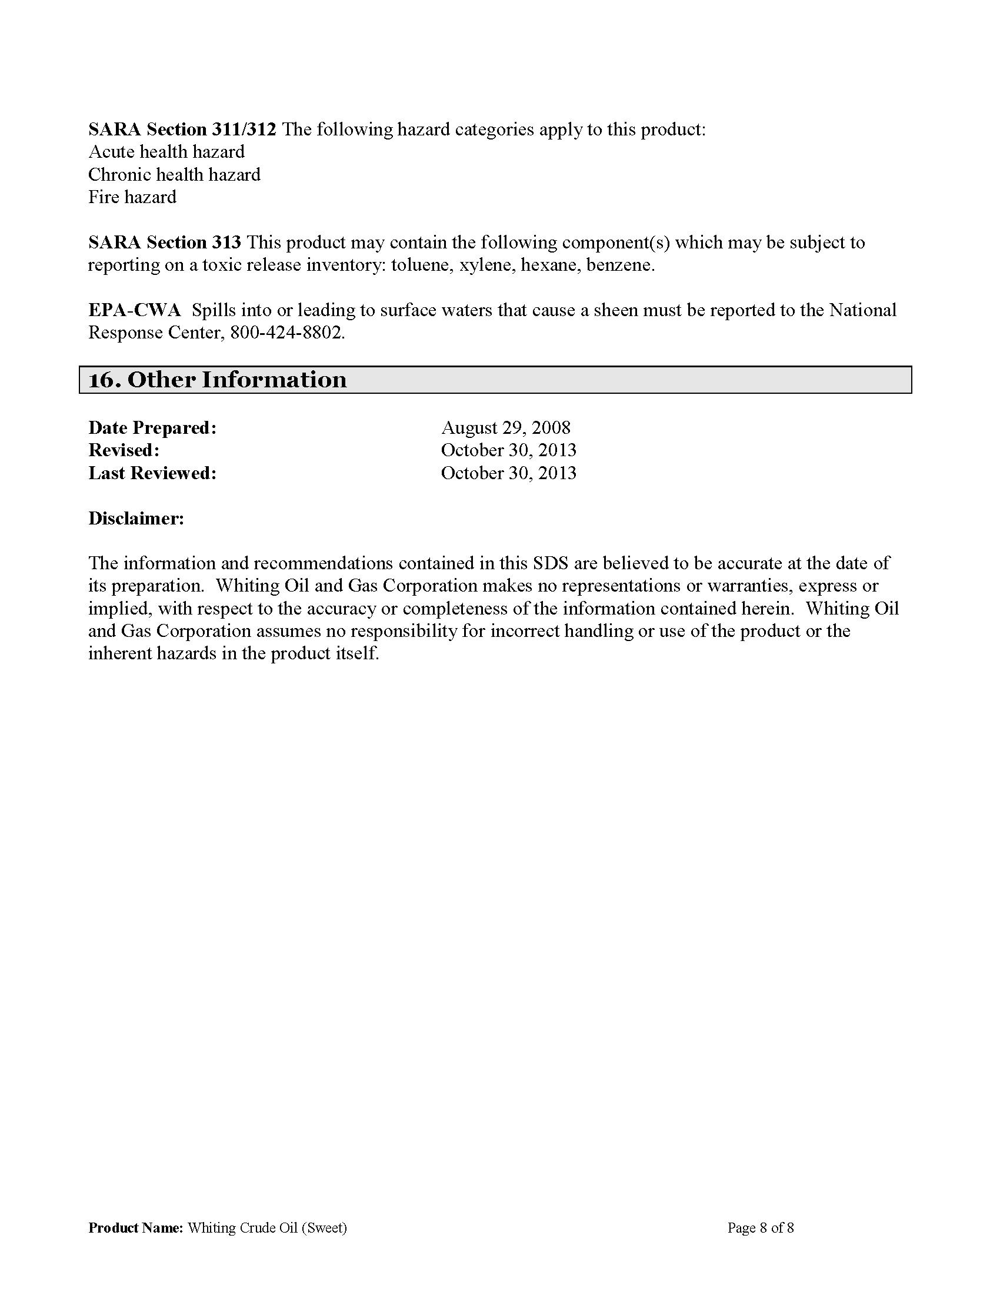

137

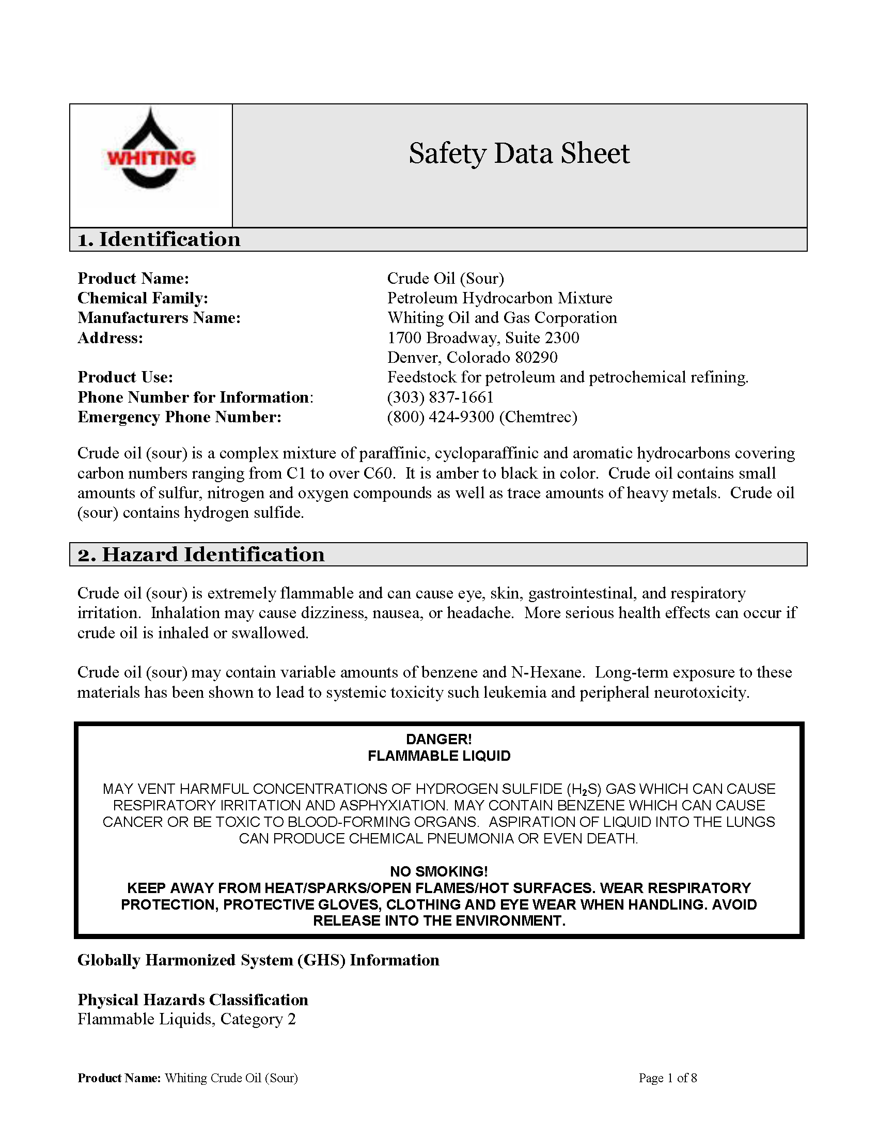

138
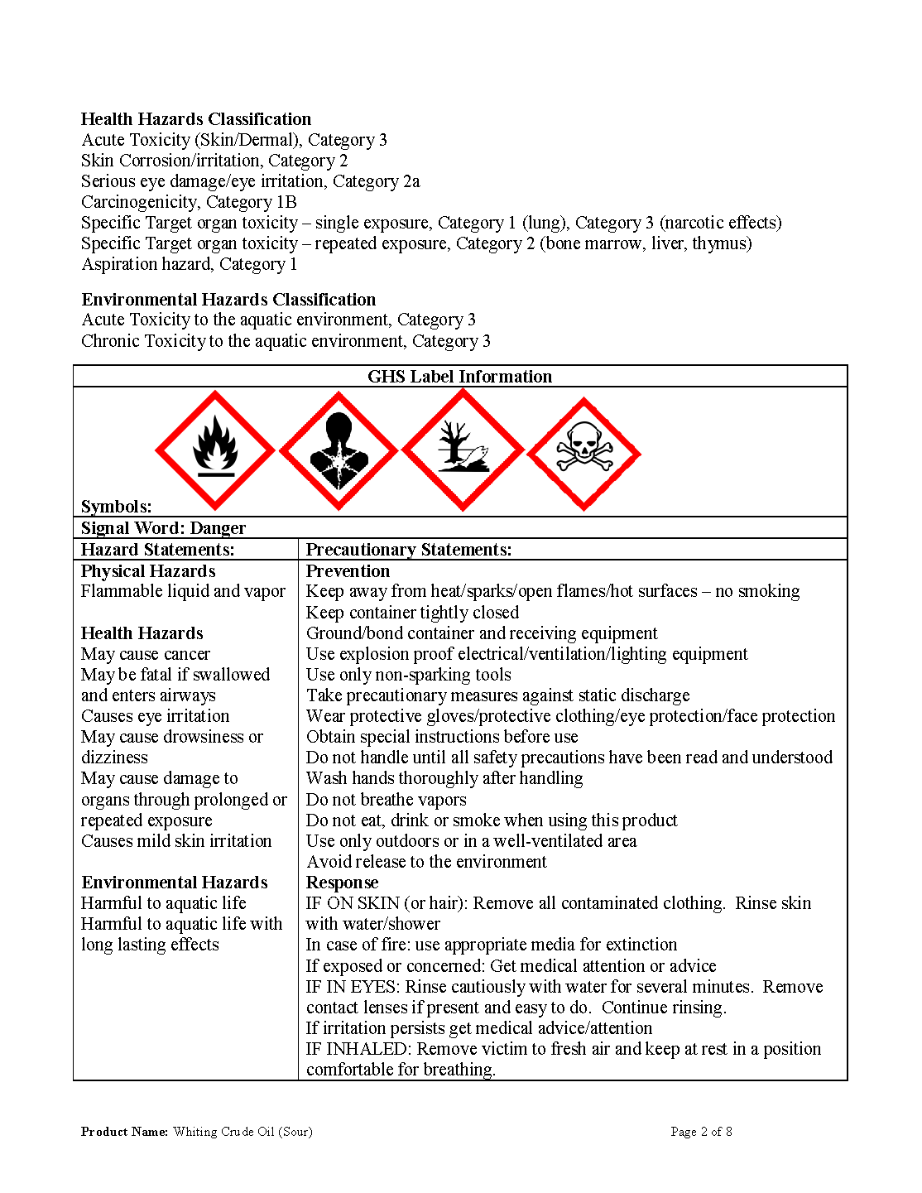
139
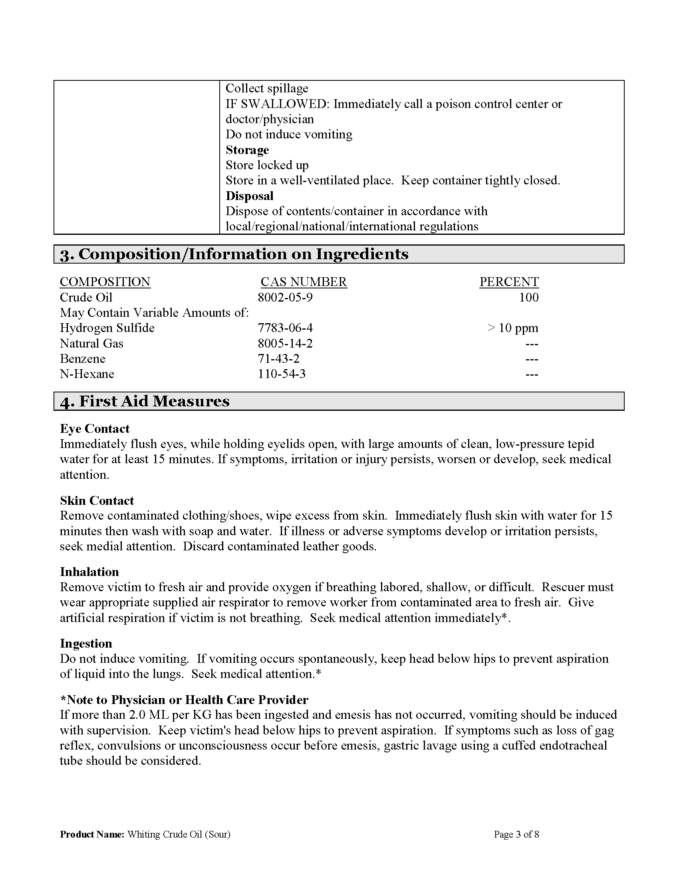
140
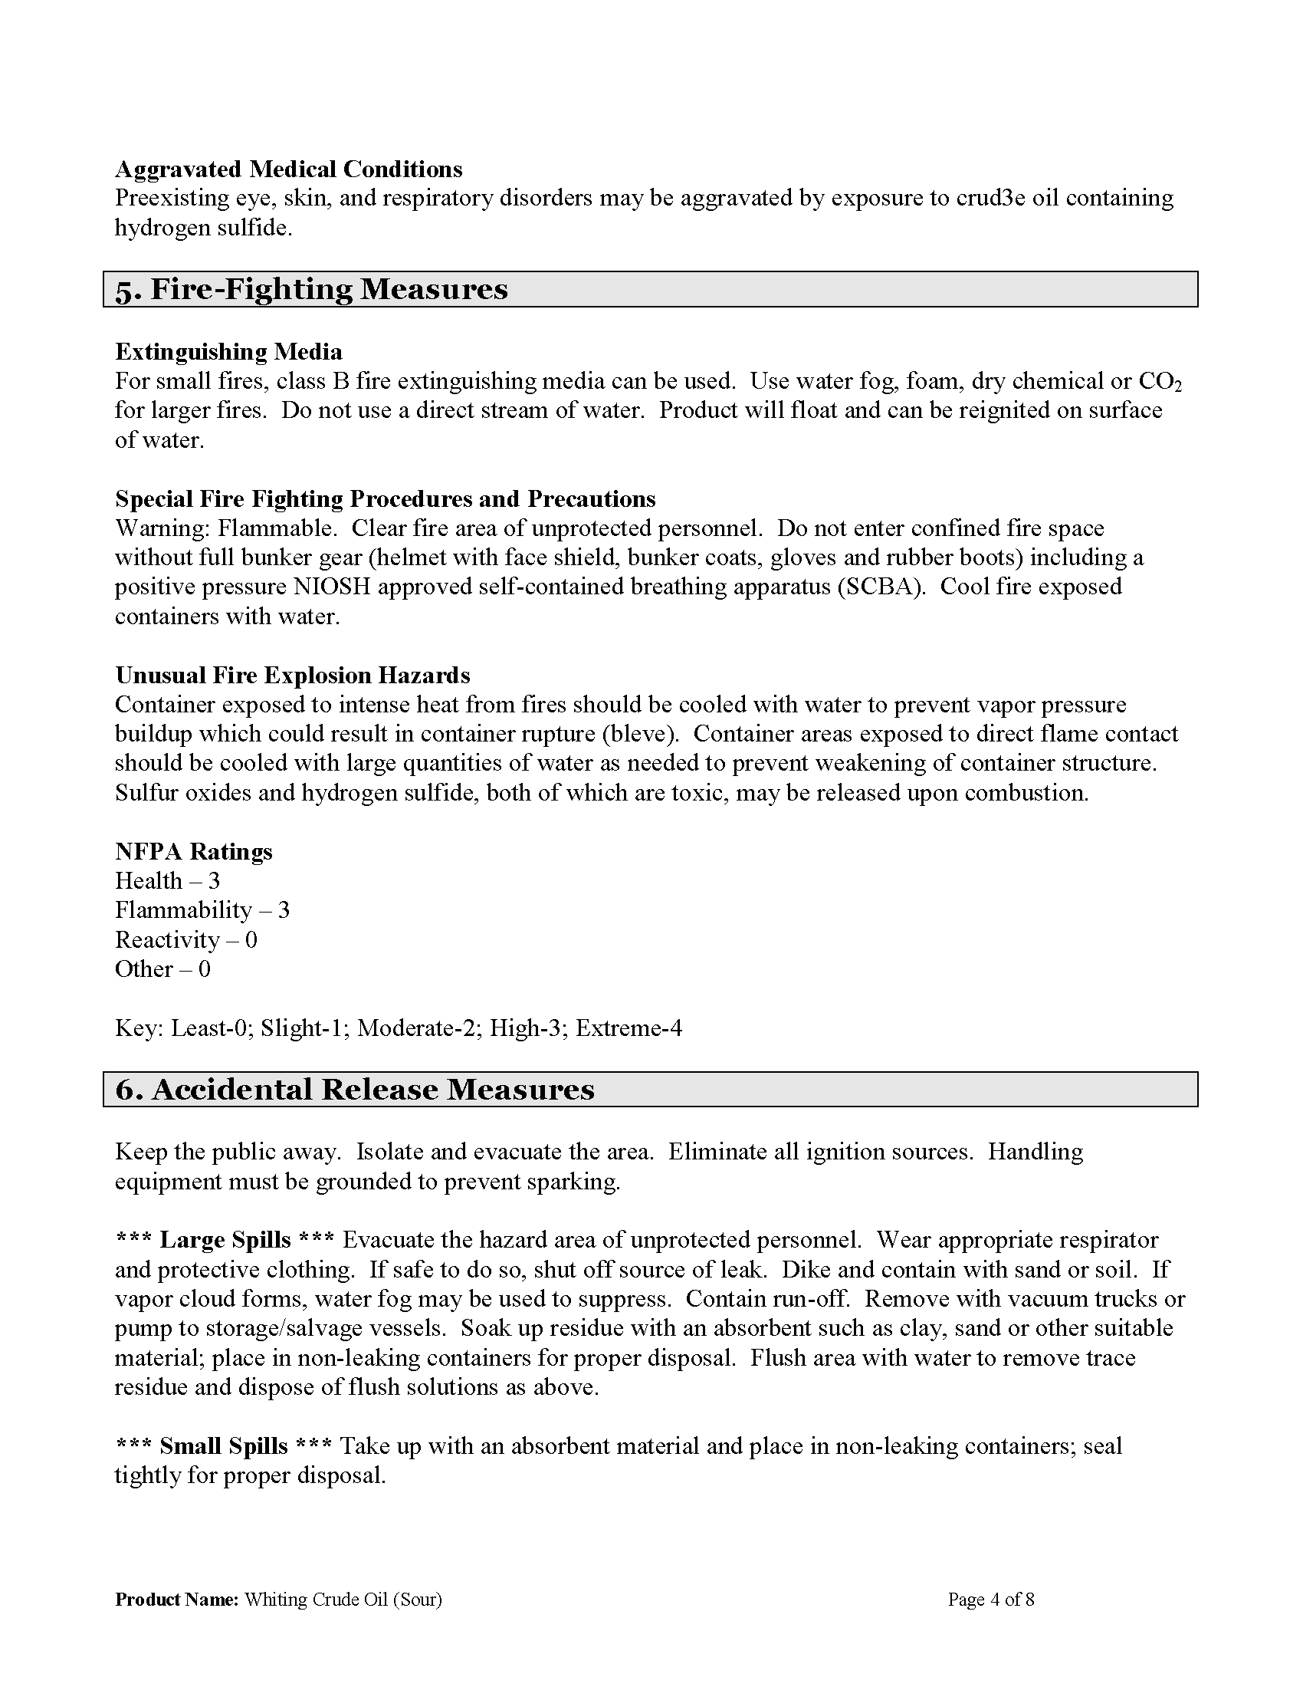
141
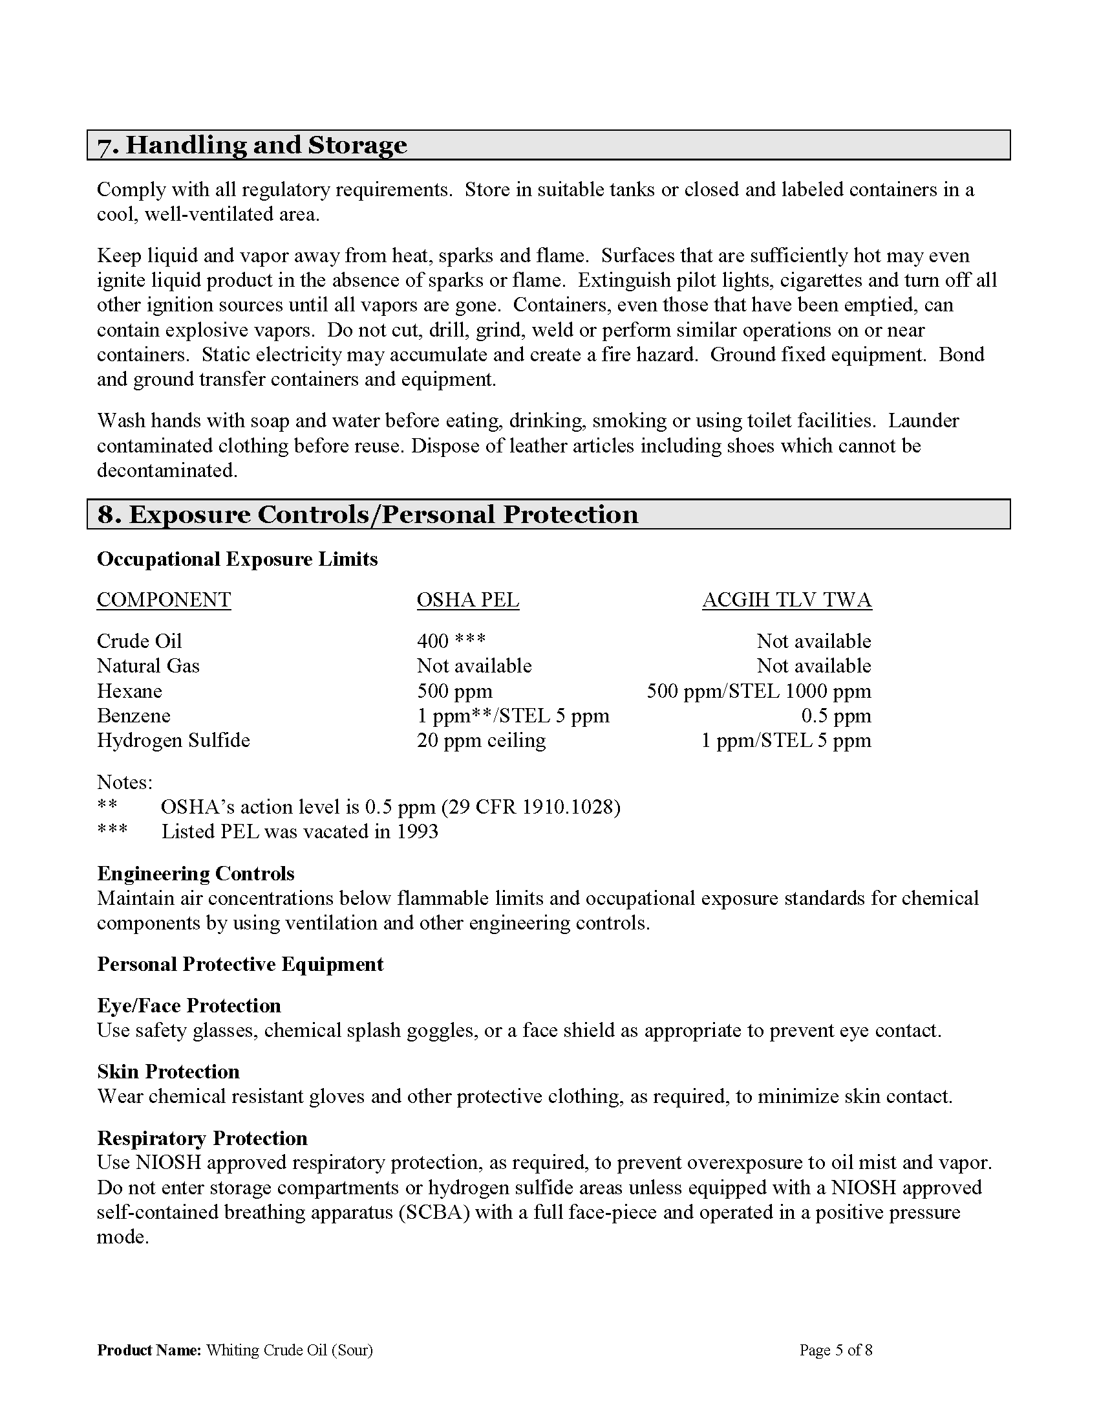
142
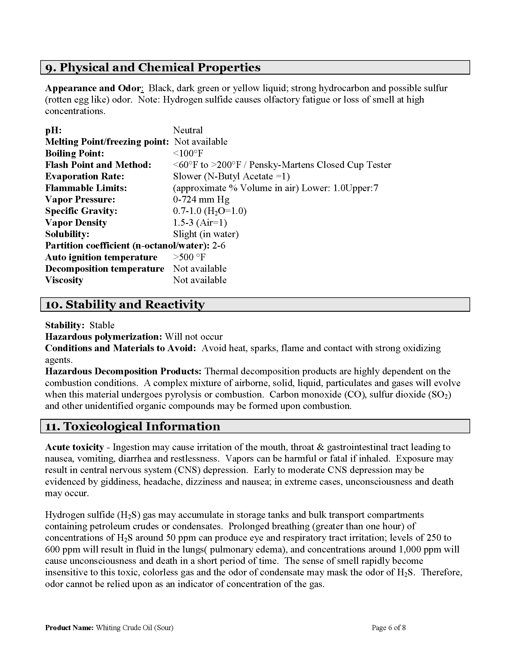
143
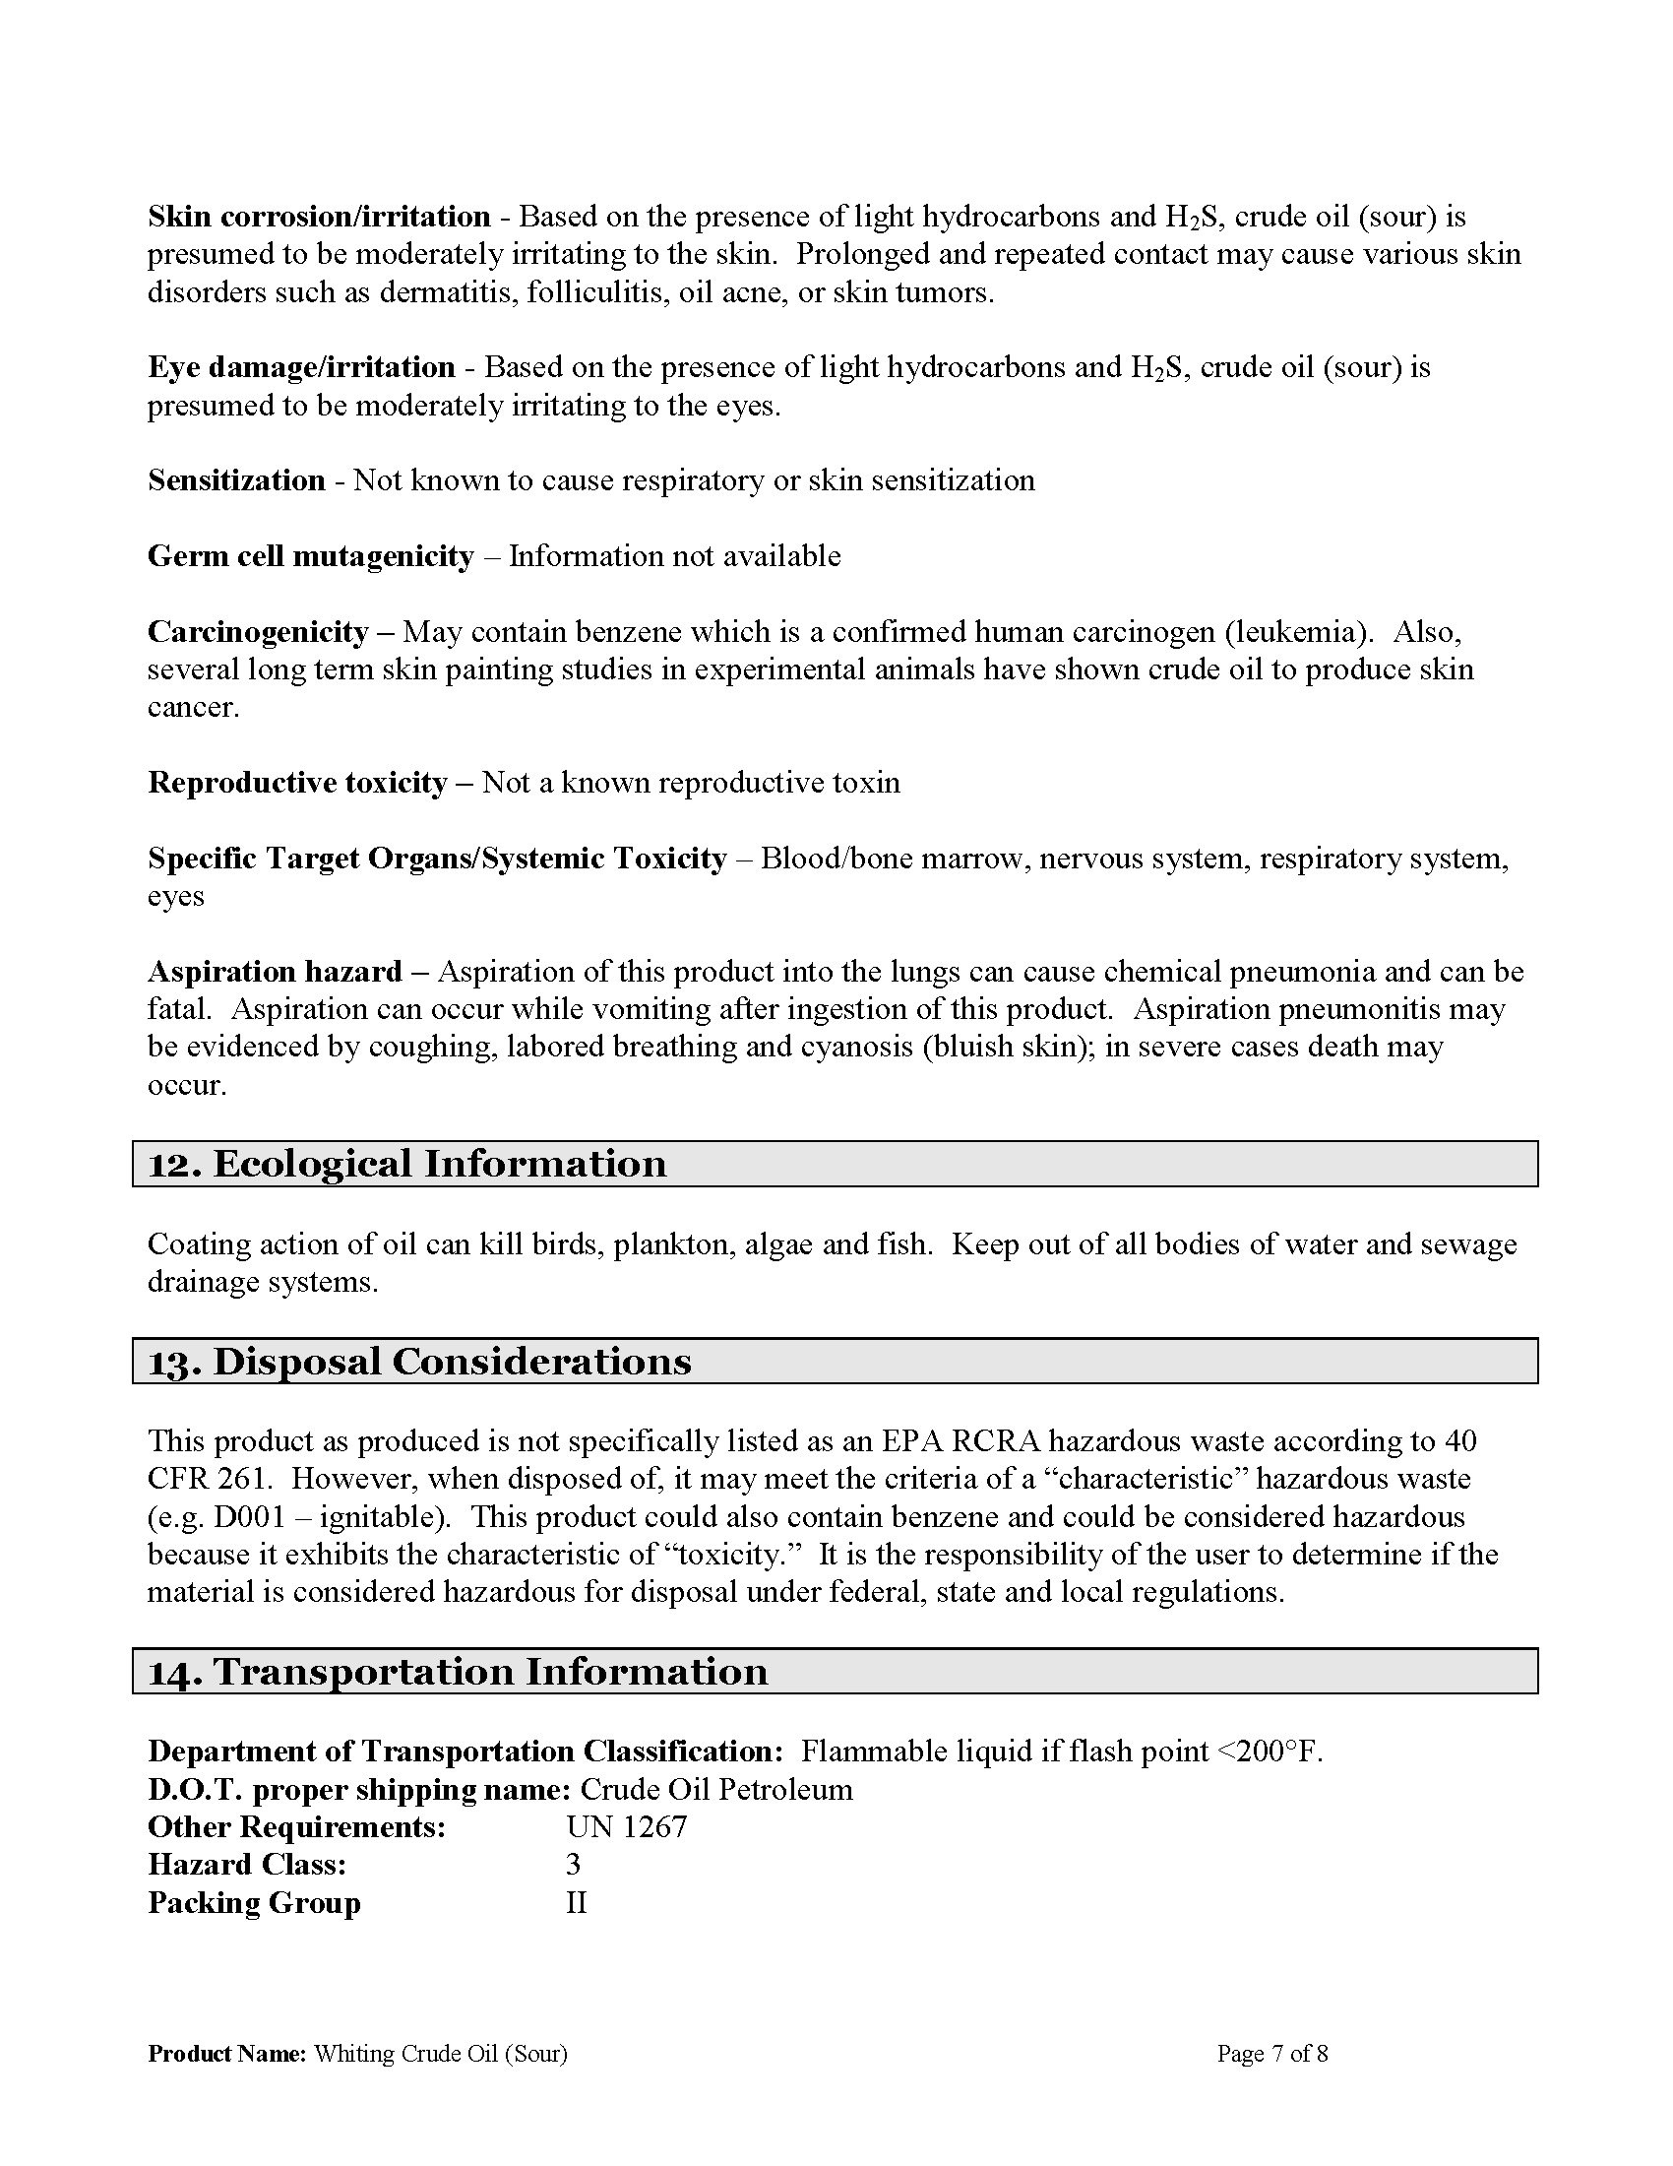
144
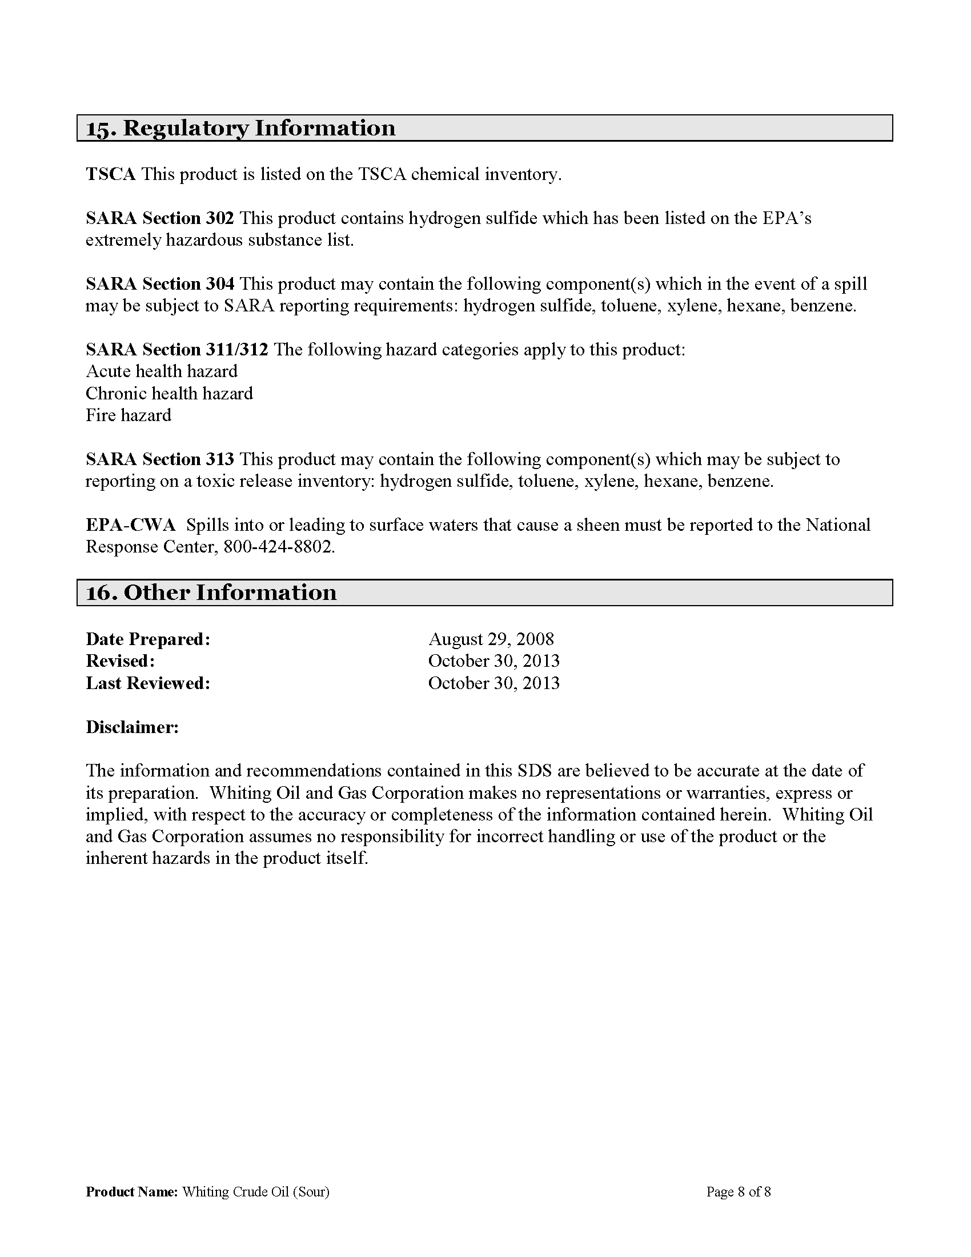
145

Checklist #2 - Hazard Analysis
Product Name: Ethyl Alcohol (Ethanol)
Flash Point: 55° F
Flammable/Explosive Range: 3.3% - 19% (LEL – UEL)
Vapor Pressure: (water=25 mm/Hg) 44 mmHg
Vapor Density: (Air=1 <1 Rise >1 Sink)
Corrosivity: (Acid or Caustic)______________
Solubility: (Soluble-Yes or No) Yes
Toxicity: (TLV, IDLH) TWA 1000 ppm (1900 mg/m³) IDLH 3300 ppm (10%LEL)
DOT 2016 ERG Guide No: 127 (Orange border pages)
PPE requirements:
• Wear positive pressure self-contained breathing apparatus (SCBA).
• Structural firefighters’ protective clothing will only provide limited protection.
_____Contact Hazmat Team for assistance in interpretation of data.
_____If product is not identified or data is inconclusive, assume a worst case scenario and protect public/exposures.
_____Set Cold, Warm and Hot Zones if possible.

146

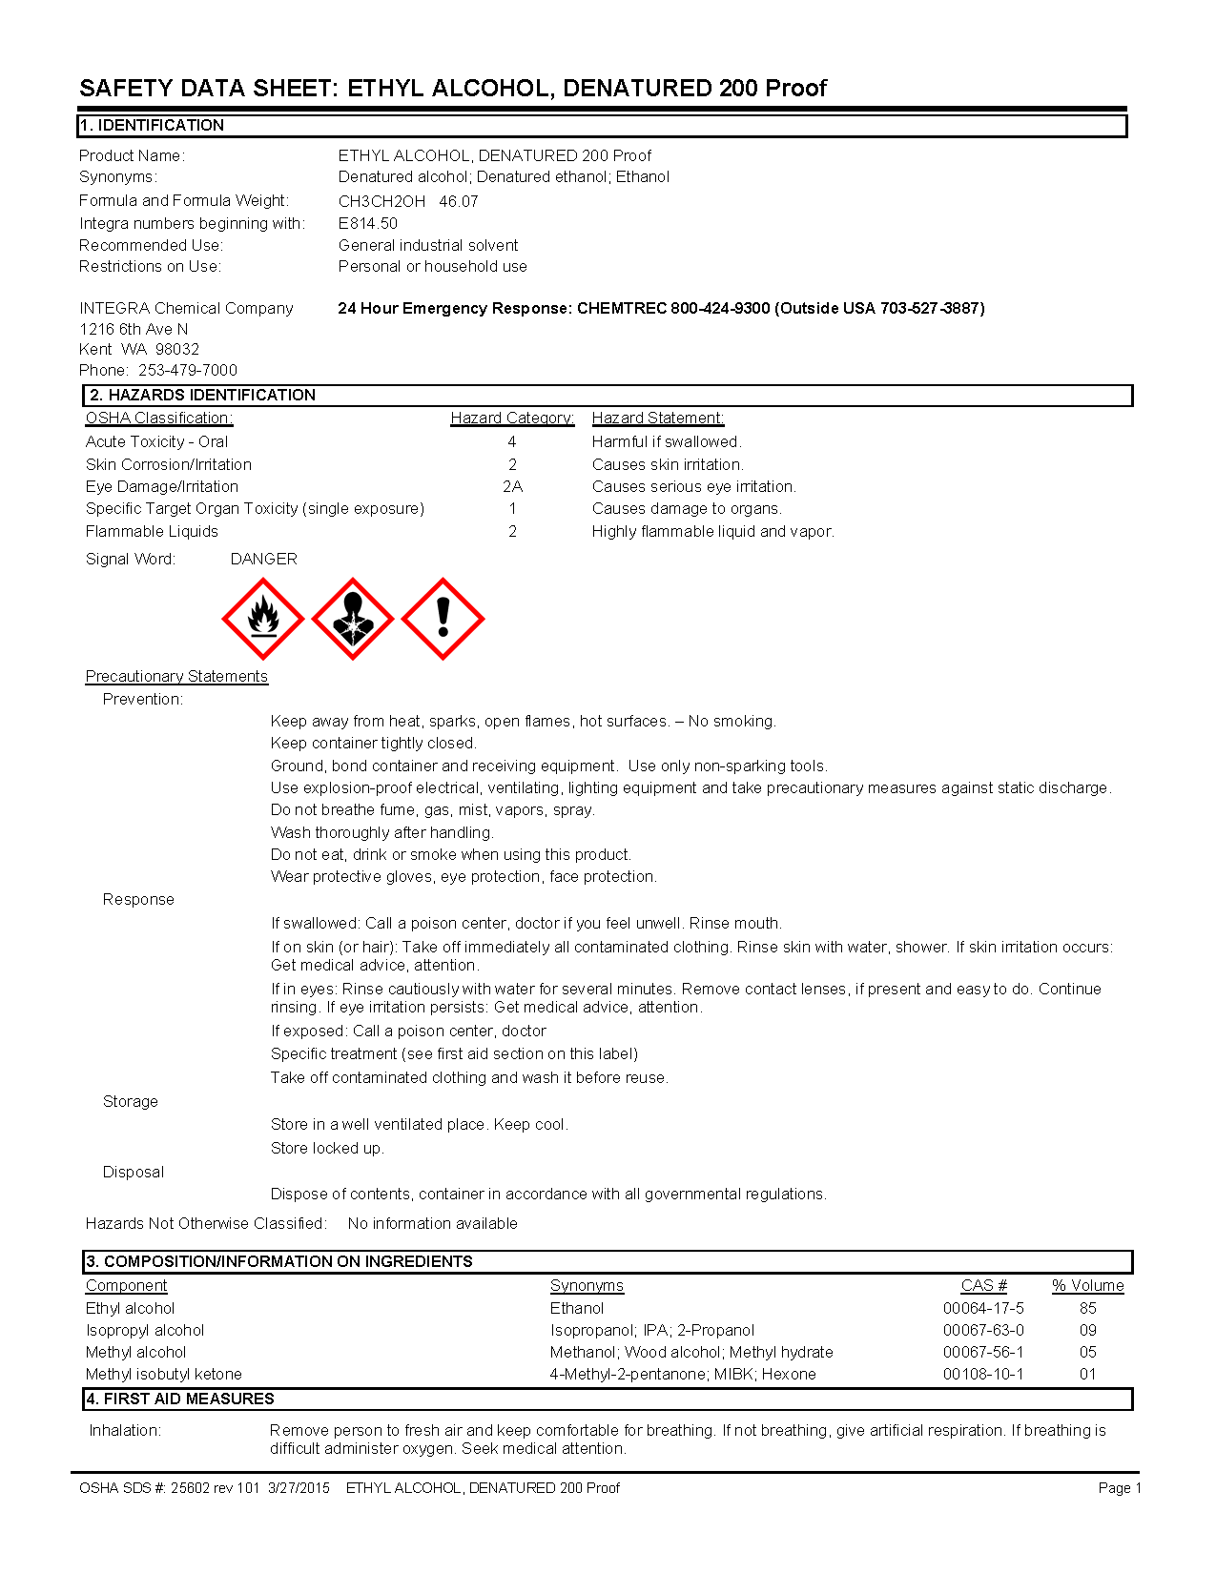

147

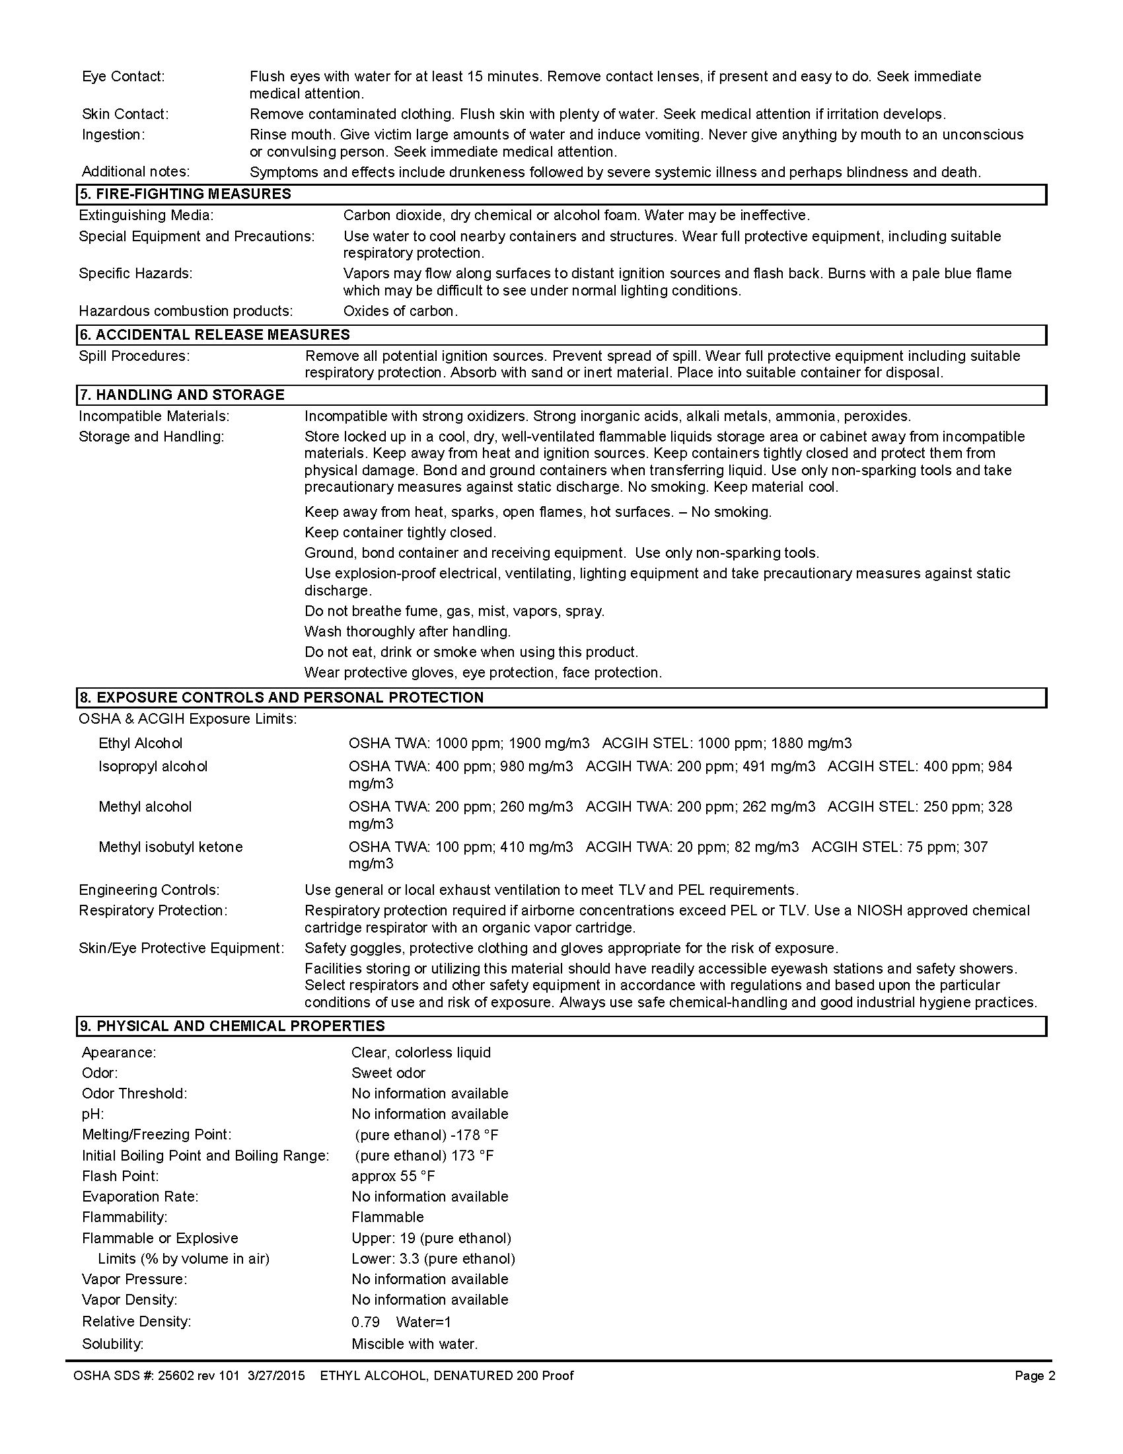

148

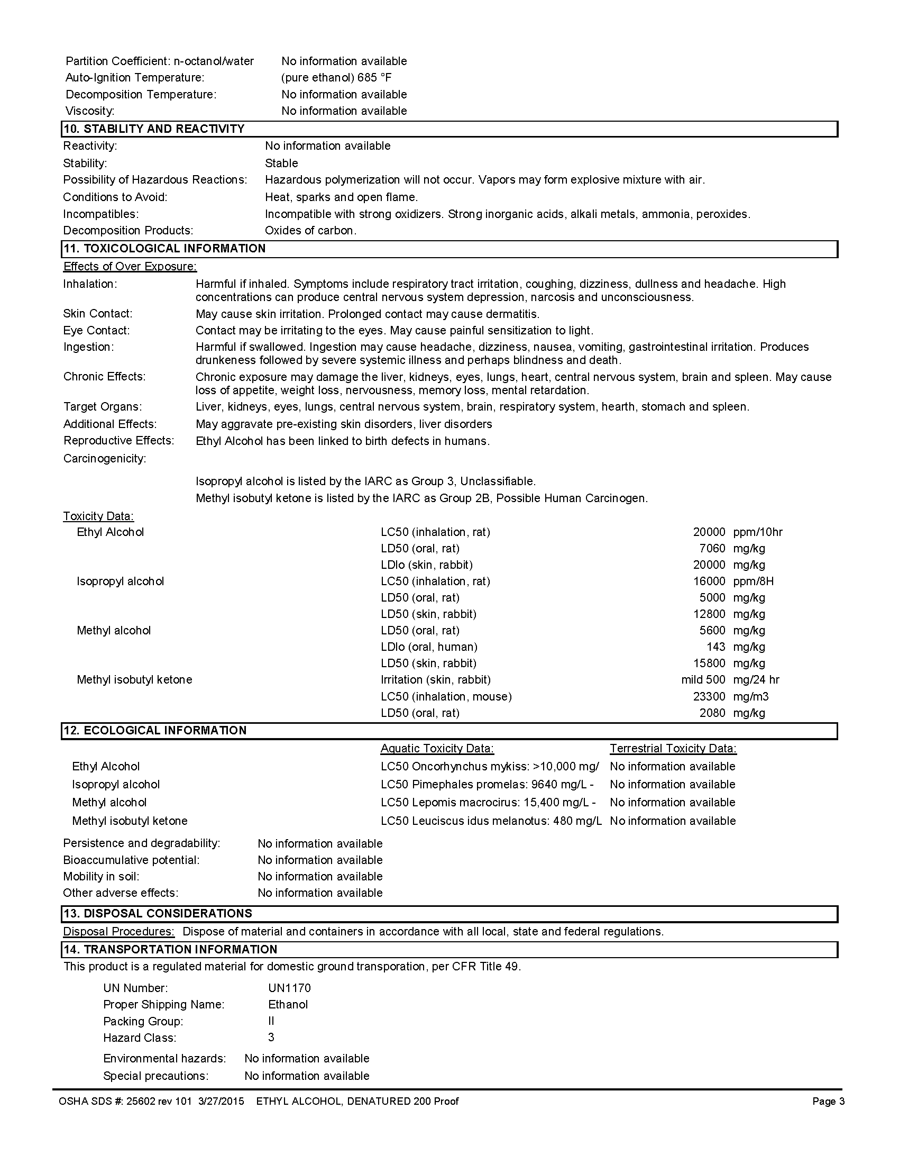

149

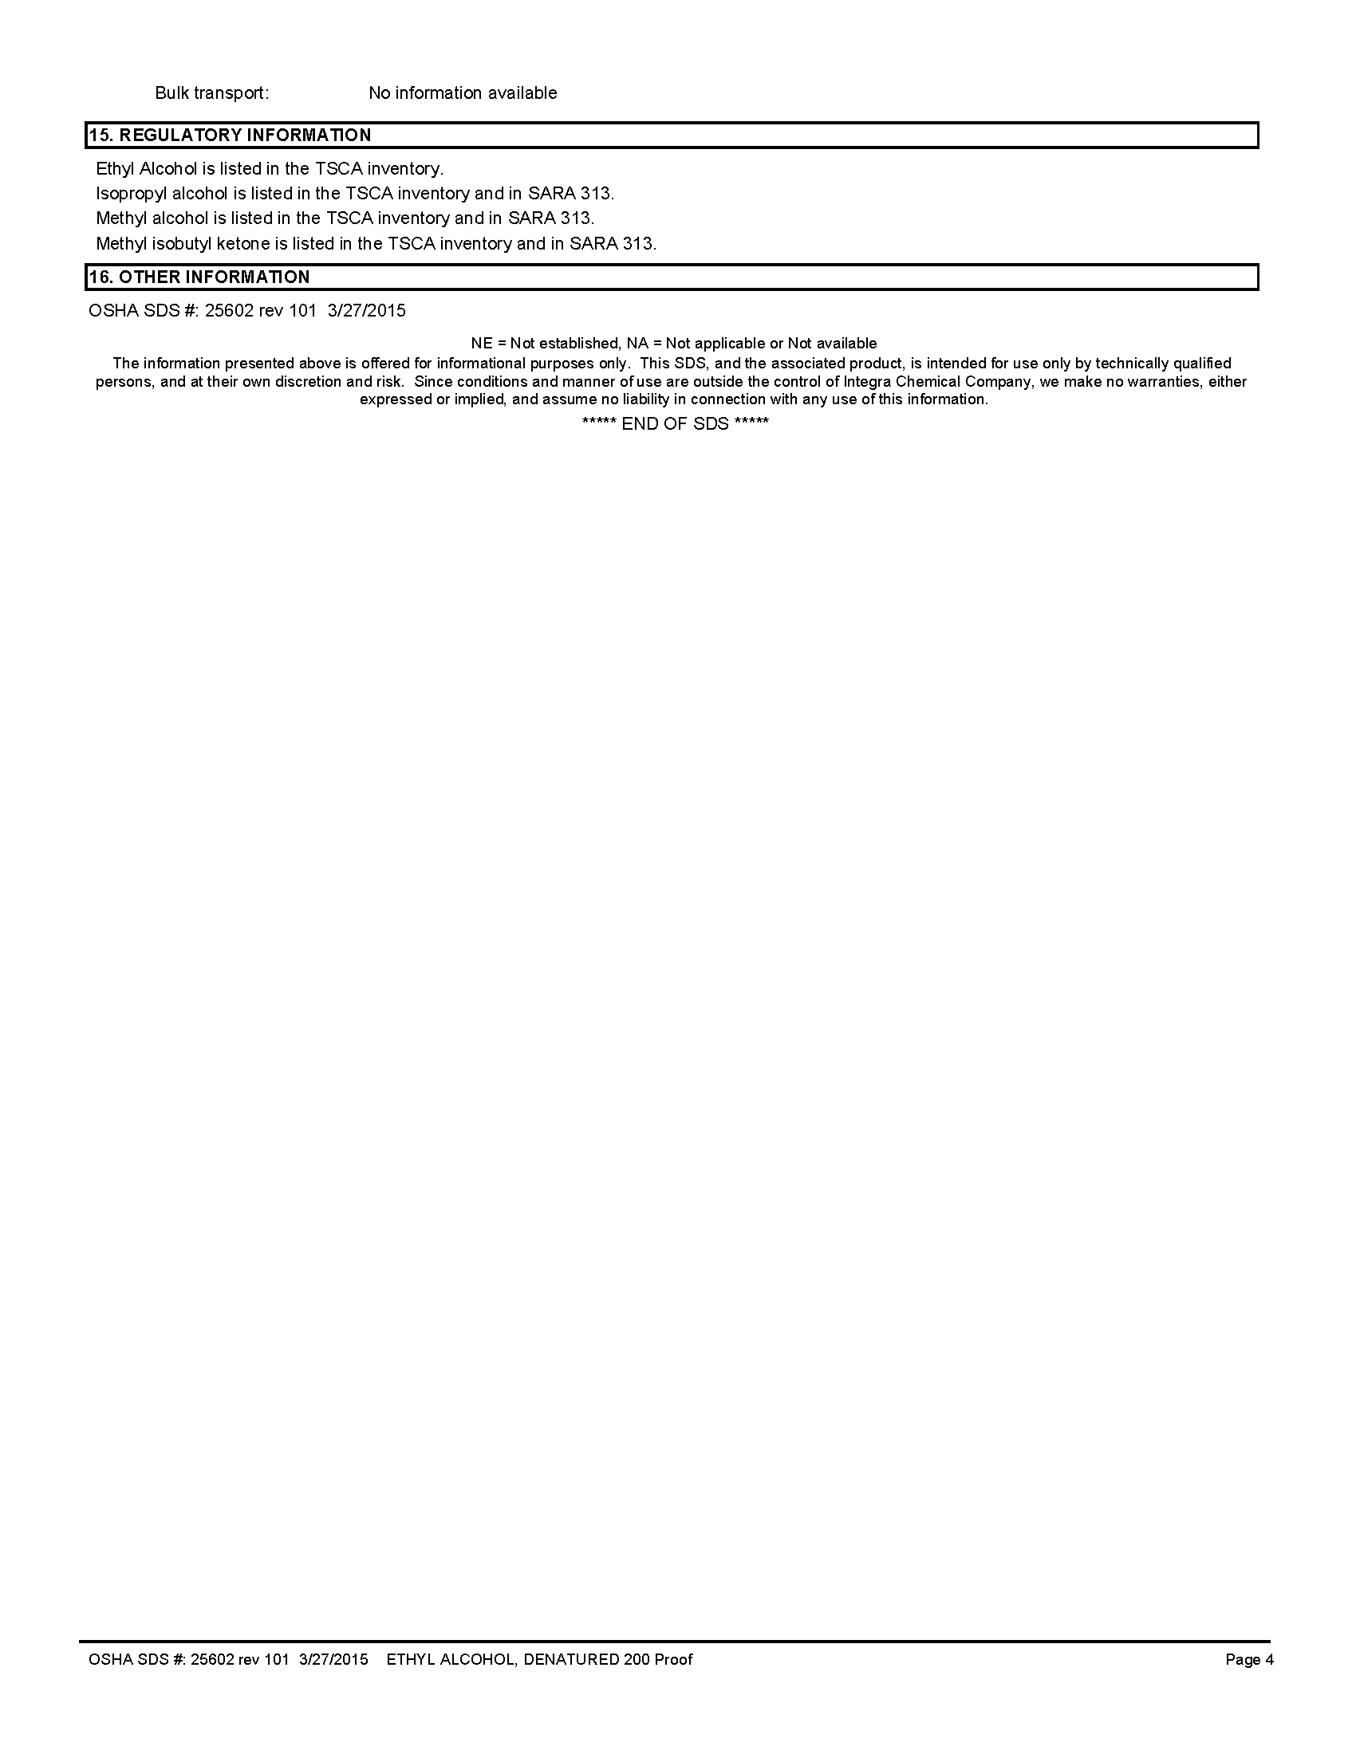

150

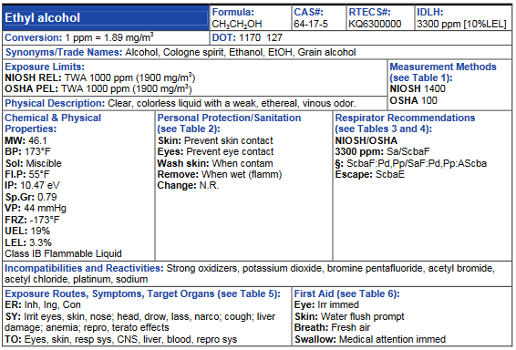

151

Checklist #2 - Hazard Analysis
Product Name: Sodium chlorate
Flash Point: N/A
Flammable/Explosive Range: N/A
Vapor Pressure: (water=25 mm/Hg) N/A
Vapor Density: (Air=1 <1 Rise >1 Sink) N/A
Corrosivity: (Acid or Caustic) neutral
Solubility: (Soluble-Yes or No) Yes
Toxicity: (TLV, IDLH) N/A
DOT 2016 ERG Guide No: 140 (2012ERG) (Orange border pages)
PPE requirements:
• Wear positive pressure self-contained breathing apparatus (SCBA).
• Wear chemical protective clothing that is specifically recommended by the manufacturer. It may provide little or no thermal protection.
• Structural firefighters’ protective clothing will only provide limited protection.
_____Contact Hazmat Team for assistance in interpretation of data.
_____If product is not identified or data is inconclusive, assume a worst case scenario and protect public/exposures.
_____Set Cold, Warm and Hot Zones if possible.

152

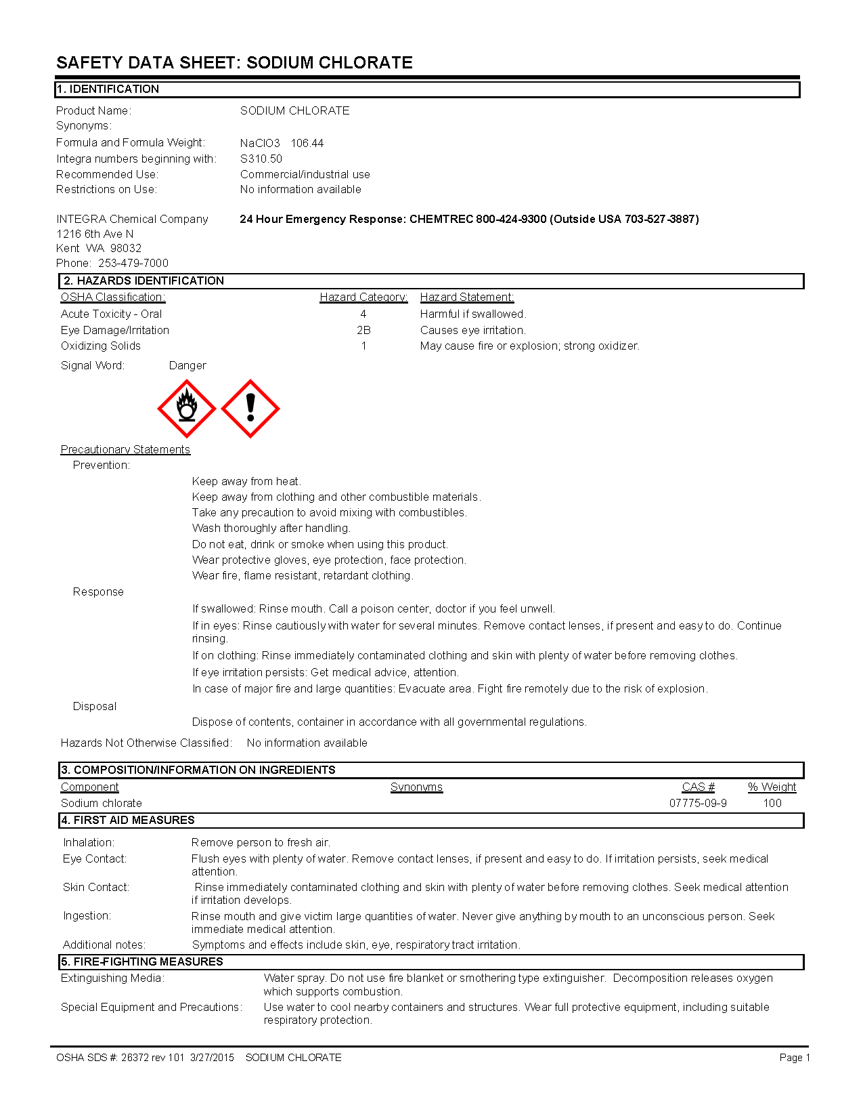

153

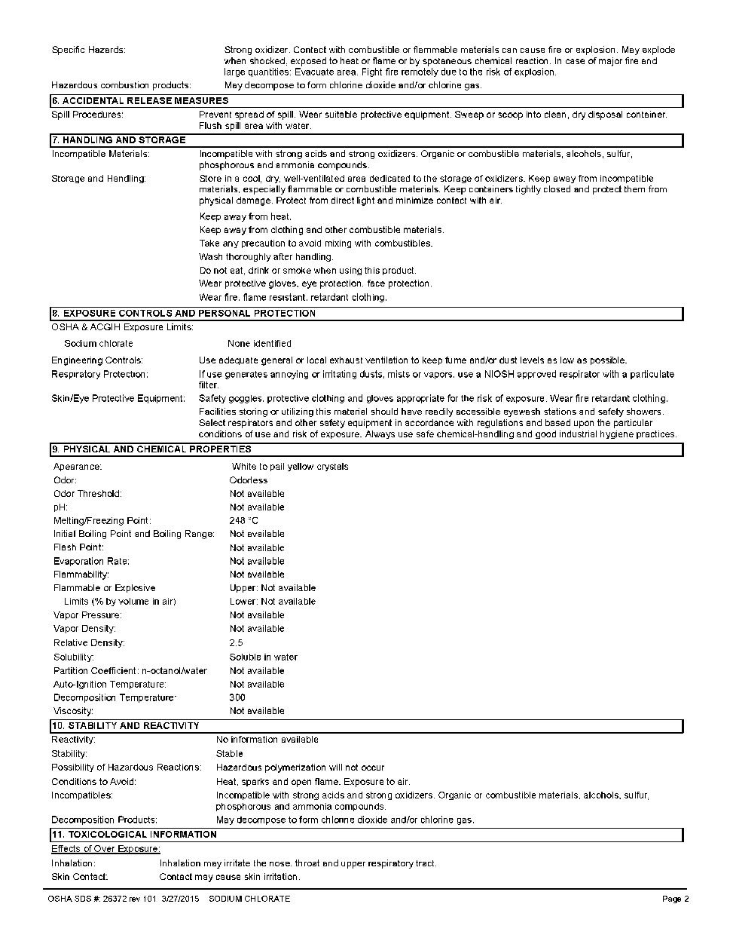

154

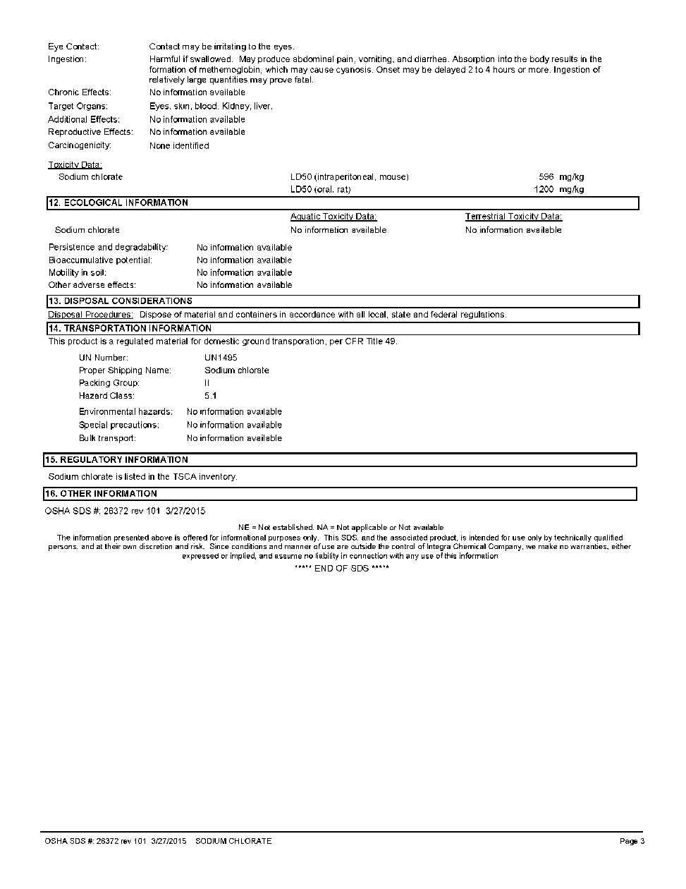

155

Appendix F
Four Railroad Chemicals Guidelines

156

APPENDIX F: Four Railroad Chemical Guidelines

Some Important Tactical, Informational and Operational
Guidelines for: Sodium Chlorate Anhydrous Ammonia Ethanol
Bakken Crude Oil

Sodium Chlorate:

Odorless, pale yellow to white crystalline solid.

Strong Oxidizer. Contact with wood, organic matter, railroad ties, sulfuric acid may result in fires or explosions. Can increase the intensity of fires and may result in explosions.

Personnel near a spill or derailment should wear full turnouts and SCBA. Stay out of product! Avoid inhalation or contact of any dusts, vapors, smoke from fire.
Initially, isolate spill or leak area for at least 150 feet in all directions. For a large spill, consider initial downwind evacuation for at least 330
feet.

If a railcar is involved in a fire, isolate for ½ mile in all directions and consider the initial evacuation for ½ mile in all directions due to the explosion potential.

157

If involved in a small fire, use water. Do not use dry chemical or foams.

If involved in a large fire, flood area from a distance with water by use
of unmanned master streams and monitors. Do not move a railcar that has been exposed to heat until technical expertise can evaluate. Cool railcars with large quantities of water from unmanned monitors well after fire is out. If this is impossible, back out and let the fire burn.(Non- Intervention)

In case of spills, keep personnel away from the product and evaluate product contact with combustibles such as rail ties. Keep water out of the container (railcar). Leave any cleanup to railroad personnel or their contractors.

Decon, if necessary, with lots of water and contain decon “runoff”.

Anhydrous Ammonia:

A clear, colorless (corrosive) gas with a strong odor. Shipped as a liquid under pressure (railcar). Contact with the liquid can cause frostbite.

Normally non-flammable outdoors but can become flammable
(explosive) when confined (as in a building or structure).

Forms ammonium hydroxide, a strong corrosive (caustic) when mixed with water or moisture. Personnel should stay out of the vapors as they are highly toxic and corrosive to the skin and respiratory system.

Full turnouts with SCBA’s may be necessary for personnel near but not in the leak area. Exposure to or working in and around anhydrous ammonia requires full respiratory and full protective clothing (Hazmat Team Operation).

158

Exposure to anhydrous ammonia can easily cause pulmonary edema
and death. Can also cause corrosive burns to the skin and mucous membranes.

Stinging of the armpits, crotch, eyes, neck or other moist body areas may indicate an exposure to ammonia.

Vapors initially are lighter than air but can commonly hug the ground as they absorb moisture from the air and become heavier. Vapors have poor predictability.

Initially isolate a spill or leak 330 feet in all directions. See ERG Tables 1 and 3 – Initial Isolation and Protective Action Distances on the UN/NA
1005 datasheet.

If a railcar is involved in fire, Isolate for 1 mile in all directions and consider initial evacuation for 1 mile in all directions.

Use water fog to disperse, reduce or control vapor cloud. If possible, safely contain any residual from water fallout from these operations.

Do not direct water at the spill or source of the leak.

Ethanol: (ethyl alcohol)

A clear colorless liquid with typical odor. Vapors are heavier than air –
watch low areas.

Highly flammable but highly water soluble.

Vapors are highly irritating to eyes, nose and throat. Isolate spill or leak for 150 feet in all directions.

159

For a large spill or leak, consider downwind evacuation for at least 1000
feet.

If a railcar is involved in fire, isolate for ½ mile in all directions and consider an initial evacuation for ½ mile.

For small fires, use dry chemical, CO2, water spray or alcohol-resistant foam.

For large fires, use water fog or alcohol-resistant foam. DO NOT USE STRAIGHT STREAMS!

If the fire involves a railroad tank car, fight fire from a maximum distance or use unmanned hose streams, foam apparatus or monitors.
Be aware of operating venting devices or discoloration of the tank car. If no fire, eliminate ignition sources, dike well ahead of spill. Try to safely contain firefighting runoff.

Air monitor the area to determine concentration of vapors
(flammability).

No personnel should be in a flammable atmosphere (above 10% of the
LEL of 3.3%, or 0.3%).

Turnouts and SCBA’s may be necessary for certain operations.

Cool flame exposed/impinged tank cars.

Adding water to a spill may raise the flashpoint.

Bakken Crude Oil:

Highly flammable form of crude oil. Flash Point less than 73° F. Has toxic components including benzene, a known carcinogen.
Vapors are highly irritating to eyes, nose and throat.

160

Isolate spill or leak for 150 feet in all directions.

For a large spill or leak, consider downwind evacuation for at least 1000 feet.

If a railcar is involved in fire, isolate for ½ mile in all directions and consider an initial evacuation for ½ mile.

For small fires, use dry chemical, CO2, water spray or foam.

For large fires, use water fog or alcohol-resistant foam. DO NOT USE STRAIGHT STREAMS!

If the fire involves a railroad tank car, fight fire from a maximum distance or use unmanned hose streams, foam apparatus or monitors.
Be aware of operating venting devices or discoloration of the tank car. If no fire, eliminate ignition sources, dike well ahead of spill. Try to
safely contain firefighting runoff.

Air monitor the area to determine concentration of vapors
(flammability).

No personnel should be in a flammable atmosphere (above 10% of the
LEL of 1.0% or 0.1%).

Turnouts and SCBA’s may be necessary for certain operations.

Cool flame exposed/impinged tank cars.

For a large fire, order and use Foam Cache from State Fire Marshal.

161

Appendix G
Apparatus Inventories

162
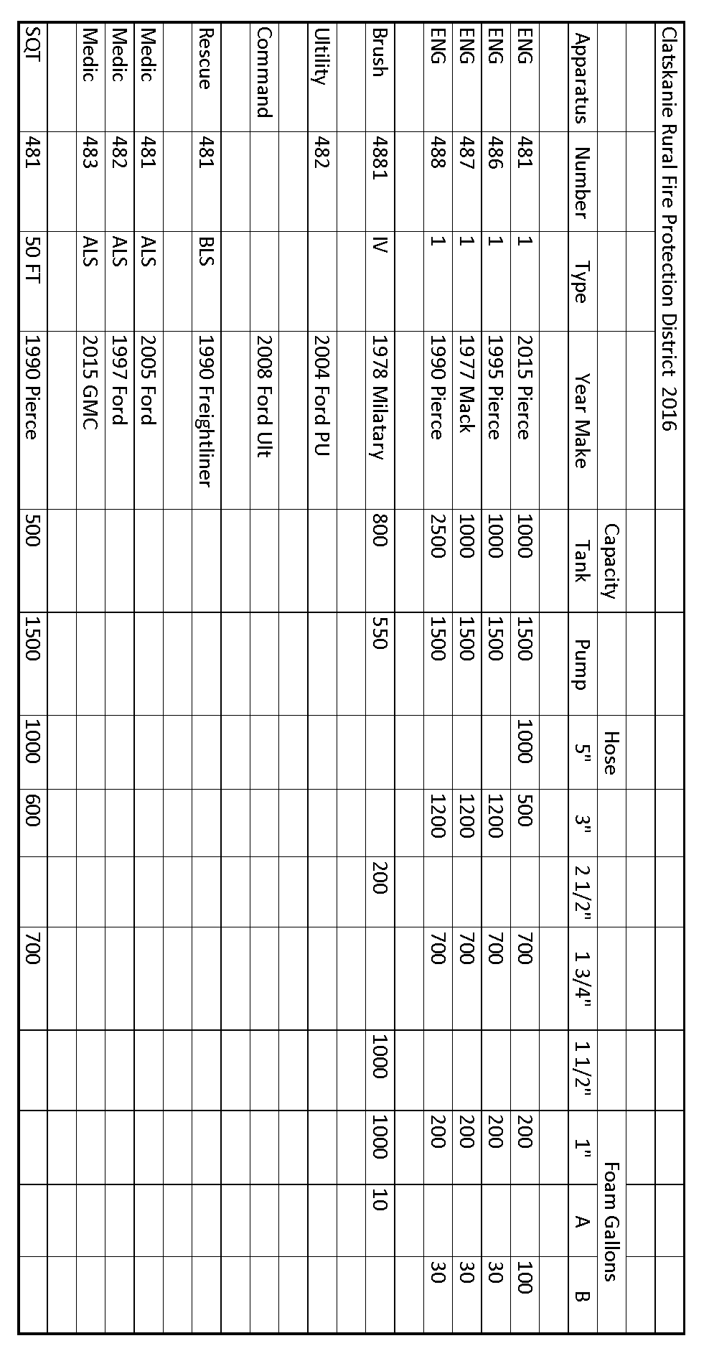
163
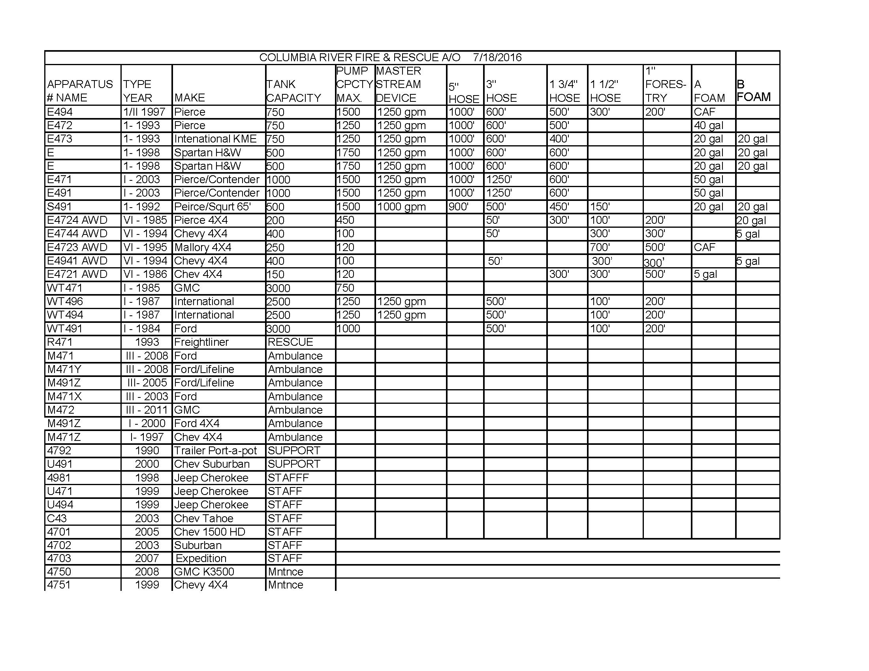
164
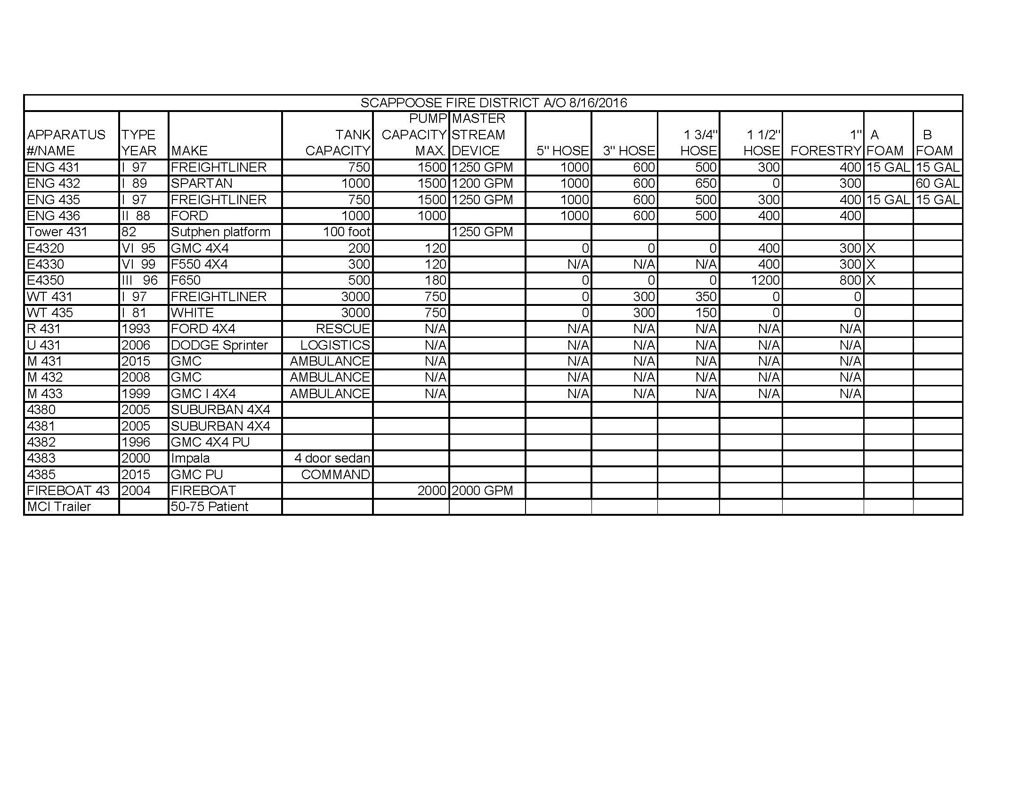
165

Appendix H
ICS Forms

201 Incident briefing 202 Incident objectives
203 Organization Assignment List 204 Assignment list
205 Incident radio comm plan 206 Medical plan
207 Incident Organization chart 208 safety message / plan
209 Incident status summary 210 Resource status summary
211 Incident check in 213 General message
214 Activity log 215 Operational plng worksheet
215A Incident action plan safety analysis

166

INCIDENT BRIEFING (ICS 201)

1. Incident Name: | 2. Incident Number: |  | 3. Date/Time Initiated:  Date: Time:
4. Map/Sketch (include sketch, showing the total area of operations, the incident site/area, impacted and threatened areas, overflight results, trajectories, impacted shorelines, or other graphics depicting situational status and resource assignment):
5. Situation Summary and Health and Safety Briefing (for briefings or transfer of command): Recognize potential incident Health and Safety Hazards and develop necessary measures (remove hazard, provide personal protective equipment, warn people of the hazard) to protect responders from those hazards.
6. Prepared by: Name: Position/Title: Signature:
ICS 201, Page 1 |  | Date/Time:

167
1. Incident Name: |  | 2. Incident Number: |  | 3. Date/Time Initiated:  Date: Time:
7. Current and Planned Objectives:
8. Current and Planned Actions, Strategies, and Tactics:
Time: | Actions:
6. Prepared by: Name: Position/Title: Signature:
ICS 201, Page 2 |  |  | Date/Time:
168
1. Incident Name: | 2. Incident Number: |  | 3. Date/Time Initiated:  Date: Time:
9. Current Organization (fill in additional organization as appropriate):
Liaison Officer
Incident Commander(s)

Safety Officer

Public Information Officer

Planning Section Chief Operations Section Chief Finance/Administration Logistics Section Chief
Section Chief
6. Prepared by: Name: Position/Title: Signature:
ICS 201, Page 3 |  | Date/Time:
169
1. Incident Name: |  | 2. Incident Number: |  |  |  |  | 3. Date/Time Initiated:  Date: Time:
10. Resource Summary:
Resource | Resource Identifier | Date/Time Ordered |  | ETA | Arrived | Notes (location/assignment/status)
 |  |  |  |  | 
 |  |  |  |  | 
 |  |  |  |  | 
 |  |  |  |  | 
 |  |  |  |  | 
 |  |  |  |  | 
 |  |  |  |  | 
 |  |  |  |  | 
 |  |  |  |  | 
 |  |  |  |  | 
 |  |  |  |  | 
 |  |  |  |  | 
 |  |  |  |  | 
 |  |  |  |  | 
 |  |  |  |  | 
 |  |  |  |  | 
 |  |  |  |  | 
6. Prepared by: Name: Position/Title: Signature:
ICS 201, Page 4 |  |  | Date/Time:

ICS 201
Incident Briefing

Purpose. The Incident Briefing (ICS 201) provides the Incident Commander (and the Command and General Staffs) with basic information regarding the incident situation and the resources allocated to the incident. In addition to a briefing document, the ICS 201 also serves as an initial action worksheet. It serves as a permanent record of the initial response to the incident.

Preparation. The briefing form is prepared by the Incident Commander for presentation to the incoming Incident Commander along with a more detailed oral briefing.

Distribution. Ideally, the ICS 201 is duplicated and distributed before the initial briefing of the Command and General Staffs or other responders as appropriate. The “Map/Sketch” and “Current and Planned Actions, Strategies, and Tactics” sections (pages 1–2) of the briefing form are given to the Situation Unit, while the “Current Organization” and “Resource Summary” sections (pages 3–4) are given to the Resources Unit.

Notes:
- The ICS 201 can serve as part of the initial Incident Action Plan (IAP).
- If additional pages are needed for any form page, use a blank ICS 201 and repaginate as needed.

Block Number | Block Title | Instructions
1 | Incident Name | Enter the name assigned to the incident.
2 | Incident Number | Enter the number assigned to the incident.
3 | Date/Time Initiated  - Date, Time | Enter date initiated (month/day/year) and time initiated (using the 24- hour clock).
4 | Map/Sketch (include sketch, showing the total area of operations, the incident site/area, impacted and threatened areas, overflight results, trajectories, impacted shorelines, or other graphics depicting situational status and resource assignment) | Show perimeter and other graphics depicting situational status, resource assignments, incident facilities, and other special information on a map/sketch or with attached maps. Utilize commonly accepted ICS map symbology.  If specific geospatial reference points are needed about the incident’s location or area outside the ICS organization at the incident, that information should be submitted on the Incident Status Summary (ICS 209).  North should be at the top of page unless noted otherwise.
5 | Situation Summary and Health and Safety Briefing (for briefings or transfer of command): Recognize potential incident Health and Safety Hazards and develop necessary measures (remove hazard, provide personal protective equipment, warn people of the hazard) to protect responders from those hazards. | Self-explanatory.
6 | Prepared by  - Name  - Position/Title  - Signature  - Date/Time | Enter the name, ICS position/title, and signature of the person preparing the form. Enter date (month/day/year) and time prepared (24-hour clock).
7 | Current and Planned Objectives | Enter the objectives used on the incident and note any specific problem areas.

Block Number | Block Title | Instructions
8 | Current and Planned Actions, Strategies, and Tactics  - Time  - Actions | Enter the current and planned actions, strategies, and tactics and time they may or did occur to attain the objectives. If additional pages are needed, use a blank sheet or another ICS 201 (Page 2), and adjust page numbers accordingly.
9 | Current Organization (fill in additional organization as appropriate)  - Incident Commander(s)  - Liaison Officer  - Safety Officer  - Public Information Officer  - Planning Section Chief  - Operations Section Chief  - Finance/Administration Section Chief  - Logistics Section Chief | - Enter on the organization chart the names of the individuals assigned to each position.  - Modify the chart as necessary, and add any lines/spaces needed for Command Staff Assistants, Agency Representatives, and the organization of each of the General Staff Sections.  - If Unified Command is being used, split the Incident Commander box.  - Indicate agency for each of the Incident Commanders listed if Unified Command is being used.
10 | Resource Summary | Enter the following information about the resources allocated to the incident. If additional pages are needed, use a blank sheet or another ICS 201 (Page 4), and adjust page numbers accordingly.
 | - Resource | Enter the number and appropriate category, kind, or type of resource ordered.
 | - Resource Identifier | Enter the relevant agency designator and/or resource designator (if any).
 | - Date/Time Ordered | Enter the date (month/day/year) and time (24-hour clock) the resource was ordered.
 | - ETA | Enter the estimated time of arrival (ETA) to the incident (use 24-hour clock).
 | - Arrived | Enter an “X” or a checkmark upon arrival to the incident.
 | - Notes (location/ assignment status) | Enter notes such as the assigned location of the resource and/or the actual assignment and status.

INCIDENT OBJECTIVES (ICS 202)

1. Incident Name: |  | 2. Operational Period: Date From: Date To:  Time From: Time To:
3. Objective(s):
4. Operational Period Command Emphasis:
General Situational Awareness
5. Site Safety Plan Required? Yes  No 
Approved Site Safety Plan(s) Located at:
6. Incident Action Plan (the items checked below are included in this Incident Action Plan):
  ICS 203  ICS 207 Other Attachments:
  ICS 204  ICS 208 
  ICS 205  Map/Chart 
  ICS 205A  Weather Forecast/Tides/Currents 
  ICS 206 
7. Prepared by: Name: Position/Title: Signature:
8. Approved by Incident Commander: Name: Signature:
ICS 202 | IAP Page |  | Date/Time:

ICS 202
Incident Objectives

Purpose. The Incident Objectives (ICS 202) describes the basic incident strategy, incident objectives, command emphasis/priorities, and safety considerations for use during the next operational period.

Preparation. The ICS 202 is completed by the Planning Section following each Command and General Staff meeting conducted to prepare the Incident Action Plan (IAP). In case of a Unified Command, one Incident Commander (IC) may approve the ICS 202. If additional IC signatures are used, attach a blank page.

Distribution. The ICS 202 may be reproduced with the IAP and may be part of the IAP and given to all supervisory personnel at the Section, Branch, Division/Group, and Unit levels. All completed original forms must be given to the Documentation Unit.

Notes:
- The ICS 202 is part of the IAP and can be used as the opening or cover page.
- If additional pages are needed, use a blank ICS 202 and repaginate as needed.

Block Number | Block Title | Instructions
1 | Incident Name | Enter the name assigned to the incident. If needed, an incident number can be added.
2 | Operational Period  - Date and Time From  - Date and Time To | Enter the start date (month/day/year) and time (using the 24-hour clock) and end date and time for the operational period to which the form applies.
3 | Objective(s) | Enter clear, concise statements of the objectives for managing the response. Ideally, these objectives will be listed in priority order. These objectives are for the incident response for this operational period as well as for the duration of the incident. Include alternative and/or specific tactical objectives as applicable.  Objectives should follow the SMART model or a similar approach:  Specific – Is the wording precise and unambiguous?  Measurable – How will achievements be measured?  Action-oriented – Is an action verb used to describe expected accomplishments?  Realistic – Is the outcome achievable with given available resources?  Time-sensitive – What is the timeframe?
4 | Operational Period Command Emphasis | Enter command emphasis for the operational period, which may include tactical priorities or a general weather forecast for the operational period. It may be a sequence of events or order of events to address. This is not a narrative on the objectives, but a discussion about where to place emphasis if there are needs to prioritize based on the Incident Commander’s or Unified Command’s direction.  Examples: Be aware of falling debris, secondary explosions, etc.
 | General Situational Awareness | General situational awareness may include a weather forecast, incident conditions, and/or a general safety message. If a safety message is included here, it should be reviewed by the Safety Officer to ensure it is in alignment with the Safety Message/Plan (ICS 208).
5 | Site Safety Plan Required?  Yes  No  | Safety Officer should check whether or not a site safety plan is required for this incident.
 | Approved Site Safety Plan(s) Located At | Enter the location of the approved Site Safety Plan(s).

Block Number | Block Title | Instructions
6 | Incident Action Plan (the items checked below are included in this Incident Action Plan):   ICS 203   ICS 204   ICS 205   ICS 205A   ICS 206   ICS 207   ICS 208   Map/Chart   Weather Forecast/ Tides/Currents  Other Attachments: | Check appropriate forms and list other relevant documents that are included in the IAP.   ICS 203 – Organization Assignment List   ICS 204 – Assignment List   ICS 205 – Incident Radio Communications Plan   ICS 205A – Communications List   ICS 206 – Medical Plan   ICS 207 – Incident Organization Chart   ICS 208 – Safety Message/Plan
7 | Prepared by  - Name  - Position/Title  - Signature | Enter the name, ICS position, and signature of the person preparing the form. Enter date (month/day/year) and time prepared (24-hour clock).
8 | Approved by Incident Commander  - Name  - Signature  - Date/Time | In the case of a Unified Command, one IC may approve the ICS 202. If additional IC signatures are used, attach a blank page.

ORGANIZATION ASSIGNMENT LIST (ICS 203)

1. Incident Name: |  |  | 2. Operational Period: Date From: Date To:  Time From: Time To:
3. Incident Commander(s) and Command Staff: |  |  |  |  | 7. Operations Section:
IC/UCs |  |  |  |  | Chief
 |  |  |  |  | Deputy
Deputy |  |  |  |  | Staging Area
Safety Officer |  |  |  |  | Branch
Public Info. Officer |  |  |  |  | Branch Director
Liaison Officer |  |  |  |  | Deputy
4. Agency/Organization Representatives: |  |  |  |  | Division/Group
Agency/Organization |  | Name |  |  | Division/Group
 |  |  |  |  | Division/Group
 |  |  |  |  | Division/Group
 |  |  |  |  | Division/Group
 |  |  |  |  | Branch
 |  |  |  |  | Branch Director
 |  |  |  |  | Deputy
5. Planning Section: |  |  |  |  | Division/Group
Chief |  |  |  |  | Division/Group
Deputy |  |  |  |  | Division/Group
Resources Unit |  |  |  |  | Division/Group
Situation Unit |  |  |  |  | Division/Group
Documentation Unit |  |  |  |  | Branch
Demobilization Unit |  |  |  |  | Branch Director
Technical Specialists |  |  |  |  | Deputy
 |  |  |  |  | Division/Group
 |  |  |  |  | Division/Group
 |  |  |  |  | Division/Group
6. Logistics Section: |  |  |  |  | Division/Group
Chief |  |  |  |  | Division/Group
Deputy |  |  |  |  | Air Operations Branch
Support Branch |  |  |  |  | Air Ops Branch Dir.
Director
Supply Unit
Facilities Unit |  |  |  |  | 8. Finance/Administration Section:
Ground Support Unit |  |  |  |  | Chief
Service Branch |  |  |  |  | Deputy
Director |  |  |  |  | Time Unit
Communications Unit |  |  |  |  | Procurement Unit
Medical Unit |  |  |  |  | Comp/Claims Unit
Food Unit |  |  |  |  | Cost Unit
9. Prepared by: Name: Position/Title: Signature:
ICS 203 |  | IAP Page |  | Date/Time:

ICS 203
Organization Assignment List

Purpose. The Organization Assignment List (ICS 203) provides ICS personnel with information on the units that are currently activated and the names of personnel staffing each position/unit. It is used to complete the Incident Organization Chart (ICS 207) which is posted on the Incident Command Post display. An actual organization will be incident or event-specific. Not all positions need to be filled. Some blocks may contain more than one name. The size of the organization is dependent on the magnitude of the incident, and can be expanded or contracted as necessary.

Preparation. The Resources Unit prepares and maintains this list under the direction of the Planning Section Chief. Complete only the blocks for the positions that are being used for the incident. If a trainee is assigned to a position, indicate this with a “T” in parentheses behind the name (e.g., “A. Smith (T)”).

Distribution. The ICS 203 is duplicated and attached to the Incident Objectives (ICS 202) and given to all recipients as part of the Incident Action Plan (IAP). All completed original forms must be given to the Documentation Unit.

Notes:
- The ICS 203 serves as part of the IAP.
- If needed, more than one name can be put in each block by inserting a slash.
- If additional pages are needed, use a blank ICS 203 and repaginate as needed.
- ICS allows for organizational flexibility, so the Intelligence/Investigations Function can be embedded in several different places within the organizational structure.

Block Number | Block Title | Instructions
1 | Incident Name | Enter the name assigned to the incident.
2 | Operational Period  - Date and Time From  - Date and Time To | Enter the start date (month/day/year) and time (using the 24-hour clock) and end date and time for the operational period to which the form applies.
3 | Incident Commander(s) and Command Staff  - IC/UCs  - Deputy  - Safety Officer  - Public Information Officer  - Liaison Officer | Enter the names of the Incident Commander(s) and Command Staff. Label Assistants to Command Staff as such (for example, “Assistant Safety Officer”).  For all individuals, use at least the first initial and last name. For Unified Command, also include agency names.
4 | Agency/Organization Representatives  - Agency/Organization  - Name | Enter the agency/organization names and the names of their representatives. For all individuals, use at least the first initial and last name.
5 | Planning Section  - Chief  - Deputy  - Resources Unit  - Situation Unit  - Documentation Unit  - Demobilization Unit  - Technical Specialists | Enter the name of the Planning Section Chief, Deputy, and Unit Leaders after each position title. List Technical Specialists with an indication of specialty.  If there is a shift change during the specified operational period, list both names, separated by a slash.  For all individuals, use at least the first initial and last name.

Block Number | Block Title | Instructions
6 | Logistics Section  - Chief  - Deputy  Support Branch  - Director  - Supply Unit  - Facilities Unit  - Ground Support Unit  Service Branch  - Director  - Communications Unit  - Medical Unit  - Food Unit | Enter the name of the Logistics Section Chief, Deputy, Branch Directors, and Unit Leaders after each position title.  If there is a shift change during the specified operational period, list both names, separated by a slash.  For all individuals, use at least the first initial and last name.
7 | Operations Section  - Chief  - Deputy  - Staging Area  Branch  - Branch Director  - Deputy  - Division/Group  Air Operations Branch  - Air Operations Branch Director | Enter the name of the Operations Section Chief, Deputy, Branch Director(s), Deputies, and personnel staffing each of the listed positions. For Divisions/Groups, enter the Division/Group identifier in the left column and the individual’s name in the right column.  Branches and Divisions/Groups may be named for functionality or by geography. For Divisions/Groups, indicate Division/Group Supervisor. Use an additional page if more than three Branches are activated.  If there is a shift change during the specified operational period, list both names, separated by a slash.  For all individuals, use at least the first initial and last name.
8 | Finance/Administration Section  - Chief  - Deputy  - Time Unit  - Procurement Unit  - Compensation/Claims Unit  - Cost Unit | Enter the name of the Finance/Administration Section Chief, Deputy, and Unit Leaders after each position title.  If there is a shift change during the specified operational period, list both names, separated by a slash.  For all individuals, use at least the first initial and last name.
9 | Prepared by  - Name  - Position/Title  - Signature  - Date/Time | Enter the name, ICS position, and signature of the person preparing the form. Enter date (month/day/year) and time prepared (24-hour clock).

ASSIGNMENT LIST (ICS 204)

1. Incident Name: |  | 2. Operational Period:  Date From: Date To:  Time From: Time To: |  |  |  | 3.  Branch: Division: Group: Staging Area:
4. Operations Personnel: Name Contact Number(s) Operations Section Chief:
Branch Director:

Division/Group Supervisor:
5. Resources Assigned: |  |  | # of Persons |  | Contact (e.g., phone, pager, radio frequency, etc.) | Reporting Location, Special Equipment and Supplies, Remarks, Notes, Information
Resource Identifier | Leader
6. Work Assignments:
7. Special Instructions:
8. Communications (radio and/or phone contact numbers needed for this assignment):
Name/Function Primary Contact: indicate cell, pager, or radio (frequency/system/channel)
/
/
/
/
9. Prepared by: Name: Position/Title: Signature:
ICS 204 | IAP Page |  |  | Date/Time:

ICS 204
Assignment List

Purpose. The Assignment List(s) (ICS 204) informs Division and Group supervisors of incident assignments. Once the Command and General Staffs agree to the assignments, the assignment information is given to the appropriate Divisions and Groups.

Preparation. The ICS 204 is normally prepared by the Resources Unit, using guidance from the Incident Objectives (ICS 202), Operational Planning Worksheet (ICS 215), and the Operations Section Chief. It must be approved by the Incident Commander, but may be reviewed and initialed by the Planning Section Chief and Operations Section Chief as well.

Distribution. The ICS 204 is duplicated and attached to the ICS 202 and given to all recipients as part of the Incident Action Plan (IAP). In some cases, assignments may be communicated via radio/telephone/fax. All completed original forms must be given to the Documentation Unit.

Notes:
- The ICS 204 details assignments at Division and Group levels and is part of the IAP.
- Multiple pages/copies can be used if needed.
- If additional pages are needed, use a blank ICS 204 and repaginate as needed.

Block Number | Block Title | Instructions
1 | Incident Name | Enter the name assigned to the incident.
2 | Operational Period  - Date and Time From  - Date and Time To | Enter the start date (month/day/year) and time (using the 24-hour clock) and end date and time for the operational period to which the form applies.
3 | Branch Division Group  Staging Area | This block is for use in a large IAP for reference only.  Write the alphanumeric abbreviation for the Branch, Division, Group, and Staging Area (e.g., “Branch 1,” “Division D,” “Group 1A”) in large letters for easy referencing.
4 | Operations Personnel  - Name, Contact Number(s)  - Operations Section Chief  - Branch Director  - Division/Group Supervisor | Enter the name and contact numbers of the Operations Section Chief, applicable Branch Director(s), and Division/Group Supervisor(s).
5 | Resources Assigned | Enter the following information about the resources assigned to the Division or Group for this period:
 | - Resource Identifier | The identifier is a unique way to identify a resource (e.g., ENG-13, IA-SCC-413). If the resource has been ordered but no identification has been received, use TBD (to be determined).
 | - Leader | Enter resource leader’s name.
 | - # of Persons | Enter total number of persons for the resource assigned, including the leader.
 | - Contact (e.g., phone, pager, radio frequency, etc.) | Enter primary means of contacting the leader or contact person (e.g., radio, phone, pager, etc.). Be sure to include the area code when listing a phone number.
5  (continued) | - Reporting Location, Special Equipment and Supplies, Remarks, Notes, Information | Provide special notes or directions specific to this resource. If required, add notes to indicate: (1) specific location/time where the resource should report or be dropped off/picked up; (2) special equipment and supplies that will be used or needed; (3) whether or not the resource received briefings; (4) transportation needs; or (5) other information.

Block Number | Block Title | Instructions
6 | Work Assignments | Provide a statement of the tactical objectives to be achieved within the operational period by personnel assigned to this Division or Group.
7 | Special Instructions | Enter a statement noting any safety problems, specific precautions to be exercised, dropoff or pickup points, or other important information.
8 | Communications (radio and/or phone contact numbers needed for this assignment)  - Name/Function  - Primary Contact: indicate cell, pager, or radio (frequency/system/channel) | Enter specific communications information (including emergency numbers) for this Branch/Division/Group.  If radios are being used, enter function (command, tactical, support, etc.), frequency, system, and channel from the Incident Radio Communications Plan (ICS 205).  Phone and pager numbers should include the area code and any satellite phone specifics.  In light of potential IAP distribution, use sensitivity when including cell phone number.  Add a secondary contact (phone number or radio) if needed.
9 | Prepared by  - Name  - Position/Title  - Signature  - Date/Time | Enter the name, ICS position, and signature of the person preparing the form. Enter date (month/day/year) and time prepared (24-hour clock).

Hazardous Materials Transportation by Rail Response Plan CEPA LEPC ICS Forms ICS 201-ICS 215A

INCIDENT RADIO COMMUNICATIONS PLAN (ICS 205)

1. Incident Name: |  |  |  |  | 2. Date/Time Prepared:  Date: Time: |  |  |  |  |  |  | 3. Operational Period:  Date From: Date To:  Time From: Time To:
4. Basic Radio Channel Use:
Zone Grp. | Ch  # | Function | Channel Name/Trunked Radio System Talkgroup |  |  | Assignment |  | RX Freq N or W | RX  Tone/NAC | TX Freq N or W | TX  Tone/NAC |  | Mode (A, D, or M) | Remarks
5. Special Instructions:
6. Prepared by (Communications Unit Leader): Name: Signature:
ICS 205 |  |  |  | IAP Page |  |  | Date/Time:

182

ICS 205
Incident Radio Communications Plan

Purpose. The Incident Radio Communications Plan (ICS 205) provides information on all radio frequency or trunked radio system talkgroup assignments for each operational period. The plan is a summary of information obtained about available radio frequencies or talkgroups and the assignments of those resources by the Communications Unit Leader for use by incident responders. Information from the Incident Radio Communications Plan on frequency or talkgroup assignments is normally placed on the Assignment List (ICS 204).

Preparation. The ICS 205 is prepared by the Communications Unit Leader and given to the Planning Section Chief for inclusion in the Incident Action Plan.

Distribution. The ICS 205 is duplicated and attached to the Incident Objectives (ICS 202) and given to all recipients as part of the Incident Action Plan (IAP). All completed original forms must be given to the Documentation Unit. Information from the ICS 205 is placed on Assignment Lists.

Notes:
- The ICS 205 is used to provide, in one location, information on all radio frequency assignments down to the Division/Group level for each operational period.
- The ICS 205 serves as part of the IAP.

Block Number | Block Title | Instructions
1 | Incident Name | Enter the name assigned to the incident.
2 | Date/Time Prepared | Enter date prepared (month/day/year) and time prepared (using the 24-hour clock).
3 | Operational Period  - Date and Time From  - Date and Time To | Enter the start date (month/day/year) and time (using the 24-hour clock) and end date and time for the operational period to which the form applies.
4 | Basic Radio Channel Use | Enter the following information about radio channel use:
 | Zone Group
 | Channel Number | Use at the Communications Unit Leader’s discretion. Channel Number (Ch  #) may equate to the channel number for incident radios that are programmed or cloned for a specific Communications Plan, or it may be used just as a reference line number on the ICS 205 document.
 | Function | Enter the Net function each channel or talkgroup will be used for (Command, Tactical, Ground-to-Air, Air-to-Air, Support, Dispatch).
 | Channel Name/Trunked Radio System Talkgroup | Enter the nomenclature or commonly used name for the channel or talk group such as the National Interoperability Channels which follow DHS frequency Field Operations Guide (FOG).
 | Assignment | Enter the name of the ICS Branch/Division/Group/Section to which this channel/talkgroup will be assigned.
 | RX (Receive) Frequency (N or W) | Enter the Receive Frequency (RX Freq) as the mobile or portable subscriber would be programmed using xxx.xxxx out to four decimal places, followed by an “N” designating narrowband or a “W” designating wideband emissions.  The name of the specific trunked radio system with which the talkgroup is associated may be entered across all fields on the ICS 205 normally used for conventional channel programming information.
 | RX Tone/NAC | Enter the Receive Continuous Tone Coded Squelch System (CTCSS) subaudible tone (RX Tone) or Network Access Code (RX NAC) for the receive frequency as the mobile or portable subscriber would be programmed.

Block Number | Block Title | Instructions
4  (continued) | TX (Transmit) Frequency (N or W) | Enter the Transmit Frequency (TX Freq) as the mobile or portable subscriber would be programmed using xxx.xxxx out to four decimal places, followed by an “N” designating narrowband or a “W” designating wideband emissions.
 | TX Tone/NAC | Enter the Transmit Continuous Tone Coded Squelch System (CTCSS) subaudible tone (TX Tone) or Network Access Code (TX NAC) for the transmit frequency as the mobile or portable subscriber would be programmed.
 | Mode (A, D, or M) | Enter “A” for analog operation, “D” for digital operation, or “M” for mixed mode operation.
 | Remarks | Enter miscellaneous information concerning repeater locations, information concerning patched channels or talkgroups using links or gateways, etc.
5 | Special Instructions | Enter any special instructions (e.g., using cross-band repeaters, secure- voice, encoders, private line (PL) tones, etc.) or other emergency communications needs). If needed, also include any special instructions for handling an incident within an incident.
6 | Prepared by (Communications Unit Leader)  - Name  - Signature  - Date/Time | Enter the name and signature of the person preparing the form, typically the Communications Unit Leader. Enter date (month/day/year) and time prepared (24-hour clock).

COMMUNICATIONS LIST (ICS 205A)
1. Incident Name: |  |  | 2. Operational Period: Date From: Date To:  Time From: Time To:
3. Basic Local Communications Information:
Incident Assigned Position |  | Name (Alphabetized) |  |  | Method(s) of Contact (phone, pager, cell, etc.)
4. Prepared by: Name: Position/Title: Signature:
ICS 205A | IAP Page |  |  | Date/Time:

ICS 205A
Communications List

Purpose. The Communications List (ICS 205A) records methods of contact for incident personnel. While the Incident Radio Communications Plan (ICS 205) is used to provide information on all radio frequencies down to the Division/Group level, the ICS 205A indicates all methods of contact for personnel assigned to the incident (radio frequencies, phone numbers, pager numbers, etc.), and functions as an incident directory.

Preparation. The ICS 205A can be filled out during check-in and is maintained and distributed by Communications Unit personnel. This form should be updated each operational period.

Distribution. The ICS 205A is distributed within the ICS organization by the Communications Unit, and posted as necessary. All completed original forms must be given to the Documentation Unit. If this form contains sensitive information such as cell phone numbers, it should be clearly marked in the header that it contains sensitive information and is not for public release.

Notes:
- The ICS 205A is an optional part of the Incident Action Plan (IAP).
- This optional form is used in conjunction with the ICS 205.
- If additional pages are needed, use a blank ICS 205A and repaginate as needed.

Block Number | Block Title | Instructions
1 | Incident Name | Enter the name assigned to the incident.
2 | Operational Period  - Date and Time From  - Date and Time To | Enter the start date (month/day/year) and time (using the 24-hour clock) and end date and time for the operational period to which the form applies.
3 | Basic Local Communications Information | Enter the communications methods assigned and used for personnel by their assigned ICS position.
 | - Incident Assigned Position | Enter the ICS organizational assignment.
 | - Name | Enter the name of the assigned person.
 | - Method(s) of Contact (phone, pager, cell, etc.) | For each assignment, enter the radio frequency and contact number(s) to include area code, etc. If applicable, include the vehicle license or ID number assigned to the vehicle for the incident (e.g., HAZMAT 1, etc.).
4 | Prepared by  - Name  - Position/Title  - Signature  - Date/Time | Enter the name, ICS position, and signature of the person preparing the form. Enter date (month/day/year) and time prepared (24-hour clock).

MEDICAL PLAN (ICS 206)

1. Incident Name: |  |  |  | 2. Operational Period: Date From: Date To:  Time From: Time To:
3. Medical Aid Stations:
Name |  |  | Location |  |  |  | Contact Number(s)/Frequency |  |  | Paramedics on Site?
 |  |  |  |  |  |  |  |  |  |  Yes  No
 |  |  |  |  |  |  |  |  |  |  Yes  No
 |  |  |  |  |  |  |  |  |  |  Yes  No
 |  |  |  |  |  |  |  |  |  |  Yes  No
 |  |  |  |  |  |  |  |  |  |  Yes  No
 |  |  |  |  |  |  |  |  |  |  Yes  No
4. Transportation (indicate air or ground):
Ambulance Service |  |  | Location |  |  |  | Contact Number(s)/Frequency |  |  | Level of Service
 |  |  |  |  |  |  |  |  |  |  ALS  BLS
 |  |  |  |  |  |  |  |  |  |  ALS  BLS
 |  |  |  |  |  |  |  |  |  |  ALS  BLS
 |  |  |  |  |  |  |  |  |  |  ALS  BLS
5. Hospitals:
Hospital Name | Address,  Latitude & Longitude if Helipad |  |  | Contact Number(s)/ Frequency |  | Travel Time |  |  | Trauma Center | Burn Center | Helipad
 |  |  |  |  |  | Air |  | Ground
 |  |  |  |  |  |  |  |  |  Yes Level: |  Yes   No |  Yes   No
 |  |  |  |  |  |  |  |  |  Yes Level: |  Yes   No |  Yes   No
 |  |  |  |  |  |  |  |  |  Yes Level: |  Yes   No |  Yes   No
 |  |  |  |  |  |  |  |  |  Yes Level: |  Yes   No |  Yes   No
 |  |  |  |  |  |  |  |  |  Yes Level: |  Yes   No |  Yes   No
6. Special Medical Emergency Procedures:
 Check box if aviation assets are utilized for rescue. If assets are used, coordinate with Air Operations.
7. Prepared by (Medical Unit Leader): Name: Signature:
8. Approved by (Safety Officer): Name: Signature:
ICS 206 |  | IAP Page |  |  | Date/Time:

ICS 206
Medical Plan

Purpose. The Medical Plan (ICS 206) provides information on incident medical aid stations, transportation services, hospitals, and medical emergency procedures.

Preparation. The ICS 206 is prepared by the Medical Unit Leader and reviewed by the Safety Officer to ensure ICS coordination. If aviation assets are utilized for rescue, coordinate with Air Operations.

Distribution. The ICS 206 is duplicated and attached to the Incident Objectives (ICS 202) and given to all recipients as part of the Incident Action Plan (IAP). Information from the plan pertaining to incident medical aid stations and medical emergency procedures may be noted on the Assignment List (ICS 204). All completed original forms must be given to the Documentation Unit.

Notes:
- The ICS 206 serves as part of the IAP.
- This form can include multiple pages.

Block Number | Block Title | Instructions
1 | Incident Name | Enter the name assigned to the incident.
2 | Operational Period  - Date and Time From  - Date and Time To | Enter the start date (month/day/year) and time (using the 24-hour clock) and end date and time for the operational period to which the form applies.
3 | Medical Aid Stations | Enter the following information on the incident medical aid station(s):
 | - Name | Enter name of the medical aid station.
 | - Location | Enter the location of the medical aid station (e.g., Staging Area, Camp Ground).
 | - Contact Number(s)/Frequency | Enter the contact number(s) and frequency for the medical aid station(s).
 | - Paramedics on Site?   Yes  No | Indicate (yes or no) if paramedics are at the site indicated.
4 | Transportation (indicate air or ground) | Enter the following information for ambulance services available to the incident:
 | - Ambulance Service | Enter name of ambulance service.
 | - Location | Enter the location of the ambulance service.
 | - Contact Number(s)/Frequency | Enter the contact number(s) and frequency for the ambulance service.
 | - Level of Service   ALS  BLS | Indicate the level of service available for each ambulance, either ALS (Advanced Life Support) or BLS (Basic Life Support).

Block Number | Block Title | Instructions
5 | Hospitals | Enter the following information for hospital(s) that could serve this incident:
 | - Hospital Name | Enter hospital name and identify any predesignated medivac aircraft by name a frequency.
 | - Address, Latitude & Longitude if Helipad | Enter the physical address of the hospital and the latitude and longitude if the hospital has a helipad.
 | - Contact Number(s)/ Frequency | Enter the contact number(s) and/or communications frequency(s) for the hospital.
 | - Travel Time  - Air  - Ground | Enter the travel time by air and ground from the incident to the hospital.
 | - Trauma Center   Yes Level: | Indicate yes and the trauma level if the hospital has a trauma center.
 | - Burn Center   Yes  No | Indicate (yes or no) if the hospital has a burn center.
 | - Helipad   Yes  No | Indicate (yes or no) if the hospital has a helipad.  Latitude and Longitude data format need to compliment Medical Evacuation Helicopters and Medical Air Resources
6 | Special Medical Emergency Procedures | Note any special emergency instructions for use by incident personnel, including (1) who should be contacted, (2) how should they be contacted; and (3) who manages an incident within an incident due to a rescue, accident, etc. Include procedures for how to report medical emergencies.
 |  Check box if aviation assets are utilized for rescue. If assets are used, coordinate with Air Operations. | Self explanatory. Incident assigned aviation assets should be included in ICS 220.
7 | Prepared by (Medical Unit Leader)  - Name  - Signature | Enter the name and signature of the person preparing the form, typically the Medical Unit Leader. Enter date (month/day/year) and time prepared (24-hour clock).
8 | Approved by (Safety Officer)  - Name  - Signature  - Date/Time | Enter the name of the person who approved the plan, typically the Safety Officer. Enter date (month/day/year) and time reviewed (24-hour clock).

Hazardous Materials Transportation by Rail Response Plan CEPA LEPC ICS Forms ICS 201-ICS 215A

INCIDENT ORGANIZATION CHART (ICS 207)

1. Incident Name: |  |  | 2. Operational Period: Date From: Date To:  Time From: Time To:
3. Organization Chart
Liaison Officer
Incident Commander(s)

Safety Officer

Operations Section Chief
Public Information Officer

Staging Area Manager

Planning Section Logistics Section Finance/Admin Chief Chief Section Chief

Resources Unit Ldr. Support Branch Dir. Time Unit Ldr.

Situation Unit Ldr. Supply Unit Ldr. Procurement Unit Ldr.

Documentation Unit Ldr. Facilities Unit Ldr. Comp./Claims Unit Ldr.

Demobilization Unit Ldr. Ground Spt. Unit Ldr. Cost Unit Ldr.

Service Branch Dir.

Comms Unit Ldr.

Medical Unit Ldr.

Food Unit Ldr.
ICS 207 | IAP Page | 4. Prepared by: Name: Position/Title: Signature: Date/Time:

190

ICS 207
Incident Organization Chart

Purpose. The Incident Organization Chart (ICS 207) provides a visual wall chart depicting the ICS organization position assignments for the incident. The ICS 207 is used to indicate what ICS organizational elements are currently activated and the names of personnel staffing each element. An actual organization will be event-specific. The size of the organization is dependent on the specifics and magnitude of the incident and is scalable and flexible. Personnel responsible for managing organizational positions are listed in each box as appropriate.

Preparation. The ICS 207 is prepared by the Resources Unit Leader and reviewed by the Incident Commander. Complete only the blocks where positions have been activated, and add additional blocks as needed, especially for Agency Representatives and all Operations Section organizational elements. For detailed information about positions, consult the NIMS ICS Field Operations Guide. The ICS 207 is intended to be used as a wall-size chart and printed on a plotter for better visibility. A chart is completed for each operational period, and updated when organizational changes occur.

Distribution. The ICS 207 is intended to be wall mounted at Incident Command Posts and other incident locations as needed, and is not intended to be part of the Incident Action Plan (IAP). All completed original forms must be given to the Documentation Unit.

Notes:
- The ICS 207 is intended to be wall mounted (printed on a plotter). Document size can be modified based on individual needs.
- Also available as 8½ x 14 (legal size) chart.
- ICS allows for organizational flexibility, so the Intelligence/Investigative Function can be embedded in several different places within the organizational structure.
- Use additional pages if more than three branches are activated. Additional pages can be added based on individual need (such as to distinguish more Division/Groups and Branches as they are activated).

Block Number | Block Title | Instructions
1 | Incident Name | Print the name assigned to the incident.
2 | Operational Period  - Date and Time From  - Date and Time To | Enter the start date (month/day/year) and time (using the 24-hour clock) and end date and time for the operational period to which the form applies.
3 | Organization Chart | - Complete the incident organization chart.  - For all individuals, use at least the first initial and last name.  - List agency where it is appropriate, such as for Unified Commanders.  - If there is a shift change during the specified operational period, list both names, separated by a slash.
4 | Prepared by  - Name  - Position/Title  - Signature  - Date/Time | Enter the name, ICS position, and signature of the person preparing the form. Enter date (month/day/year) and time prepared (24-hour clock).

SAFETY MESSAGE/PLAN (ICS 208)

1. Incident Name: |  | 2. Operational Period: Date From: Date To:  Time From: Time To:
3. Safety Message/Expanded Safety Message, Safety Plan, Site Safety Plan:
4. Site Safety Plan Required? Yes  No 
Approved Site Safety Plan(s) Located At:
5. Prepared by: Name: Position/Title: Signature:
ICS 208 | IAP Page |  | Date/Time:

ICS 208
Safety Message/Plan

Purpose. The Safety Message/Plan (ICS 208) expands on the Safety Message and Site Safety Plan.

Preparation. The ICS 208 is an optional form that may be included and completed by the Safety Officer for the Incident Action Plan (IAP).

Distribution. The ICS 208, if developed, will be reproduced with the IAP and given to all recipients as part of the IAP. All completed original forms must be given to the Documentation Unit.

Notes:
- The ICS 208 may serve (optionally) as part of the IAP.
- Use additional copies for continuation sheets as needed, and indicate pagination as used.

Block Number | Block Title | Instructions
1 | Incident Name | Enter the name assigned to the incident.
2 | Operational Period  - Date and Time From  - Date and Time To | Enter the start date (month/day/year) and time (using the 24-hour clock) and end date and time for the operational period to which the form applies.
3 | Safety Message/Expanded Safety Message, Safety Plan, Site Safety Plan | Enter clear, concise statements for safety message(s), priorities, and key command emphasis/decisions/directions. Enter information such as known safety hazards and specific precautions to be observed during this operational period. If needed, additional safety message(s) should be referenced and attached.
4 | Site Safety Plan Required?  Yes  No  | Check whether or not a site safety plan is required for this incident.
 | Approved Site Safety Plan(s) Located At | Enter where the approved Site Safety Plan(s) is located.
5 | Prepared by  - Name  - Position/Title  - Signature  - Date/Time | Enter the name, ICS position, and signature of the person preparing the form. Enter date (month/day/year) and time prepared (24-hour clock).

*1. Incident Name: |  |  |  | 2. Incident Number:
*3. Report Version (check one box on left): |  | *4. Incident Commander(s) & Agency or Organization: |  | 5. Incident Management Organization: | *6. Incident Start Date/Time:  Date: Time:  Time Zone:
 Initial   Update   Final | Rpt #  (if used):
7. Current Incident Size or Area Involved (use unit label – e.g., “sq mi,” “city block”): |  | 8. Percent (%) Contained  Completed | *9. Incident Definition: | 10. Incident Complexity Level: | *11. For Time Period:  From Date/Time: To Date/Time:
Approval & Routing Information

*12. Prepared By:  Print Name: ICS Position:  Date/Time Prepared: | *13. Date/Time Submitted:  Time Zone:
*14. Approved By:  Print Name: ICS Position:  Signature: | *15. Primary Location, Organization, or Agency Sent To:
Incident Location Information

*16. State: | *17. County/Parish/Borough: | *18. City:
19. Unit or Other: | *20. Incident Jurisdiction: | 21. Incident Location Ownership  (if different than jurisdiction):
22. Longitude (indicate format): Latitude (indicate format): | 23. US National Grid Reference: | 24. Legal Description (township, section, range):
*25. Short Location or Area Description (list all affected areas or a reference point): |  | 26. UTM Coordinates:
27. Note any electronic geospatial data included or attached (indicate data format, content, and collection time information and labels):
Incident Summary

*28. Significant Events for the Time Period Reported (summarize significant progress made, evacuations, incident growth, etc.):
29. Primary Materials or Hazards Involved (hazardous chemicals, fuel types, infectious agents, radiation, etc.):
30. Damage Assessment Information (summarize damage and/or restriction of use or availability to residential or commercial property, natural resources, critical infrastructure and key resources, etc.): |  | A. Structural Summary | B. # Threatened (72 hrs) | C. # Damaged | D. # Destroyed
 |  | E. Single Residences
 |  | F. Nonresidential Commercial Property
 |  | Other Minor Structures
 |  | Other
ICS 209, Page 1 of | * Required when applicable.

Additional Incident Decision Support Information

*31. Public Status Summary: | A. # This Reporting  Period |  | B. Total # to Date | *32. Responder Status Summary: | A. # This Reporting  Period | B. Total # to Date
C. Indicate Number of Civilians (Public) Below: |  |  |  | C. Indicate Number of Responders Below:
D. Fatalities |  |  |  | D. Fatalities
E. With Injuries/Illness |  |  |  | E. With Injuries/Illness
F. Trapped/In Need of Rescue |  |  |  | F. Trapped/In Need of Rescue
G. Missing (note if estimated) |  |  |  | G. Missing
H. Evacuated (note if estimated) |  |  |  | H. Sheltering in Place
I. Sheltering in Place (note if estimated) |  |  |  | I. Have Received Immunizations
J. In Temporary Shelters (note if est.) |  |  |  | J. Require Immunizations
K. Have Received Mass Immunizations |  |  |  | K. In Quarantine
L. Require Immunizations (note if est.)
M. In Quarantine
N. Total # Civilians (Public) Affected: |  |  |  | N. Total # Responders Affected:
33. Life, Safety, and Health Status/Threat Remarks: |  |  |  | *34. Life, Safety, and Health Threat Management: | A. Check if Active
 |  |  |  | A. No Likely Threat | 
 |  |  |  | B. Potential Future Threat | 
 |  |  |  | C. Mass Notifications in Progress | 
 |  |  |  | D. Mass Notifications Completed | 
 |  |  |  | E. No Evacuation(s) Imminent | 
 |  |  |  | F. Planning for Evacuation | 
 |  |  |  | G. Planning for Shelter-in-Place | 
35. Weather Concerns (synopsis of current and predicted weather; discuss related factors that may cause concern): |  |  |  | H. Evacuation(s) in Progress | 
 |  |  |  | I. Shelter-in-Place in Progress | 
 |  |  |  | J. Repopulation in Progress | 
 |  |  |  | K. Mass Immunization in Progress | 
 |  |  |  | L. Mass Immunization Complete | 
 |  |  |  | M. Quarantine in Progress | 
 |  |  |  | N. Area Restriction in Effect | 
 |  |  |  |  | 
 |  |  |  |  | 
 |  |  |  |  | 
 |  |  |  |  | 
36. Projected Incident Activity, Potential, Movement, Escalation, or Spread and influencing factors during the next operational period and in 12-, 24-, 48-, and 72-hour timeframes:
12 hours:

24 hours:

48 hours:

72 hours:

Anticipated after 72 hours:
37. Strategic Objectives (define planned end-state for incident):
ICS 209, Page 2 of |  | * Required when applicable.

Additional Incident Decision Support Information (continued)

38. Current Incident Threat Summary and Risk Information in 12-, 24-, 48-, and 72-hour timeframes and beyond. Summarize primary incident threats to life, property, communities and community stability, residences, health care facilities, other critical infrastructure and key resources, commercial facilities, natural and environmental resources, cultural resources, and continuity of operations and/or business. Identify corresponding incident-related potential economic or cascading impacts.
12 hours:

24 hours:

48 hours:

72 hours:

Anticipated after 72 hours:
39. Critical Resource Needs in 12-, 24-, 48-, and 72-hour timeframes and beyond to meet critical incident objectives. List resource category, kind, and/or type, and amount needed, in priority order:
12 hours:

24 hours:

48 hours:

72 hours:

Anticipated after 72 hours:
- Strategic Discussion: Explain the relation of overall strategy, constraints, and current available information to:
  - critical resource needs identified above,
  - the Incident Action Plan and management objectives and targets,
  - anticipated results.
Explain major problems and concerns such as operational challenges, incident management problems, and social, political, economic, or environmental concerns or impacts.
41. Planned Actions for Next Operational Period:
42. Projected Final Incident Size/Area (use unit label – e.g., “sq mi”):
43. Anticipated Incident Management Completion Date:
44. Projected Significant Resource Demobilization Start Date:
45. Estimated Incident Costs to Date:
46. Projected Final Incident Cost Estimate:
47. Remarks (or continuation of any blocks above – list block number in notation):
ICS 209, Page 3 of | * Required when applicable.

INCIDENT STATUS SUMMARY (ICS 209)
1. Incident Name:
2. Incident Number:
Incident Resource Commitment Summary

48. Agency or Organization: | 49. Resources (summarize resources by category, kind, and/or type; show # of resources on top ½ of box, show # of personnel associated with resource on bottom ½ of box): |  |  |  |  |  |  |  |  |  |  |  |  |  |  |  |  |  |  |  |  |  | 50. Additional Personnel  not assigned to a resource: | 51. Total Personnel (includes those associated with resources  – e.g., aircraft or engines – and individual overhead):
52. Total Resources
53. Additional Cooperating and Assisting Organizations Not Listed Above:
ICS 209, Page of |  |  |  |  |  |  |  |  | * Required when applicable.

ICS 209
Incident Status Summary

Purpose. The ICS 209 is used for reporting information on significant incidents. It is not intended for every incident, as most incidents are of short duration and do not require scarce resources, significant mutual aid, or additional support and attention. The ICS 209 contains basic information elements needed to support decisionmaking at all levels above the incident to support the incident. Decisionmakers may include the agency having jurisdiction, but also all multiagency coordination system (MACS) elements and parties, such as cooperating and assisting agencies/organizations, dispatch centers, emergency operations centers, administrators, elected officials, and local, tribal, county, State, and Federal agencies. Once ICS 209 information has been submitted from the incident, decisionmakers and others at all incident support and coordination points may transmit and share the information (based on its sensitivity and appropriateness) for access and use at local, regional, State, and national levels as it is needed to facilitate support.

Accurate and timely completion of the ICS 209 is necessary to identify appropriate resource needs, determine allocation of limited resources when multiple incidents occur, and secure additional capability when there are limited resources due to constraints of time, distance, or other factors. The information included on the ICS 209 influences the priority of the incident, and thus its share of available resources and incident support.

The ICS 209 is designed to provide a “snapshot in time” to effectively move incident decision support information where it is needed. It should contain the most accurate and up-to-date information available at the time it is prepared. However, readers of the ICS 209 may have access to more up-to-date or real-time information in reference to certain information elements on the ICS 209. Coordination among communications and information management elements within ICS and among MACS should delineate authoritative sources for more up-to-date and/or real-time information when ICS 209 information becomes outdated in a quickly evolving incident.

Reporting Requirements. The ICS 209 is intended to be used when an incident reaches a certain threshold where it becomes significant enough to merit special attention, require additional resource support needs, or cause media attention, increased public safety threat, etc. Agencies or organizations may set reporting requirements and, therefore, ICS 209s should be completed according to each jurisdiction or discipline’s policies, mobilization guide, or preparedness plans. It is recommended that consistent ICS 209 reporting parameters be adopted and used by jurisdictions or disciplines for consistency over time, documentation, efficiency, trend monitoring, incident tracking, etc.

For example, an agency or MAC (Multiagency Coordination) Group may require the submission of an initial ICS 209 when a new incident has reached a certain predesignated level of significance, such as when a given number of resources are committed to the incident, when a new incident is not completed within a certain timeframe, or when impacts/threats to life and safety reach a given level.

Typically, ICS 209 forms are completed either once daily or for each operational period – in addition to the initial submission. Jurisdictional or organizational guidance may indicate frequency of ICS 209 submission for particular definitions of incidents or for all incidents. This specific guidance may help determine submission timelines when operational periods are extremely short (e.g., 2 hours) and it is not necessary to submit new ICS 209 forms for all operational periods.

Any plans or guidelines should also indicate parameters for when it is appropriate to stop submitting ICS 209s for an incident, based upon incident activity and support levels.

Preparation. When an Incident Management Organization (such as an Incident Management Team) is in place, the Situation Unit Leader or Planning Section Chief prepares the ICS 209 at the incident. On other incidents, the ICS 209 may be completed by a dispatcher in the local communications center, or by another staff person or manager. This form should be completed at the incident or at the closest level to the incident.

The ICS 209 should be completed with the best possible, currently available, and verifiable information at the time it is completed and signed.

This form is designed to serve incidents impacting specific geographic areas that can easily be defined. It also has the flexibility for use on ubiquitous events, or those events that cover extremely large areas and that may involve many jurisdictions and ICS organizations. For these incidents, it will be useful to clarify on the form exactly which portion of the larger incident the ICS 209 is meant to address. For example, a particular ICS 209 submitted during a statewide outbreak of mumps may be relevant only to mumps-related activities in Story County, Iowa. This can be indicated in both the incident name, Block 1, and in the Incident Location Information section in Blocks 16–26.

RESOURCE STATUS CHANGE (ICS 210)

1. Incident Name: |  |  | 2. Operational Period: Date From: Date To:  Time From: Time To:
3. Resource Number | 4. New Status (Available, Assigned, O/S) | 5. From (Assignment and Status): |  |  | 6. To (Assignment and Status): | 7. Time and Date of Change:
8. Comments:
9. Prepared by: Name: Position/Title: Signature:
ICS 210 |  |  |  | Date/Time:

ICS 210
Resource Status Change

Purpose. The Resource Status Change (ICS 210) is used by the Incident Communications Center Manager to record status change information received on resources assigned to the incident. This information could be transmitted with a General Message (ICS 213). The form could also be used by Operations as a worksheet to track entry, etc.

Preparation. The ICS 210 is completed by radio/telephone operators who receive status change information from individual resources, Task Forces, Strike Teams, and Division/Group Supervisors. Status information could also be reported by Staging Area and Helibase Managers and fixed-wing facilities.

Distribution. The ICS 210 is maintained by the Communications Unit and copied to Resources Unit and filed by Documentation Unit.

Notes:
- The ICS 210 is essentially a message form that can be used to update Resource Status Cards or T-Cards (ICS 219) for incident-level resource management.
- If additional pages are needed, use a blank ICS 210 and repaginate as needed.

Block Number | Block Title | Instructions
1 | Incident Name | Enter the name assigned to the incident.
2 | Operational Period  - Date and Time From  - Date and Time To | Enter the start date (month/day/year) and time (using the 24-hour clock) and end date and time for the operational period to which the form applies.
3 | Resource Number | Enter the resource identification (ID) number (this may be a letter and number combination) assigned by either the sending unit or the incident.
4 | New Status (Available, Assigned, Out of Service) | Indicate the current status of the resource:  - Available – Indicates resource is available for incident use immediately.  - Assigned – Indicates resource is checked in and assigned a work task on the incident.  - Out of Service – Indicates resource is assigned to the incident but unable to respond for mechanical, rest, or personnel reasons. If space permits, indicate the estimated time of return (ETR). It may be useful to indicate the reason a resource is out of service (e.g., “O/S – Mech” (for mechanical issues), “O/S – Rest” (for off shift), or “O/S – Pers” (for personnel issues).
5 | From (Assignment and Status) | Indicate the current location of the resource (where it came from) and the status. When more than one Division, Staging Area, or Camp is used, identify the specific location (e.g., Division A, Staging Area, Incident Command Post, Western Camp).
6 | To (Assignment and Status) | Indicate the assigned incident location of the resource and status. When more than one Division, Staging Area, or Camp is used, identify the specific location.
7 | Time and Date of Change | Enter the time and location of the status change (24-hour clock). Enter the date as well if relevant (e.g., out of service).
8 | Comments | Enter any special information provided by the resource or dispatch center. This may include details about why a resource is out of service, or individual identifying designators (IDs) of Strike Teams and Task Forces.
9 | Prepared by  - Name  - Position/Title  - Signature  - Date/Time | Enter the name, ICS position/title, and signature of the person preparing the form. Enter date (month/day/year) and time prepared (24-hour clock).

Hazardous Materials Transportation by Rail Response Plan CEPA LEPC ICS Forms ICS 201-ICS 215A

INCIDENT CHECK-IN LIST (ICS 211)

1. Incident Name: |  |  |  |  |  | 2. Incident Number: |  |  |  | 3. Check-In Location (complete all that apply): |  |  |  |  |  |  |  |  |  | 4. Start Date/Time:  Date: Time:
 |  |  |  |  |  |  |  |  |  |  Base |  Staging Area |  |  |  ICP |  |  Helibase |  |  Other
Check-In Information (use reverse of form for remarks or comments)
5. List single resource personnel (overhead) by agency and name,  OR list resources by the following format: |  |  |  |  |  |  |  | 6. Order Request # | 7. Date/Time Check-In | 8. Leader’s Name |  | 9. Total Number of Personnel | 10. Incident Contact Information |  | 11. Home Unit or Agency |  | 12. Departure Point, Date and Time |  | 13. Method of Travel | 14. Incident Assignment | 15. Other Qualifications | 16. Data Provided to Resources Unit
State | Agency | Category | Kind | Type | Resource Name or Identifier |  | ST or TF
ICS 211 |  |  | 17. Prepared by: Name: Position/Title: Signature: Date/Time:

201

ICS 211
Incident Check-In List

Purpose. Personnel and equipment arriving at the incident can check in at various incident locations. Check-in consists of reporting specific information, which is recorded on the Check-In List (ICS 211). The ICS 211 serves several purposes, as it: (1) records arrival times at the incident of all overhead personnel and equipment, (2) records the initial location of personnel and equipment to facilitate subsequent assignments, and (3) supports demobilization by recording the home base, method of travel, etc., for resources checked in.

Preparation. The ICS 211 is initiated at a number of incident locations including: Staging Areas, Base, and Incident Command Post (ICP). Preparation may be completed by: (1) overhead at these locations, who record the information and give it to the Resources Unit as soon as possible, (2) the Incident Communications Center Manager located in the Communications Center, who records the information and gives it to the Resources Unit as soon as possible, (3) a recorder from the Resources Unit during check-in to the ICP. As an option, the ICS 211 can be printed on colored paper to match the designated Resource Status Card (ICS 219) colors. The purpose of this is to aid the process of completing a large volume of ICS 219s. The ICS 219 colors are:
- 219-1: Header Card – Gray (used only as label cards for T-Card racks)
- 219-2: Crew/Team Card – Green
- 219-3: Engine Card – Rose
- 219-4: Helicopter Card – Blue
- 219-5: Personnel Card – White
- 219-6: Fixed-Wing Card – Orange
- 219-7: Equipment Card – Yellow
- 219-8: Miscellaneous Equipment/Task Force Card – Tan
- 219-10: Generic Card – Light Purple

Distribution. ICS 211s, which are completed by personnel at the various check-in locations, are provided to the Resources Unit, Demobilization Unit, and Finance/Administration Section. The Resources Unit maintains a master list of all equipment and personnel that have reported to the incident.

Notes:
- Also available as 8½ x 14 (legal size) or 11 x 17 chart.
- Use reverse side of form for remarks or comments.
- If additional pages are needed for any form page, use a blank ICS 211 and repaginate as needed.
- Contact information for sender and receiver can be added for communications purposes to confirm resource orders. Refer to 213RR example (Appendix B)

Block Number | Block Title | Instructions
1 | Incident Name | Enter the name assigned to the incident.
2 | Incident Number | Enter the number assigned to the incident.
3 | Check-In Location   Base   Staging Area   ICP   Helibase   Other | Check appropriate box and enter the check-in location for the incident. Indicate specific information regarding the locations under each checkbox. ICP is for Incident Command Post.  Other may include…
4 | Start Date/Time  - Date  - Time | Enter the date (month/day/year) and time (using the 24-hour clock) that the form was started.

Block Number | Block Title | Instructions
 | Check-In Information | Self explanatory.
5 | List single resource personnel (overhead) by agency and name, OR list resources by the following format | Enter the following information for resources:  OPTIONAL: Indicate if resource is a single resource versus part of Strike Team or Task Force. Fields can be left blank if not necessary.
 | - State | Use this section to list the home State for the resource.
 | - Agency | Use this section to list agency name (or designator), and individual names for all single resource personnel (e.g., ORC, ARL, NYPD).
 | - Category | Use this section to list the resource category based on NIMS, discipline, or jurisdiction guidance.
 | - Kind | Use this section to list the resource kind based on NIMS, discipline, or jurisdiction guidance.
 | - Type | Use this section to list the resource type based on NIMS, discipline, or jurisdiction guidance.
 | - Resource Name or Identifier | Use this section to enter the resource name or unique identifier. If it is a Strike Team or a Task Force, list the unique Strike Team or Task Force identifier (if used) on a single line with the component resources of the Strike Team or Task Force listed on the following lines. For example, for an Engine Strike Team with the call sign “XLT459” show “XLT459” in this box and then in the next five rows, list the unique identifier for the five engines assigned to the Strike Team.
 | - ST or TF | Use ST or TF to indicate whether the resource is part of a Strike Team or Task Force. See above for additional instructions.
6 | Order Request # | The order request number will be assigned by the agency dispatching resources or personnel to the incident. Use existing protocol as appropriate for the jurisdiction and/or discipline, since several incident numbers may be used for the same incident.
7 | Date/Time Check-In | Enter date (month/day/year) and time of check-in (24-hour clock) to the incident.
8 | Leader’s Name | - For equipment, enter the operator’s name.  - Enter the Strike Team or Task Force leader’s name.  - Leave blank for single resource personnel (overhead).
9 | Total Number of Personnel | Enter total number of personnel associated with the resource. Include leaders.
10 | Incident Contact Information | Enter available contact information (e.g., radio frequency, cell phone number, etc.) for the incident.
11 | Home Unit or Agency | Enter the home unit or agency to which the resource or individual is normally assigned (may not be departure location).
12 | Departure Point, Date and Time | Enter the location from which the resource or individual departed for this incident. Enter the departure time using the 24-hour clock.
13 | Method of Travel | Enter the means of travel the individual used to bring himself/herself to the incident (e.g., bus, truck, engine, personal vehicle, etc.).
14 | Incident Assignment | Enter the incident assignment at time of dispatch.
15 | Other Qualifications | Enter additional duties (ICS positions) pertinent to the incident that the resource/individual is qualified to perform. Note that resources should not be reassigned on the incident without going through the established ordering process. This data may be useful when resources are demobilized and remobilized for another incident.

Block Number | Block Title | Instructions
16 | Data Provided to Resources Unit | Enter the date and time that the information pertaining to that entry was transmitted to the Resources Unit, and the initials of the person who transmitted the information.
17 | Prepared by  - Name  - Position/Title  - Signature  - Date/Time | Enter the name, ICS position/title, and signature of the person preparing the form. Enter date (month/day/year) and time prepared (24-hour clock).

GENERAL MESSAGE (ICS 213)

1. Incident Name (Optional):
2. To (Name and Position):
3. From (Name and Position):
4. Subject: |  | 5. Date: | 6. Time
7. Message:
8. Approved by: Name: Signature: Position/Title:
9. Reply:
10. Replied by: Name: Position/Title: Signature:
ICS 213 | Date/Time:

ICS 213
General Message

Purpose. The General Message (ICS 213) is used by the incident dispatchers to record incoming messages that cannot be orally transmitted to the intended recipients. The ICS 213 is also used by the Incident Command Post and other incident personnel to transmit messages (e.g., resource order, incident name change, other ICS coordination issues, etc.) to the Incident Communications Center for transmission via radio or telephone to the addressee. This form is used to send any message or notification to incident personnel that requires hard-copy delivery.

Preparation. The ICS 213 may be initiated by incident dispatchers and any other personnel on an incident.

Distribution. Upon completion, the ICS 213 may be delivered to the addressee and/or delivered to the Incident Communication Center for transmission.

Notes:
- The ICS 213 is a three-part form, typically using carbon paper. The sender will complete Part 1 of the form and send Parts 2 and 3 to the recipient. The recipient will complete Part 2 and return Part 3 to the sender.
- A copy of the ICS 213 should be sent to and maintained within the Documentation Unit.
- Contact information for the sender and receiver can be added for communications purposes to confirm resource orders. Refer to 213RR example (Appendix B)

Block Number | Block Title | Instructions
1 | Incident Name (Optional) | Enter the name assigned to the incident. This block is optional.
2 | To (Name and Position) | Enter the name and position the General Message is intended for. For all individuals, use at least the first initial and last name. For Unified Command, include agency names.
3 | From (Name and Position) | Enter the name and position of the individual sending the General Message. For all individuals, use at least the first initial and last name. For Unified Command, include agency names.
4 | Subject | Enter the subject of the message.
5 | Date | Enter the date (month/day/year) of the message.
6 | Time | Enter the time (using the 24-hour clock) of the message.
7 | Message | Enter the content of the message. Try to be as concise as possible.
8 | Approved by  - Name  - Signature  - Position/Title | Enter the name, signature, and ICS position/title of the person approving the message.
9 | Reply | The intended recipient will enter a reply to the message and return it to the originator.
10 | Replied by  - Name  - Position/Title  - Signature  - Date/Time | Enter the name, ICS position/title, and signature of the person replying to the message. Enter date (month/day/year) and time prepared (24- hour clock).

1. Incident Name: |  |  | 2. Operational Period: Date From: Date To:  Time From: Time To:
3. Name: |  | 4. ICS Position: |  |  | 5. Home Agency (and Unit):
6. Resources Assigned:
Name |  | ICS Position |  |  | Home Agency (and Unit)
7. Activity Log:
Date/Time | Notable Activities
8. Prepared by: Name: Position/Title: Signature:
ICS 214, Page 1 |  |  |  | Date/Time:

1. Incident Name: |  | 2. Operational Period: Date From: Date To:  Time From: Time To:
7. Activity Log (continuation):
Date/Time | Notable Activities
8. Prepared by: Name: Position/Title: Signature:
ICS 214, Page 2 |  |  | Date/Time:

ICS 214
Activity Log

Purpose. The Activity Log (ICS 214) records details of notable activities at any ICS level, including single resources, equipment, Task Forces, etc. These logs provide basic incident activity documentation, and a reference for any after- action report.

Preparation. An ICS 214 can be initiated and maintained by personnel in various ICS positions as it is needed or appropriate. Personnel should document how relevant incident activities are occurring and progressing, or any notable events or communications.

Distribution. Completed ICS 214s are submitted to supervisors, who forward them to the Documentation Unit. All completed original forms must be given to the Documentation Unit, which maintains a file of all ICS 214s. It is recommended that individuals retain a copy for their own records.

Notes:
- The ICS 214 can be printed as a two-sided form.
- Use additional copies as continuation sheets as needed, and indicate pagination as used.

Block Number | Block Title | Instructions
1 | Incident Name | Enter the name assigned to the incident.
2 | Operational Period  - Date and Time From  - Date and Time To | Enter the start date (month/day/year) and time (using the 24-hour clock) and end date and time for the operational period to which the form applies.
3 | Name | Enter the title of the organizational unit or resource designator (e.g., Facilities Unit, Safety Officer, Strike Team).
4 | ICS Position | Enter the name and ICS position of the individual in charge of the Unit.
5 | Home Agency (and Unit) | Enter the home agency of the individual completing the ICS 214. Enter a unit designator if utilized by the jurisdiction or discipline.
6 | Resources Assigned | Enter the following information for resources assigned:
 | - Name | Use this section to enter the resource’s name. For all individuals, use at least the first initial and last name. Cell phone number for the individual can be added as an option.
 | - ICS Position | Use this section to enter the resource’s ICS position (e.g., Finance Section Chief).
 | - Home Agency (and Unit) | Use this section to enter the resource’s home agency and/or unit (e.g., Des Moines Public Works Department, Water Management Unit).
7 | Activity Log  - Date/Time  - Notable Activities | - Enter the time (24-hour clock) and briefly describe individual notable activities. Note the date as well if the operational period covers more than one day.  - Activities described may include notable occurrences or events such as task assignments, task completions, injuries, difficulties encountered, etc.  - This block can also be used to track personal work habits by adding columns such as “Action Required,” “Delegated To,” “Status,” etc.
8 | Prepared by  - Name  - Position/Title  - Signature  - Date/Time | Enter the name, ICS position/title, and signature of the person preparing the form. Enter date (month/day/year) and time prepared (24-hour clock).

Hazardous Materials Transportation by Rail Response Plan CEPA LEPC ICS Forms ICS 201-ICS 215A

OPERATIONAL PLANNING WORKSHEET (ICS 215)

1. Incident Name: |  |  |  |  |  |  |  |  | 2. Operational Period: Date From: Date To:  Time From: Time To:
3. Branch | 4. Division, Group, or Other | 5. Work Assignment  & Special Instructions | 6. Resources |  |  |  |  |  |  |  |  |  |  |  |  | 7. Overhead Position(s) | 8. Special Equipment & Supplies | 9. Reporting Location | 10. Requested Arrival Time
 |  |  | Req.
 |  |  | Have
 |  |  | Need
 |  |  | Req.
 |  |  | Have
 |  |  | Need
 |  |  | Req.
 |  |  | Have
 |  |  | Need
 |  |  | Req.
 |  |  | Have
 |  |  | Need
 |  |  | Req.
 |  |  | Have
 |  |  | Need
 |  |  | Req.
 |  |  | Have
 |  |  | Need
ICS 215 |  | 11. Total Resources  Required |  |  |  |  |  |  |  |  |  |  |  |  |  |  | 14. Prepared by:  Name: Position/Title: Signature:  Date/Time:
 |  | 12. Total Resources Have on Hand
 |  | 13. Total Resources Need To Order

210

ICS 215
Operational Planning Worksheet

Purpose. The Operational Planning Worksheet (ICS 215) communicates the decisions made by the Operations Section Chief during the Tactics Meeting concerning resource assignments and needs for the next operational period. The ICS 215 is used by the Resources Unit to complete the Assignment Lists (ICS 204) and by the Logistics Section Chief for ordering resources for the incident.

Preparation. The ICS 215 is initiated by the Operations Section Chief and often involves logistics personnel, the Resources Unit, and the Safety Officer. The form is shared with the rest of the Command and General Staffs during the Planning Meeting. It may be useful in some disciplines or jurisdictions to prefill ICS 215 copies prior to incidents.

Distribution. When the Branch, Division, or Group work assignments and accompanying resource allocations are agreed upon, the form is distributed to the Resources Unit to assist in the preparation of the ICS 204. The Logistics Section will use a copy of this worksheet for preparing requests for resources required for the next operational period.

Notes:
- This worksheet can be made into a wall mount.
- Also available as 8½ x 14 (legal size) and 11 x 17 chart.
- If additional pages are needed, use a blank ICS 215 and repaginate as needed.

Block Number | Block Title | Instructions
1 | Incident Name | Enter the name assigned to the incident.
2 | Operational Period  - Date and Time From  - Date and Time To | Enter the start date (month/day/year) and time (using the 24-hour clock) and end date and time for the operational period to which the form applies.
3 | Branch | Enter the Branch of the work assignment for the resources.
4 | Division, Group, or Other | Enter the Division, Group, or other location (e.g., Staging Area) of the work assignment for the resources.
5 | Work Assignment & Special Instructions | Enter the specific work assignments given to each of the Divisions/Groups and any special instructions, as required.
6 | Resources | Complete resource headings for category, kind, and type as appropriate for the incident. The use of a slash indicates a single resource in the upper portion of the slash and a Strike Team or Task Force in the bottom portion of the slash.
 | - Required | Enter, for the appropriate resources, the number of resources by type (engine, squad car, Advanced Life Support ambulance, etc.) required to perform the work assignment.
 | - Have | Enter, for the appropriate resources, the number of resources by type (engines, crew, etc.) available to perform the work assignment.
 | - Need | Enter the number of resources needed by subtracting the number in the “Have” row from the number in the “Required” row.
7 | Overhead Position(s) | List any supervisory and nonsupervisory ICS position(s) not directly assigned to a previously identified resource (e.g., Division/Group Supervisor, Assistant Safety Officer, Technical Specialist, etc.).
8 | Special Equipment & Supplies | List special equipment and supplies, including aviation support, used or needed. This may be a useful place to monitor span of control.
9 | Reporting Location | Enter the specific location where the resources are to report (Staging Area, location at incident, etc.).
10 | Requested Arrival Time | Enter the time (24-hour clock) that resources are requested to arrive at the reporting location.

Block Number | Block Title | Instructions
11 | Total Resources Required | Enter the total number of resources required by category/kind/type as preferred (e.g., engine, squad car, ALS ambulance, etc.). A slash can be used again to indicate total single resources in the upper portion of the slash and total Strike Teams/ Task Forces in the bottom portion of the slash.
12 | Total Resources Have on Hand | Enter the total number of resources on hand that are assigned to the incident for incident use. A slash can be used again to indicate total single resources in the upper portion of the slash and total Strike Teams/Task Forces in the bottom portion of the slash.
13 | Total Resources Need To Order | Enter the total number of resources needed. A slash can be used again to indicate total single resources in the upper portion of the slash and total Strike Teams/Task Forces in the bottom portion of the slash.
14 | Prepared by  - Name  - Position/Title  - Signature  - Date/Time | Enter the name, ICS position, and signature of the person preparing the form. Enter date (month/day/year) and time prepared (24-hour clock).

INCIDENT ACTION PLAN SAFETY ANALYSIS (ICS 215A)

1. Incident Name: |  |  |  | 2. Incident Number:
3. Date/Time Prepared:  Date: Time: |  | 4. Operational Period: Date From: Date To:  Time From: Time To:
5. Incident Area | 6. Hazards/Risks |  |  |  | 7. Mitigations
8. Prepared by (Safety Officer): Name: Signature:
Prepared by (Operations Section Chief): Name: Signature:
ICS 215A |  |  | Date/Time:

ICS 215A
Incident Action Plan Safety Analysis

Purpose. The purpose of the Incident Action Plan Safety Analysis (ICS 215A) is to aid the Safety Officer in completing an operational risk assessment to prioritize hazards, safety, and health issues, and to develop appropriate controls. This worksheet addresses communications challenges between planning and operations, and is best utilized in the planning phase and for Operations Section briefings.

Preparation. The ICS 215A is typically prepared by the Safety Officer during the incident action planning cycle. When the Operations Section Chief is preparing for the tactics meeting, the Safety Officer collaborates with the Operations Section Chief to complete the Incident Action Plan Safety Analysis. This worksheet is closely linked to the Operational Planning Worksheet (ICS 215). Incident areas or regions are listed along with associated hazards and risks. For those assignments involving risks and hazards, mitigations or controls should be developed to safeguard responders, and appropriate incident personnel should be briefed on the hazards, mitigations, and related measures. Use additional sheets as needed.

Distribution. When the safety analysis is completed, the form is distributed to the Resources Unit to help prepare the Operations Section briefing. All completed original forms must be given to the Documentation Unit.

Notes:
  - This worksheet can be made into a wall mount, and can be part of the IAP.
  - If additional pages are needed, use a blank ICS 215A and repaginate as needed.

Block Number | Block Title | Instructions
1 | Incident Name | Enter the name assigned to the incident.
2 | Incident Number | Enter the number assigned to the incident.
3 | Date/Time Prepared | Enter date (month/day/year) and time (using the 24-hour clock) prepared.
4 | Operational Period  - Date and Time From  - Date and Time To | Enter the start date (month/day/year) and time (24-hour clock) and end date and time for the operational period to which the form applies.
5 | Incident Area | Enter the incident areas where personnel or resources are likely to encounter risks. This may be specified as a Branch, Division, or Group.
6 | Hazards/Risks | List the types of hazards and/or risks likely to be encountered by personnel or resources at the incident area relevant to the work assignment.
7 | Mitigations | List actions taken to reduce risk for each hazard indicated (e.g., specify personal protective equipment or use of a buddy system or escape routes).
8 | Prepared by (Safety Officer and Operations Section Chief)  - Name  - Signature  - Date/Time | Enter the name of both the Safety Officer and the Operations Section Chief, who should collaborate on form preparation. Enter date (month/day/year) and time (24-hour clock) reviewed.

Appendix I
Contact List

215

Appendix I: Contact List
(All telephone Area Codes are 503 unless noted otherwise)

FIRE DEPARTMENTS
Business Emergency FAX
Clatskanie RFP District & Ambulance 728-2025 9-1-1 728-4388
Columbia River Fire and Rescue 397-2990 9-1-1
Scappoose Fire Department & Ambulance 543-5026 9-1-1
LAW ENFORCEMENT
Columbia County Sheriff’s Office 366-4611 9-1-1 366-4644
Clatskanie Police Department 728-2145 9-1-1 728-2113
Columbia City Police Dept 397-4010 9-1-1 366-2870
Oregon State Police St Helens office 397-0235 9-1-1 397-0607
N Command Center Dispatch 375-3555 585-6635
Rainier Police Department 556-3644 9-1-1
Saint Helens Police Department 397-3333 9-1-1 397-0619
Scappoose Police Department 543-7146 9-1-1 543-7182
Vernonia Police Department 429-7335 9-1-1 429-5141
LEAD AGENCIES
Columbia County Emergency Management 366-3931 366-3927
Portland & Western Railroad 800-800-2203
Kevin Haugh, General Manager 480-7765 816-6001
Frankie Gonzales, Manager of Transportation 930-8222(cell)
SUPPORTING AGENCIES
Columbia 9-1-1 Communications District 397-7255 9-1-1 366-7136
American Red Cross 284-1234 888-680-1455
CHEMTREC 1-800-424-9300
Public Health Foundation of Columbia County 397-4651 396-2072 397-1424
Life Flight Helicopter 678-4364 678-4369
Dispatch 800-232-0911
Lifeguard Air Ambulance 640-2927
AMR 239-0389
Medix Ambulance Service 861-5554 861-1990 861-5555
Metro West Ambulance 648-6658
Dispatch 648-6656
Mist-Birkenfield Rural Fire Protection District 755-2710 9-1-1 755-2556
Oregon Department of Environmental Quality 229-5696 229-6124
Oregon Emergency Response System (OERS) 378-2911 373-7833
Oregon Office of the State Fire Marshal 373-1540 373-1825
Portland Regional HazMat Team # 7 823-3856 793-1606
Astoria Regional HazMat Team # 11 325-2345 325-4411 325-2346
Vernonia Fire Department 429-8252 9-1-1

216

APPENDIX I: CONTACT LIST (continued)
AREA HOSPITALS
Business Emergency FAX
Columbia Memorial Hospital, Astoria 325-4321
Emanuel Hospital, Portland 413-4121
Good Samaritan Hospital, Portland 413-7260
Kaiser Westside Hospital, Hillsboro 971-310-4500
OHSU Hospital, Portland 494-7551
St John’s Hospital, Longview, WA 360-636-4830
St Vincent’s Hospital, Portland 216-0300

217

