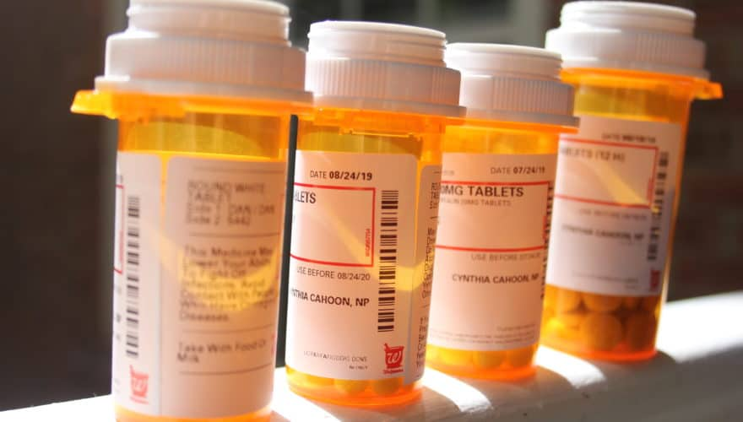

Locations for Medication Disposal
1) Hi-School Pharmacy, Scappoose
2) Rite-Aid Pharmacy, St. Helens
3) Columbia Co. Sheriff’s Office
Acceptable Items:
Prescription/Over-the-counter medications, vitamins
Unacceptable Items:
Sharps/Syringes (Scappoose Fire will accept these if registered in the exchange program.)
Aerosol cans/inhalers
Epi-Pens
Ointments, lotions, and liquids

